STUDENT ACADEMIC MANAGEMENT SYSTEM FOR SMAS MUHAMMADIYAH 1 BANDA ACEH

MUHAMMAD DARLEN SAVA

UNIVERSITI TEKNOLOGI MALAYSIA

**UNIVERSITI TEKNOLOGI MALAYSIA**

PSZ 19:16 (Pind. 1/13)

|  |  |  |
| --- | --- | --- |
|  | **CONFIDENTIAL** | (Contains confidential information under the Official Secret Act 1972)* |
|  | **RESTRICTED** | (Contains restricted information as specified by the organization where research was done)* |
| ✓ | **OPEN ACCESS** | I agree that my thesis to be published as online open access (full text) |

|  |  |  |
| --- | --- | --- |
|  |  | Certified by: |
| **SIGNATURE OF STUDENT** |  | **SIGNATURE OF SUPERVISOR** |
| A19EC0258 |  | PROF. MADYA. TS. DR. MOHD  SHAHIZAN BIN OTHMAN |
| **MATRIX NUMBER** |  | **NAME OF SUPERVISOR** |

NOTES : If the thesis is CONFIDENTIAL or RESTRICTED, please attach with the letter from the organization with period and reasons for confidentiality or restriction

**DECLARATION OF THESIS / UNDERGRADUATE PROJECT REPORT AND COPYRIGHT**

Author’s full name : MUHAMMAD DARLEN SAVA

Date of Birth

: 07/05/2001

Title

: STUDENT ACADEMIC MANAGEMENT SYSTEM FOR SMAS MUHAMMADIYAH 1 BANDA ACEH

Academic Session : 2022/2023

I declare that this thesis is classified as:

1. I acknowledged that Universiti Teknologi Malaysia reserves the right as follows:
2. The thesis is the property of Universiti Teknologi Malaysia
3. The Library of Universiti Teknologi Malaysia has the right to make copies for the purpose of research only.
4. The Library has the right to make copies of the thesis for academic

exchange.

“I hereby declare that we have read this thesis and in my opinion this thesis is suffcient in term of scope and quality for the

award of the degree of Bachelor of Computer Science (Software Engineering)”

|  |  |  |
| --- | --- | --- |
| Signature | : |  |
| Name of Supervisor | : | PROF. MADYA. TS. DR. MOHD SHAHIZAN BIN  OTHMAN |
| Date | : | 1 JULY 2023 |

STUDENT ACADEMIC MANAGEMENT SYSTEM FOR SMAS MUHAMMADIYAH 1 BANDA ACEH

MUHAMMAD DARLEN SAVA

A thesis submitted in fulfilment of the requirements for the award of the degree of

Bachelor of Computer Science (Software Engineering)

School of Computing Faculty of Engineering

Universiti Teknologi Malaysia

JULY 2022

# DECLARATION

I declare that this thesis entitled *“Student Academic Management System for SMAS Muhammadiyah 1 Banda Aceh”* is the result of my own research except as cited in the references. The thesis has not been accepted for any degree and is not concurrently submitted in candidature of any other degree.



|  |  |  |
| --- | --- | --- |
| Signature | : | .................................................... |
| Name | : | MUHAMMAD DARLEN SAVA |
| Date | : | 1 JULY 2023 |

# DEDICATION

This thesis is dedicated to my late father. He taught me to be an independent and strong man who can support the family when he eventually is not there to do it.

This thesis is also dedicated to my mother and brother, which have always helped me until now and forever.

# ACKNOWLEDGEMENT

I would like to thank you to my supervisor, which has been very helpful when helping preparing this thesis and being patience at all time. His guidance has left a powerful impact for me during this project. I would also like to thank you to my fellow colleagues that I met along the way to be super helpful by sharing information and such. Special thanks to my cousin which provided me with the required data for this project. Last but not least I can’t thank you enough for my mother and brother that help kept my spirit up until this moment.

# ABSTRACT

In this day and age, modern technologies have started to change how things work. Many institutions have begun implementing a sophisticated curriculum and teaching and learning system in the academic field. This system helps immensely reduce teacher workload and simplifies primary operations such as marking student reports. It is also beneficial to have this online system in situations such as the pandemic. While the scope of this sophisticated system is more significant than ever, some still don't have the luxury to experience it. These institutions that still do some of their operations manually did not have the resources to upgrade to the modernized system. Moreover, private institutions like SMAS MUHAMMADIYAH 1, located in Banda Aceh, Indonesia, have more challenges since the government will not be accommodating in this case. In this case, they will more likely fall behind in technological advancement. Thus, a web app system that has functions to convert all of those manual operations to be done more efficiently is needed. This web app will provide some of the most critical tasks in managing students’ academic data, such as managing academic reports, marking students, checking attendance, creating and viewing timetables, managing students’ tuition records, and managing teacher and student information. In this project, the methodology used to develop the system is the Agile methodology. The project requirements are also provided using Unified Modelling Language (UML), such as use case diagrams and sequence diagrams. These requirements will be available in the Software Requirements Specification. The design of the system is also provided in the Software Design Document. At the same time, the future testing plan will be documented in the Software Testing Documentation.

# ABSTRAK

Pada zaman ini, teknologi moden telah mula mengubah cara kerja. Banyak institusi telah mula melaksanakan kurikulum dan sistem pengajaran dan pembelajaran yang canggih dalam bidang akademik. Sistem ini sangat membantu mengurangkan beban kerja guru dan memudahkan operasi utama seperti menanda laporan pelajar. Ia juga berfaedah untuk mempunyai sistem dalam talian ini dalam situasi seperti wabak. Walaupun skop sistem canggih ini lebih penting berbanding sebelum ini, ada yang masih tidak mempunyai kemewahan untuk mengalaminya. Institusi ini yang masih melakukan beberapa operasi mereka secara manual tidak mempunyai sumber untuk menaik taraf kepada sistem moden. Lebih-lebih lagi, institusi swasta seperti SMA MUHAMMADIYAH 1, yang terletak di Banda Aceh, Indonesia, mempunyai lebih banyak cabaran kerana kerajaan tidak akan bertolak ansur dalam kes ini. Dalam kes ini, mereka lebih berkemungkinan akan ketinggalan dalam kemajuan teknologi. Oleh itu, sistem aplikasi web yang mempunyai fungsi untuk menukar semua operasi manual tersebut untuk dilakukan dengan lebih cekap diperlukan. Apl web ini akan menyediakan beberapa tugas paling kritikal dalam mengurus data akademik pelajar, seperti mengurus laporan akademik, menanda pelajar, menyemak kehadiran, mencipta dan melihat jadual waktu, mengurus rekod tuisyen pelajar dan mengurus maklumat guru dan pelajar. Dalam projek ini, metodologi yang digunakan untuk membangunkan sistem ialah metodologi Agile. Keperluan projek juga disediakan menggunakan Bahasa Pemodelan Bersepadu (UML), seperti rajah kes penggunaan dan rajah jujukan. Keperluan ini akan tersedia dalam Spesifikasi Keperluan Perisian. Reka bentuk sistem juga disediakan dalam Dokumen Reka Bentuk Perisian. Pada masa yang sama, rancangan ujian masa hadapan akan didokumenkan dalam Dokumentasi Pengujian Perisian.

# TABLE OF CONTENTS

|  |  |
| --- | --- |
| **TITLE** | **PAGE** |

DECLARATION ii

DEDICATION iii

ACKNOWLEDGEMENT iv

ABSTRACT v

ABSTRAK vi

TABLE OF CONTENTS vii

LIST OF TABLES x

LIST OF FIGURES xi

LIST OF ABBREVIATIONS xiii

LIST OF APPENDICES xiv

|  |  |  |
| --- | --- | --- |
| **CHAPTER 1** | **INTRODUCTION** | **1** |
| 1.1 | Introduction | 1 |
| 1.2 | Problem Background | 2 |
| 1.3 | Project Aim | 2 |
| 1.4 | Project Objectives | 2 |
| 1.5 | Project Scope | 3 |
| 1.6 | Project Importance | 3 |
| 1.7 | Report Organization | 3 |
| **CHAPTER 2** | **LITERATURE REVIEW** | **5** |
| 2.1 | Introduction | 5 |
| 2.2 | Case Study (If any) | 5 |
|  | 2.2.1 Company Organization Structure | 5 |
|  | 2.2.2 Manual Operation | 6 |
| 2.3 | Current System Analysis | 10 |
| 2.4 | Similar Existing System Analysis | 10 |
|  | 2.4.1 UTM Academic Management System | 10 |

* + 1. Evaluation 12
    2. Sekawan Media Aplikasi Rapor Online 13
  1. Comparison Between Existing Systems 14
  2. Literature Review of Technology Used 15

|  |  |  |  |  |  |
| --- | --- | --- | --- | --- | --- |
| 2.6.1 | | PHP |  |  | 15 |
| 2.6.2 | | Vue.js + Tailwind |  |  | 15 |
| 2.6.3 | | Laravel |  |  | 16 |
| 2.6.4 | | Visual Studio Code |  |  | 16 |
| 2.6.5 | | PostgreSQL |  |  | 16 |
| 2.6.6 | | pgAdmin |  |  | 16 |
| 2.6.7 | | Amazon S3 |  |  | 17 |
| 2.6.8 | | Amazon Elastic Compute EC2) | Cloud | (Amazon | 17 |
| 2.7 | Chapter Summary | | | | 17 |
| **CHAPTER 3** | **SYSTEM DEVELOPMENT METHODOLOGY** | | | | **19** |
| 3.1 | Introduction | | | | 19 |
| 3.2 | Methodology Choice and Justification | | | | 19 |
| 3.3 | Phases of Chosen Methodology | | | | 20 |
| 3.3.1 | | Requirements | 21 | | |
| 3.3.2 | | Design | 21 | | |
| 3.3.3 | | Development | 21 | | |
| 3.3.4 | | Testing | 21 | | |
| 3.3.5 | | Deployment | 22 | | |
| 3.3.6 | | Feedback | 22 | | |

* 1. Technology Used Description 22
  2. System Requirement Analysis 23
     1. Software Requirements 23
     2. Hardware Requirements 23
  3. Chapter Summary 24

# CHAPTER 4 REQUIREMENT ANALYSIS AND DESIGN 25

4.1 Introduction 25

|  |  |  |
| --- | --- | --- |
| 4.2 | Requirement Analysis | 25 |
|  | 4.2.1 Functional Requirements | 25 |
|  | 4.2.1.1 Use Case Diagram | 25 |
|  | 4.2.1.2 Actors Description | 27 |
|  | 4.2.1.3 Use Case Description | 27 |
|  | 4.2.1.4 Use Case Specification | 28 |
|  | 4.2.1.5 Sequence Diagram | 31 |
|  | 4.2.1.6 Activity Diagram | 33 |
|  | 4.2.2 Non-functional Requirements | 34 |
| 4.3 | Project Design | 35 |
| 4.4 | Database Design | 36 |
|  | 4.4.1 Data Dictionary | 37 |
| 4.5 | Interface Design | 38 |
|  | 4.5.1 Page Navigation Design | 38 |
|  | 4.5.2 User Interface Design | 40 |
| 4.6 | Chapter Summary | 43 |
| **CHAPTER 5** | **IMPLEMENTATION** **AND TESTING** | **44** |
| 5.1 | Introduction | 44 |
| 5.2 | Coding of System Main Functions | 44 |
| 5.3 | Interface of System Main Functions | 44 |
| 5.4 | Testing |  |
|  | 5.4.1 Black box Testing |  |
|  | 5.4.1.1 System Flow |  |
|  | 5.4.1.2 Input Output Verification |  |
|  | 5.4.1.3 Error Messages |  |
|  | 5.4.2 White box Testing |  |
|  | 5.4.3 User Testing |  |
| 5.5 | Chapter Summary |  |
| **CHAPTER 6** | **CONCLUSION** | **44** |
| 5.1 | Introduction | 44 |
| 5.2 | Achievement of Project Objectives | 44 |
| 5.3 | Suggestions for Future Improvement | 44 |
| **REFERENCES** |  | **46** |
|  |  |  |
|  |  |  |
|  |  |  |
|  |  |  |
|  |  |  |
|  |  |  |
|  |  |  |

# LIST OF TABLES

|  |  |  |
| --- | --- | --- |
| **TABLE NO.** | **TITLE** | **PAGE** |
| Table 2.1 | Comparison Between Existing System and Proposed System | 14 |
| Table 3.1 | Technology Used and Description | 22 |
| Table 4.1 | Use Case Specification for Uc002 - Manage Academic Report | 30 |
| Table 4.2 | Data Dictionary of Academic report Table | 37 |
| Table 4.3 | Data Dictionary of Knowledge mark Table | 38 |

# LIST OF FIGURES

|  |  |  |
| --- | --- | --- |
| **FIGURE NO.** | **TITLE** | **PAGE** |
| Figure 2.1 | Organization Chart of SMAS MUHAMMADIYAH 1 BANDA ACEH | 6 |
| Figure 2.2 | Manual Marking of Students | 7 |
| Figure 2.3 | First Page of The Report Book of a Student | 8 |
| Figure 2.4 | Second Page of The Report Book of a Student | 8 |
| Figure 2.5 | Attendance Book | 9 |
| Figure 2.6 | Tuition Card | 9 |
| Figure 2.7 | Myutm, Portal to UTM ACAD | 11 |
| Figure 2.8 | UTM ACAD | 11 |
| Figure 2.9 | Semester Data UI Of Evaluation | 12 |
| Figure 2.10 | Students Data UI Of Evaluation | 13 |
| Figure 2.11 | School Final Exam Marking UI Of Sekawan Media Aplikasi Rapor Online | 13 |
| Figure 2.12 | Generated Report Book UI of Sekawan Media  Aplikasi Rapor Online | 14 |
| Figure 3.1 | Agile Methodology Model | 20 |
| Figure 4.1 | Use Case Diagram of Student Academic Management System | 26 |
| Figure 4.2 | Sequence Diagram of UC002 – Manage Academic  Report | 32 |
| Figure 4.3 | Activity Diagram of UC0015-Manage User | 33 |
| Figure 4.4 | Architecture Model Diagram for Sams | 35 |
| Figure 4.5 | Erd Of Student Academic Management System | 36 |
| Figure 4.6 | Page Navigation for Teacher in Sams | 39 |
| Figure 4.7 | Page Navigation for Student in Sams | 39 |

|  |  |  |
| --- | --- | --- |
| Figure 4.8 | Page Navigation for Admin in Sams | 40 |
| Figure 4.9 | Login Page for Sams | 41 |
| Figure 4.10 | Marking Page for Teacher in Sams | 41 |
| Figure 4.11 | Academic Report Page for Teacher in Sams | 42 |
| Figure 4.12 | Account Management for Admin in Sams | 42 |

# LIST OF ABBREVIATIONS

|  |  |  |
| --- | --- | --- |
| SRS | - | Software Requirement Specification |
| SDD | - | Software Design Document |
| STD | - | Software Testing Documentation |
| UML | - | Unified Modelling Language |
| SAMS | - | Student Academic Management System |
| MVC | - | Model-View-Controller |
| UTM | - | Universiti Teknologi Malaysia |

# LIST OF APPENDICES

|  |  |  |
| --- | --- | --- |
| **APPENDIX** | **TITLE** | **PAGE** |

|  |  |  |
| --- | --- | --- |
| Appendix A | Software Requirement Specification | 47 |
| Appendix B | Software Design Document | 112 |
| Appendix C | Software Testing Documentation | 182 |
| Appendix D | Gantt Chart | 201 |

# CHAPTER 1

**INTRODUCTION**

* 1. **Introduction**

In the current day of modern technologies, many tasks and jobs have started to be done automatically throughout many fields of work. In the academic fields, the system to manage anything related to it has been significantly improved. We can lay out several reasons why this is happening. The first one is the usual suspect, which is globalization. More and more institutions introduce other cultures into their curriculum, such as English language subjects. Globalization results in a more culturally and linguistically diversified population (Miller et al., 2009). Other reasons, such as technological advancement and the research put into better teaching and learning environments, led to many sophisticated systems used daily to manage students, teachers, and the institution's data.

However, there are still some areas that still do crucial and time-consuming tasks manually. One of them is managing the academics of a student. While many institutions have already made sophisticated systems that manage all of a student's data, here in Aceh, Indonesia is still a step behind.

Thus, a web app system for managing students' academics is needed to combat this. This Student Academic Management System will help teachers ease their work, save time, and make sure that students and their parents have access to their data. It is not without a reason why the system will be developed as a web app because the most significant benefit of a website is that it can be accessed by almost every device without the need to install an actual app.

* 1. **Problem Background**

One institution that still does not have a website to manage students' academic data is SMAS Muhammadiyah, a private high school in Banda Aceh City, Indonesia. For many years now, teachers in SMAS Muhammadiyah have been dealing with report cards that they update each semester manually. While the teachers changing the report cards means that the students or their parents do not have access to their academic data for a while until the teachers completely update it. The report card collection usually happens when a final exam occurs; the students will hand in their report cards before the exam starts. After the final exam finishes, they will get their report cards back on "Report cards distribution day.” Nevertheless, it is time-consuming, but there is also a risk of losing the report card and being more vulnerable to human error.

Another problem that they are facing is the tuition management of the students. It is still done manually without a system by confirming to the student’s parents/guardians. The parents/guardians will send the teacher the receipt of payment, usually through a messaging app such as WhatsApp. Not only is it cumbersome, but also time-consuming for both parties. The same can be said for attendance checking. SMAS Muhammadiyah still uses an attendance book that is provided for each classroom. This attendance record will be filled in manually by the teacher that teaches that day in that particular classroom. The data of all students is also being kept in multiple files and books, making it decentralized. The timetable that the students use is also manually printed out, and the student needs to write down the schedule/timetable themself.

* 1. **Project Aim**

This project aims to create an effective solution to enable the institution to convert its manual student management system into a computerized system.

* 1. **Project Objectives**

The objectives of the project are:

* + 1. To identify the requirements of the student academic management system
    2. To design the student academic management system based on the Stakeholder’s requirement
    3. To develop the student academic management system based on the Stakeholder’s requirement
    4. To test the functionalities of the student academic management system according to stakeholder’s requirement
  1. **Project Scope**

The scopes of the project are:

* + 1. This project only focused on the conversion of manually managing student data to a website that stores all of the student’s data, which can be accessed by teachers, and students.
    2. SMAS Muhammadiyah 1 will provide the data that is needed for the system
    3. Users in this system are teachers, students, and admins of SMAS Muhammadiyah.
  1. **Project Importance**

The project will significantly increase the efficiency of the institution’s student management and increase the teacher’s productivity. It also provides students and their parent's ease of access to academic data. The proposed automated system will also minimize the risk of human error from all parties involved.

* 1. **Report Organization**

This PSM 1 report will consist of 5 chapters: Introduction, Literature Review, Methodology, Requirement Analysis and Design, and Conclusion. The introduction chapter consists of an introduction to the project and the problem background, aim, objectives, scope, and importance of the project. In chapter 2, the literature review will mainly discuss the case study with its organizational structure and manual operation. There will also be an analysis of the current system and comparing existing systems.

The technology used will also be included in this chapter. In the 3rd chapter, the methodology was chosen for the project, and its justification will be explained. The chosen methodology’s phases then will be briefly dissected one by one. In chapter 4, the requirement analysis and design will be laid out. This requirement analysis and design are required before taking the system into the development phase. The 5th chapter, which is the final chapter of this report, will consist of the report's conclusion. This chapter will also include achievements and suggestions so far during the project.

**CHAPTER 2**

**LITERATURE REVIEW**

* 1. **Introduction**

In this chapter, the literature review involved with the proposed system will be described in detail. It will become the source of information about existing systems or identical systems from the current market. By comparing them with the proposed system the enhancement that can be made will become clear. The technology that will be used in the development will also be stated.

* 1. **Case Study (If any)**

The proposed system is based on a case study from one of the institutions in Banda Aceh, Aceh, Indonesia. The name of the institution is SMAS MUHAMMADIYAH 1 BANDA ACEH which is a private high school that has been existing for around 62 years. They are one of few high schools in Banda Aceh that have accreditation of A.

* + 1. **Company Organization Structure**

SMAS Muhammadiyah 1 is a private high school in Aceh, Indonesia. Just like other institutions they also have the same organizational structure at their level. They consist of teachers from across Aceh that are qualified with quality and in-depth knowledge of their subject while also maintaining their responsibilities as a teacher. The picture below is the organizational structure for SMAS Muhammadiyah 1.

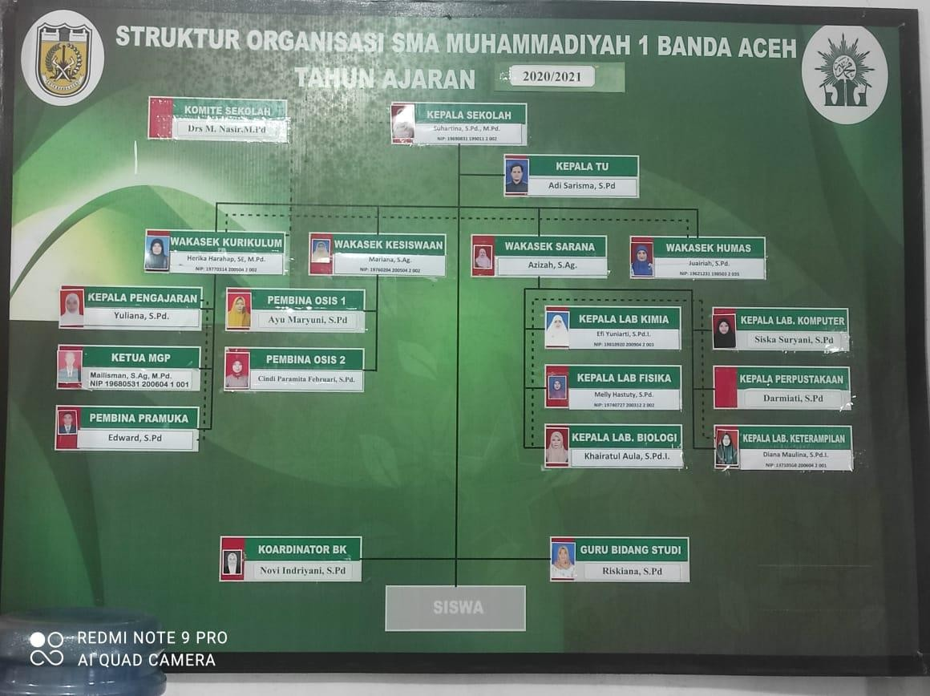

Figure 2.1: Organization Chart of SMAS MUHAMMADIYAH 1 BANDA

ACEH

* + 1. **Manual Operation**

The current system used by SMAS Muhammadiyah 1 to manage academic data is still involved using traditional and manual ways. This is ranging from marking student reports, and managing attendance records, to even keeping track of tuition records. For the marking student report process, it takes multiple teachers to recap all of the marks a student got. First, the teacher that is responsible for the course will collect their student's marks from a table that they have to fill in each time they give a mark for an assignment or in-class exercise. Then this excel table will be sent to the homeroom teacher. In the end, the homeroom teacher will have multiple excel files that they will put into the report book. The report book is also made using word/excel. From this point, we can conclude that the data is still not centralized because it moved from teacher to teacher.

As for managing the attendance record, they are still using an attendance book which will be filled by teachers that will teach in the class that day. This attendance book then will be used as a reference for the teacher by the end of the semester to be inputted into students' report books on how much they are absent because of sickness, and with/without permission. In managing the tuition record, the teachers at SMAS Muhammadiyah also still use what we called tuition book/card. This tuition book/card works the same way as the others mentioned above. The homeroom teacher will receive payment from the student’s parents and when they confirm the payment then they will approve it in the tuition book that the student has paid for the semester. The students also need to manually write down the schedule/timetable because it is usually only printed once and put in the front of the class. All of these manual operations can be seen in the pictures below,

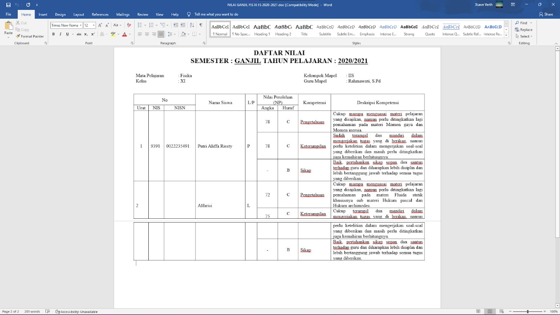

Figure 2.2: Manual marking of students

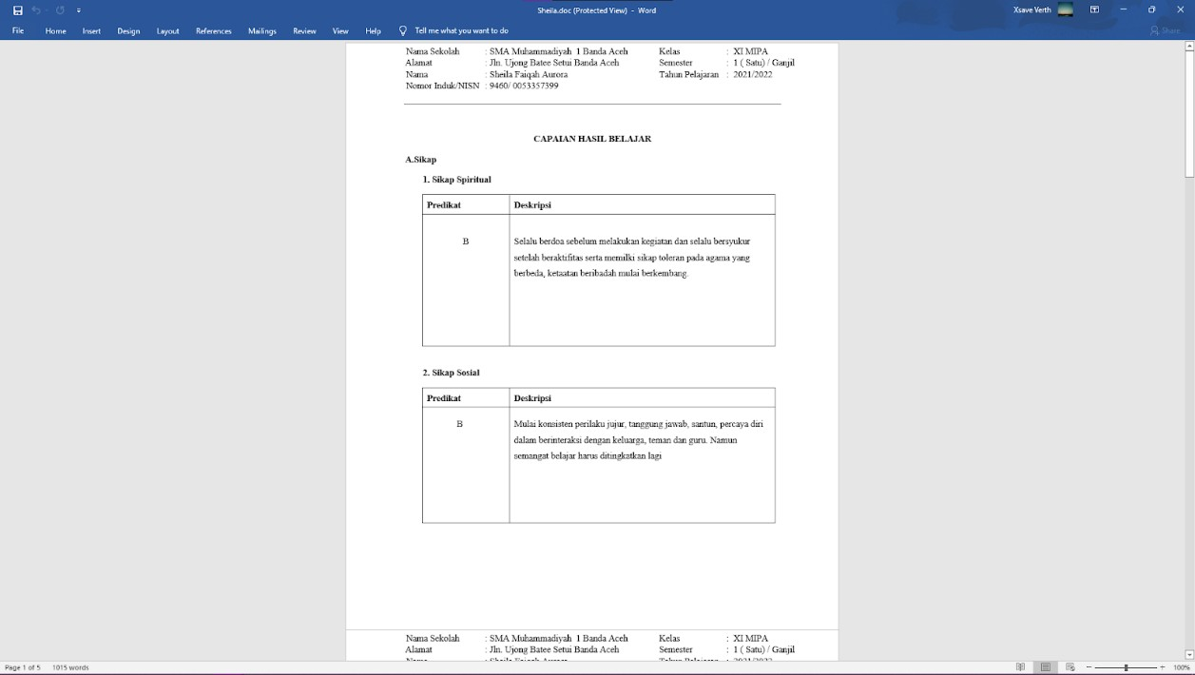

Figure 2.3: First page of the report book of a student

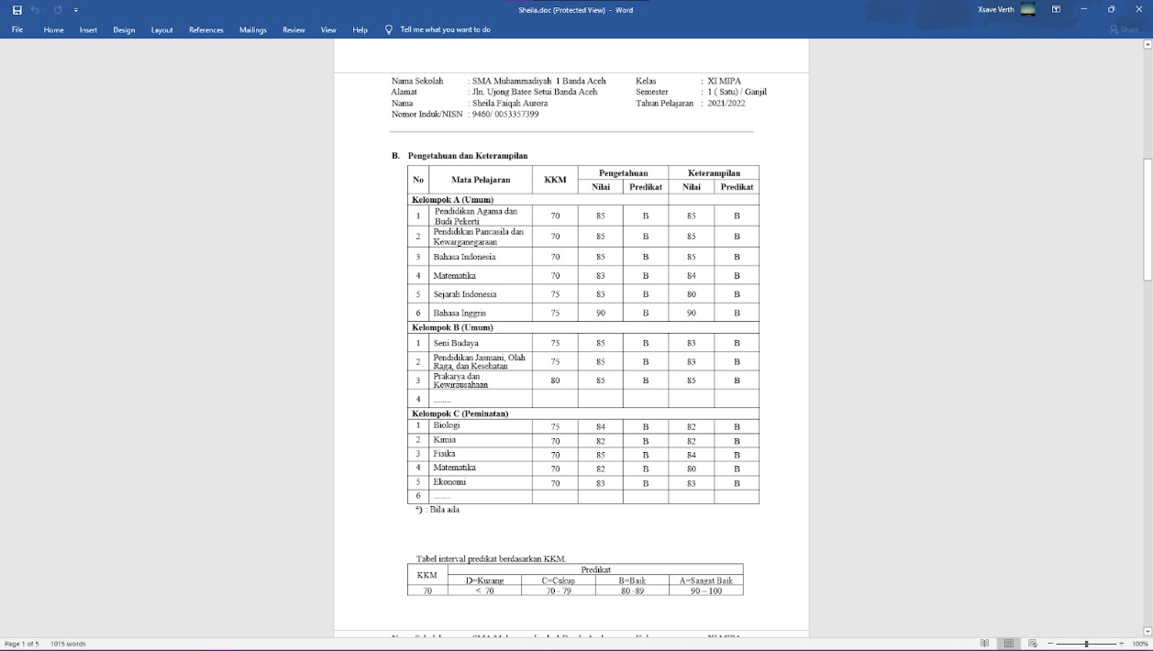

Figure 2.4: Second page of the report book of a student

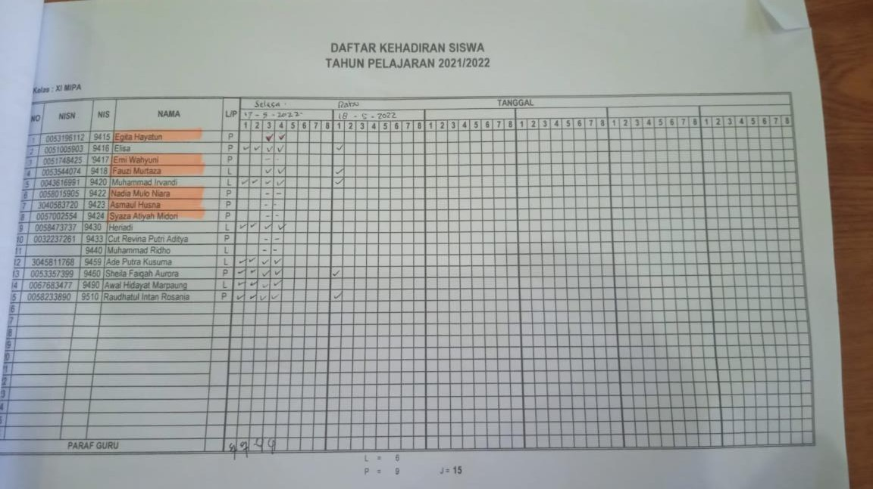

Figure 2.5: Attendance Book

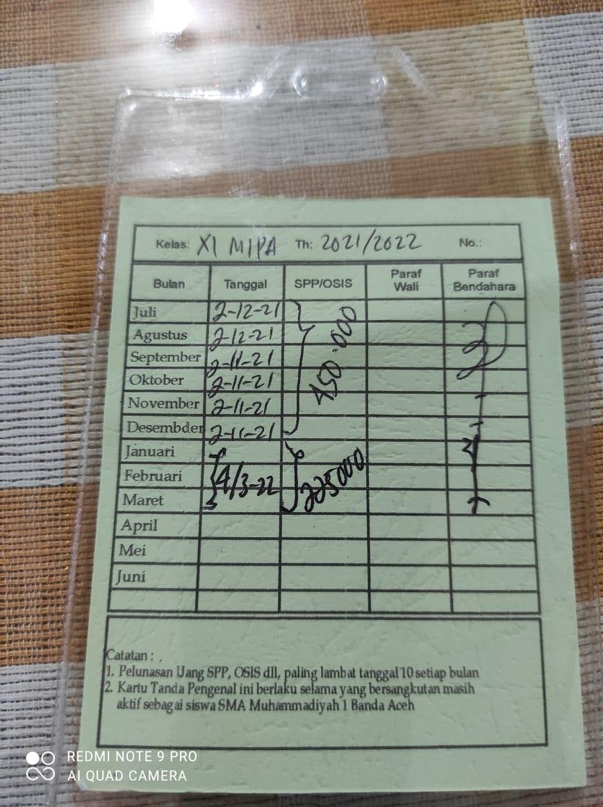

Figure 2.6: Tuition Card

* 1. **Current System Analysis**

In the current system several platforms are used causing the data to be decentralized. Some of the examples of platforms used are Microsoft Word, Microsoft Excel, Whatsapp, and also a manual operation using handwriting. The proposed system will fix this issue by having a centralized database, this way the data will not be scattered across different platforms. The current system also involved using handwriting in some instances such as filling in the attendance book or tuition book/card. Microsoft Word and Excel are used for filling in the report book and keeping track of students’ marks respectively. There are also some parts of the report book in which the teacher has to handwrite them. As for Whatsapp, it is usually used to confirm the payment of students’ tuition through their parents or even the students themself. The current task of taking students’ attendance is also done manually. The teachers that are teaching in that particular classroom will take the student’s attendance based on how many hours they teach on that day with a total of 8-hour slots per day. When the next teacher comes, they will also take attendance once again and all of this is recorded in a book called attendance book.

* 1. **Similar Existing System Analysis**
     1. **UTM Academic Management System**

UTM Academic Management System (ACAD) is a web-based system that helps to manage student academic data. This system allows the management of students’ data such as grades, personal information, and finances among other things. This system is personalized for students and lecturers of University Teknologi Malaysia. Although it is a bit convoluted to access because it is hidden behind another website called My UTM which then will redirect users to this system, it still provides its intended functions. Pictures below show the UI of my UTM and UTM ACAD

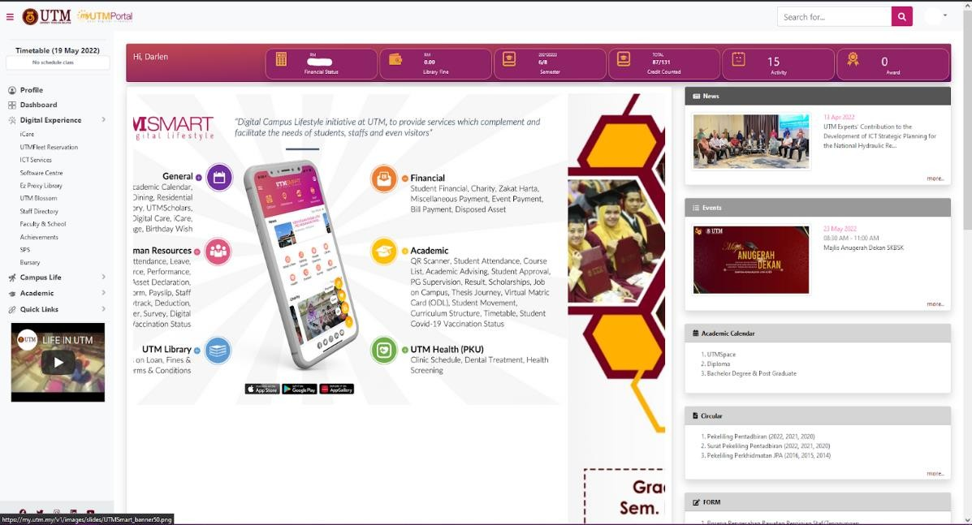

Figure 2.7: myUTM, Portal to UTM ACAD

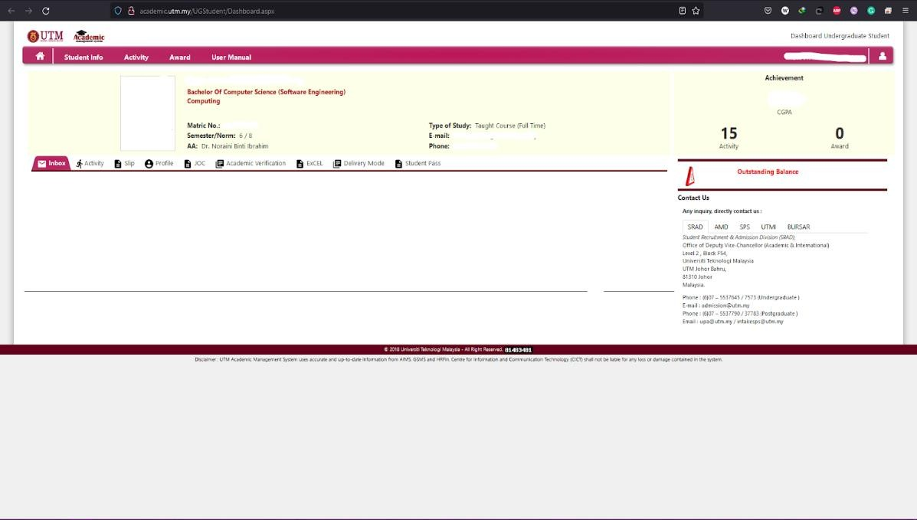

Figure 2.8: UTM ACAD

* + 1. **Evaluation**

The evaluation application is used to assess student learning results. This application evaluates the productivity of students based on exam scores, tests, and other activities (evaluation, 2016). Based on the brief explanation, this application mainly functions to help teachers monitor their student's growth and progress online. Below is the UI of evaluation:

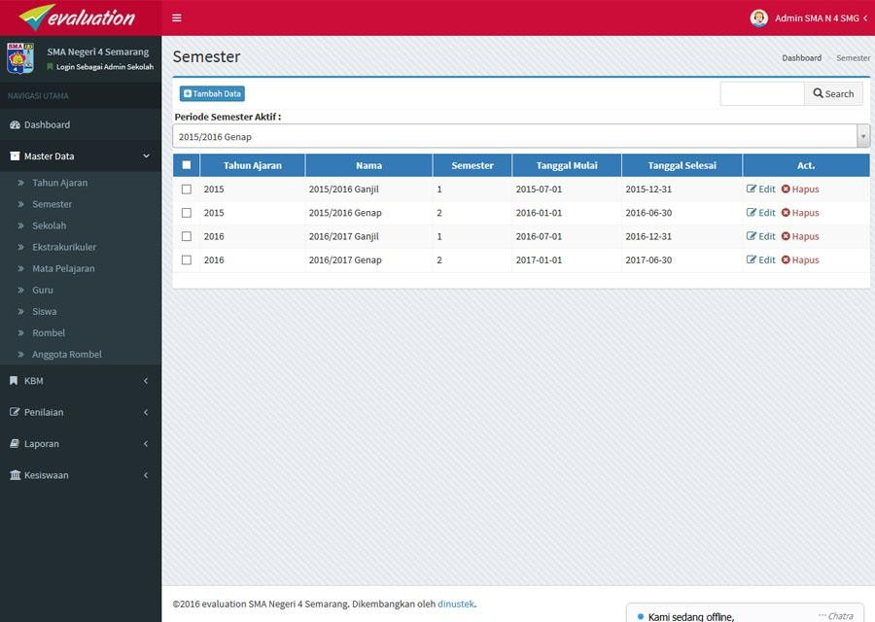

Figure 2.9: Semester Data UI of evaluation

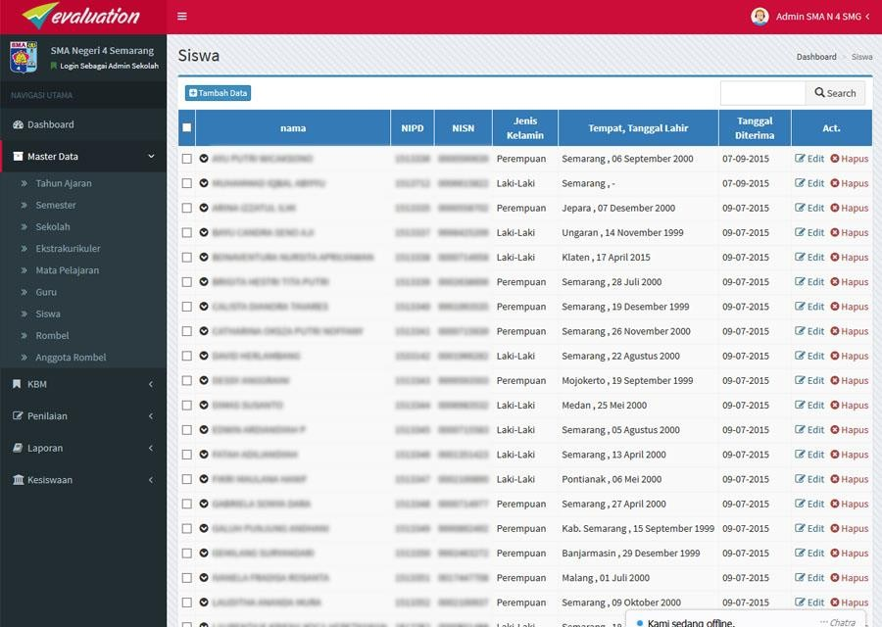

Figure 2.10: Students data UI of evaluation

* + 1. **Sekawan Media Aplikasi Rapor Online**

Rapor Online is a web-based application that makes it easy to report student learning outcomes. The Rapor Online application helps in reporting student grades from elementary to upper levels (Sekawan Media). Some of the highlights of this system are the functions such as counseling which the other existing system did not have.

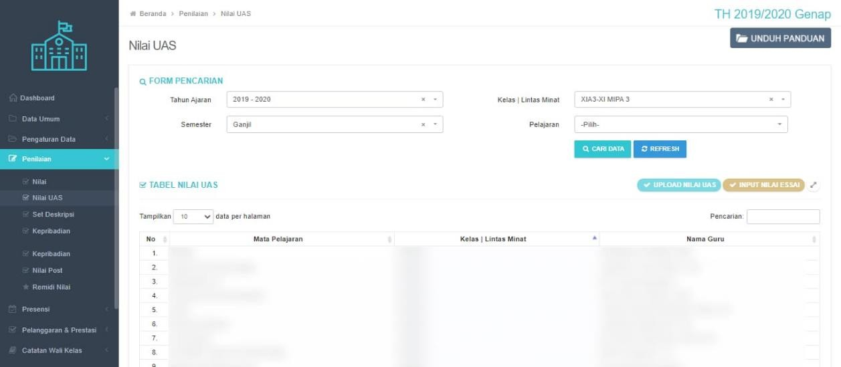

Figure 2.11: School final exam marking UI of Sekawan Media Aplikasi Rapor Online

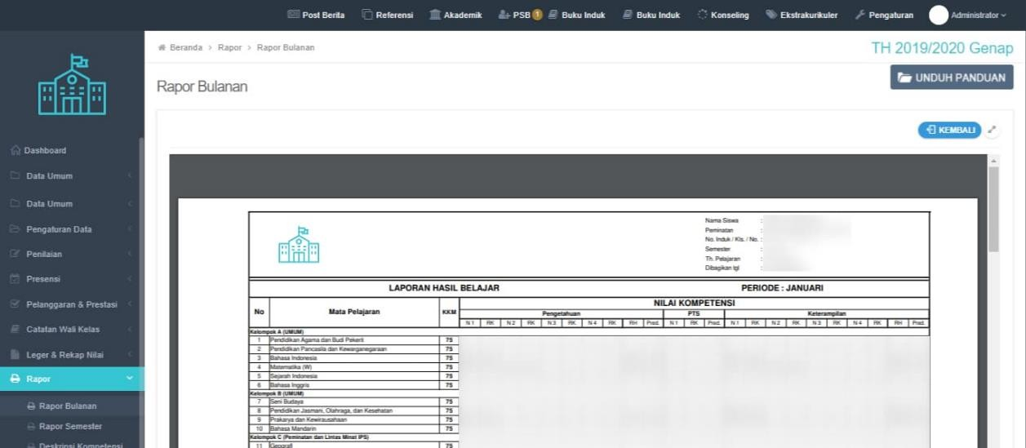

Figure 2.12: Generated report book UI of Sekawan Media Aplikasi Rapor Online

* 1. **Comparison Between Existing Systems**

In table 2.1 the comparison of functions/features between existing systems is shown. The proposed system is not included in the table because it is to be expected to include the functions that the existing system did not have or have. The main similarity between them is that all of them have the function to mark and generate reports. The existing system also has similarities with them not having a function to generate a timetable. Other than that they are pretty diverse in terms of having the functions or not.

Table 2.1: Comparison between existing system and proposed system

|  |  |  |  |  |
| --- | --- | --- | --- | --- |
| **Function/Feature** | **UTM**  **Academic Management System** | **evaluation** | **Sekawan Media Aplikasi Rapor Online** | **Student Academic Management System** |
| Report Marking | No | Yes | Yes | Yes |
| Manage Academic Report | No | Yes | Yes | Yes |
| Generate Report | Yes | Yes | Yes | Yes |

|  |  |  |  |  |
| --- | --- | --- | --- | --- |
| Student’s Profile Management | Yes | No | No | Yes |
| Teacher’s Profile Management | Yes | No | No | Yes |
| Tuition Record Management | Yes | No | No | Yes |
| Admin Dashboard | No | Yes | Yes | Yes |
| Generating Timetable | No | No | No | Yes |
| View Timetable | No | No | No | Yes |
| Centralized Database | Yes | Yes | Yes | Yes |
| Attendance Record Management | No | No | Yes | Yes |
| Multiple User role type Access | Yes | Yes | No | Yes |

* 1. **Literature Review of Technology Used**

In this part development tools and technology used for the proposed system will be examined.

* + 1. **PHP**

The proposed system will be developed using PHP which is a server scripting language that is fast, flexible, pragmatic, and suitable for web applications such as the proposed system. This language will also be used in conjunction with its framework which will be explained below.

* + 1. **Vue.js + Tailwind**

Vue.js and Tailwind will be used as the front-end of the system. Vue.js is a JavaScript framework that builds on top of vanilla HTML, CSS, and JavaScript. It

covers most of the basic or common features that are needed for front-end development. It is very flexible and can be used in many ways. As for Tailwind, it is a CSS framework that can be used for rapidly developing user interfaces. With these two combined it should be sufficient to develop the front-end.

* + 1. **Laravel**

Laravel is one of the most popular frameworks for PHP. It will be mainly focused on the backend side of the system such as database, and authentication among other things. By using Laravel it means that the development will follow along with the MVC (Model View Controller) architecture. Using MVC as its architecture and design pattern will have some benefits such as faster development and easier to organize a large-size web application. Its large library of packages/API will help the development immensely to cut down some of the basic functions.

* + 1. **Visual Studio Code**

Visual Studio Code is the choice for a code editor in this development of the Student Academic Management System. This code editor must be not too unfamiliar among developers because it is one of if not the most popular code editor software. Not only because it supports multiple languages but also has a large collection of extensions that makes coding easier and manageable.

* + 1. **PostgreSQL**

PostgreSQL is an open-source relational database that has many features and is highly extensible. It can handle small or bigger datasets while still maintaining security and performance. It is also the only relational database that meets the SQL:2016 Core conformance.

* + 1. **pgAdmin**

Since the development will be using PostgreSQL as the database it is only logical to also use the most popular tools for this open-source relational database.

pgAdmin is the tool for managing PostgreSQL, it is included with a convenient UI that helps and simplifies creating, maintaining, and using the database.

* + 1. **Amazon S3**

Amazon S3 is an object storage service from the tech giant Amazon that provides cloud storage with industry-leading in scalability, data availability, security, and performance. It is also cost-effective compared to other cloud storage and also configurable in such a way that meets the needs of stakeholder’s requirements.

* + 1. **Amazon Elastic Compute Cloud (Amazon EC2)**

Amazon EC2 is a web hosting provided by amazon. It is used by many big company names such as Netflix, Twitch, and LinkedIn. It is mainly for enterprise websites that usually have a lot of traffic to handle.

* 1. **Chapter Summary**

This Chapter mainly covers the case study which in this case is SMAS Muhammadiyah 1 and also their current system. Then there is the comparison between the existing system that has similar functions and the field of the proposed system. The technology that will be used in the development is also described in this chapter.

**CHAPTER 3**

**SYSTEM DEVELOPMENT METHODOLOGY**

* 1. **Introduction**

One of the most critical aspects of developing a system. There are a lot of methods that have their benefits and drawbacks. This chapter will discuss the chosen process and the justification for it. The phases of the selected methodology will also look in-depth, and a brief description of the technology used in the system's development and its system requirements will follow.

* 1. **Methodology Choice and Justification**

For developing any system, there are several methodologies or what is usually called The Software Development Life Cycle (SDLC) to choose from. Some popular ones are Agile, Lean, Waterfall, Iterative, Spiral, and DevOps. They all differ in one way but still have the same goal: to aid development quickly and cost-effectively. Agile, specifically Agile Scrum, will be chosen as the methodology for developing the Student Academic Management System.

Agile methodology was chosen for several reasons, but the methodology will be explained in short. Agile methodology is one of the most popular methodologies used in development nowadays. The Agile SDLC development approach emphasizes teamwork, customer satisfaction, and development across several short cycles, or sprints, instead of a top-down process with a single set of steps (mondayblog, 2022).

In agile methodology, the development of the system will be separated into different iterations, usually called “sprints.” In these sprints, a task or function of the system has to be done based on the time set. Because of this, the development will have a rapid delivery of the system since each sprint, there is something to show to the

stakeholders. It is also flexible because the stakeholders can add requirements anytime based on their feedback for each iteration/sprint. Thus, the satisfaction of stakeholders can also be seen for each iteration.

* 1. **Phases of Chosen Methodology**

In this part of the chapter, the phases of Agile methodology will be defined and explained one by one. The phases are as follows: Requirements, Design, Development, Testing, Deployment, and Feedback. The depiction of these phases is as in the picture below.

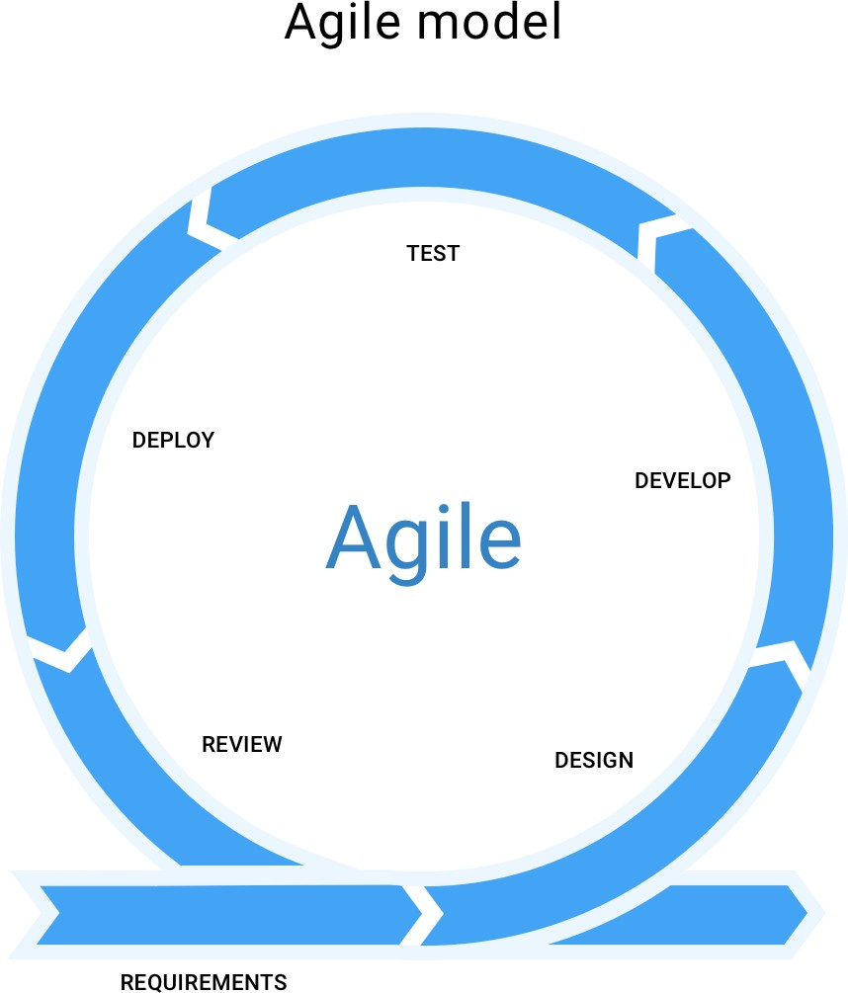

Figure 3.1: Agile methodology model

* + 1. **Requirements**

In this phase, the developer must assemble a list of requirements from the stakeholders. This requirement can be acquired by interviewing or discussing it with the stakeholders. The stakeholders will then be responsible for the backlog and user stories; meanwhile, the developer must ensure they have enough information and continue to the next step. This phase is crucial because it can determine the future of the project cost in time or money.

* + 1. **Design**

The focus in this phase is to define more in-depth details of the project from the requirements that have been set. These details include the project scope, objective, what tools will be used in the project, and the system requirement, just some examples. Discussing furthermore with the stakeholders is also considered reasonable at this phase.

* + 1. **Development**

In the development phase, the developer must transform the requirements and design into a functional system from the previous two phases. This phase is the foundation of the Agile methodology. Thus, it is where most of the developer's attention is drawn.

* + 1. **Testing**

As the name suggests, testing is the phase where the product/system is tested. During this phase, it is not possible to eliminate all bugs that reside in the system but still enough to make the system go into the deployment stage.

* + 1. **Deployment**

After testing is done and the bugs that have been encountered patched, then the deployment of the system can be done. Even though the system has been deployed, changes or fixes regarding newly found bugs can still be done.

* + 1. **Feedback**

After the product/system has been delivered to the stakeholders and is available to several users, collecting their feedback will be the last step of agile methodology. From the feedback gained, the developer can work to improve the system.

* 1. **Technology Used Description**

In this part, the development tools and technology used for the proposed system will be discussed briefly.

Table 3.1: Technology used and description

|  |  |
| --- | --- |
| **Technology** | **Description** |
| Windows 10 | Operating System |
| Google Drive | Documentation |
| Figma | Mockup interface |
| Draw.io | Design diagram |
| Visual Studio Code | Code Editor |
| Laravel | PHP framework |
| PHP | Programming Language |
| Amazon S3 | Cloud Storage |
| Amazon EC2 | Web Hosting |
| Vue.js | Javascript framework |
| Tailwind | CSS framework |

|  |  |
| --- | --- |
| PostgreSQL | Relational Database |
| pgAdmin | Database management tools |

* 1. **System Requirement Analysis**

System requirements analysis will help specify the required software and hardware to run the proposed system with the user in mind. Subchapter 3.5.1 will show the software requirements, consisting of OS and web browser choices. Subchapter

3.5.2 shows the hardware requirements, consisting of each OS and its required processor, RAM and Hard Drive.

* + 1. **Software Requirements**
       1. Operating system: Windows 8 or later, macOS Sierra 10.12 or later, and 64- bit Ubuntu 14.04+(Linux).
       2. Web Browser: Mozilla Firefox version 48 or later, Internet Explorer version 11 or later, Google Chrome version 54 or later
    2. **Hardware Requirements**
       1. Processor: Windows or Linux with Pentium 4 or newer processor that supports SSE2 or Mac computer with an Intel x86 or Apple silicon processor.
       2. RAM: Windows or Linux with 512MB of RAM / 2GB of RAM for the 64-bit version or Mac computer with 512 MB of RAM.
       3. Windows, Linux, or Mac with 200MB of hard drive space.
  1. **Chapter Summary**

The chosen methodology and the justification for choosing it is the main key point in this chapter. But there is also an in-depth look at what the methodology has to offer in the form of its phases. The technology used is also described briefly with its description. Last but not least, the system requirement analysis is also stated, which includes both software and hardware requirements to run the system.

**CHAPTER 4**

**REQUIREMENT ANALYSIS AND DESIGN**

* 1. **Introduction**

This chapter delve into the requirements to develop the system and the design of the system. The requirements analysis will be divided into 2 part which are the functional requirements that consist of diagrams such as use case diagram, sequence diagrams and activity diagrams and the non-functional requirements. The design of the system is also included which are the project architecture design, database design and interface design. The complete diagrams and design can be found in the appendix section that separated into 3 parts, appendix A for SRS, appendix B for SDD and appendix C for STD.

* 1. **Requirement Analysis**

This section will discuss about functional and non-functional requirements of the system from the stakeholder.

* + 1. **Functional Requirements**

In this part, the features and behaviors of the system will be discussed. It is crucial to have functional requirements since it define the main functions of the system.

* + - 1. **Use Case Diagram**

To represent the main functions and features of the system, use case diagram is used since it can describe the important component of the system along with its

relationship with the users of the system. The use case diagram of SAMS is depicted in figure 4.1.

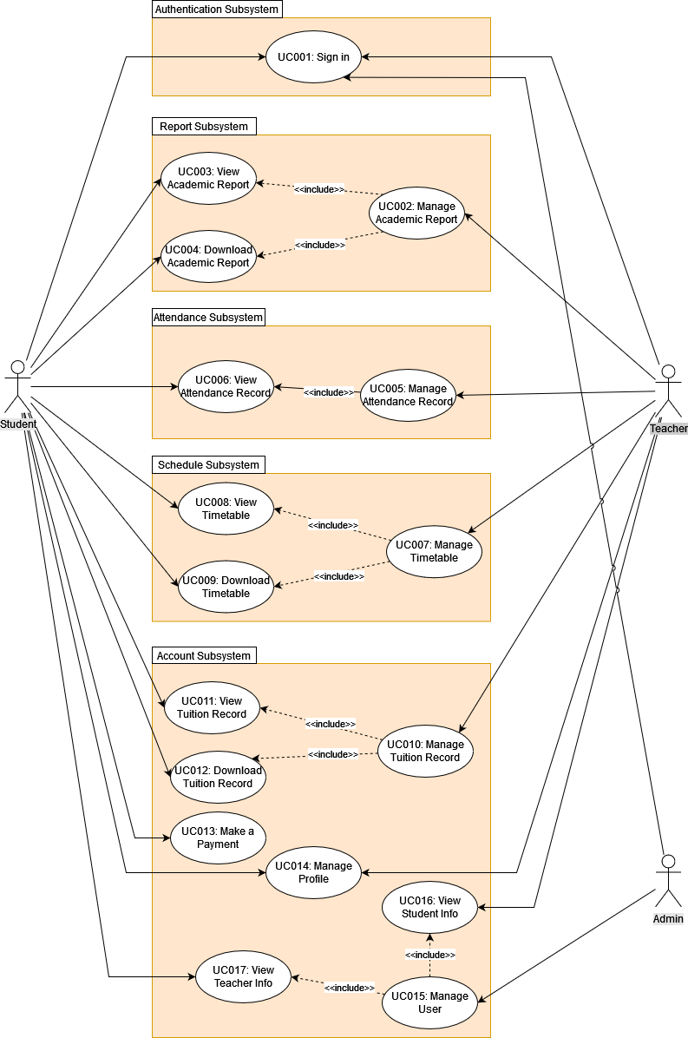

Figure 4.1 Use Case Diagram of Student Academic Management System

The figure above shows all of the functions that exist in the proposed system. Besides the use case and subsystems there are three users that directly involved in the system. The arrow shows users can only access certain functions. There are 17 use cases that divided into 5 subsystems. There are multiple use cases that included into

another use case, this is because certain user like student can only access some of the original functions. The description on what the actors and use case’s role in the system will discussed in the next subchapter.

* + - 1. **Actors Description**

Actors involved in the system are Student, Teacher and Admin. For student they will get access to most of their data by viewing or downloading it. As for teacher they mostly have access to managing use case means that they gain access to a lot of CRUD operations. Lastly, the admin has a role to manage all of the user account since creating users account is done by the admin. So, they have quite an important role in the system.

* + - 1. **Use Case Description**

Use Case Description describes how each of the use case works if an actors or user using them. All of 17 uses cases will be briefly explaining here.

* + - * 1. UC001 – Sign In: This use case is used for every user in the system to enter the system
        2. UC002 – Manage Academic Report: This use case is used for teacher to manage the academic report and marking of students
        3. UC003 - View Academic Report: This use case is used for student to view their academic report
        4. UC004 – Download Academic Report: This use case is used for student to download their academic report
        5. UC005 – Manage Attendance Record: This use case is used for teacher to manage the attendance record including to take attendance during class
        6. UC006 – View Attendance Record: This use case is used for student to views the attendance record
        7. UC007 – Manage Timetable: This use case is used for student to manage the attendance record including to take attendance during class
        8. UC008 – View Timetable: This use case is used for student to views the timetable
        9. UC009 – Download Timetable: This use case is used for student to download the timetable
        10. UC010 – Manage Tuition Record: This use case is used for teacher to manage the tuition record including approving or rejecting tuition payment
        11. UC011 – View Tuition Record: This use case is used for student to view the tuition record
        12. UC012 – Download Tuition Record: This use case is used for student to download the tuition record
        13. UC013 – Make a Payment: This use case is used for student to download the tuition record
        14. UC014 – Manage Profile: This use case is used for student and teacher to view and edit their profile
        15. UC015 – Manage User: This use case is used for admin to manage user account both student and teacher
        16. UC016 – View Student Info: This use case is used for teacher to view list of students and their detailed information
        17. UC017 – View Teacher Info: This use case is used for student to view list of students and their detailed information
      1. **Use Case Specification**

Use case specification will describes the use cases in a more detailed manner. In this case, one of the use cases will be used as an example on how use case specification works. The rest of the use case specification can be found in the SRS in the appendix A.

|  |  |
| --- | --- |
| **Use Case ID:** | UC-002 |
| **Use Case**  **Name:** | Manage Academic Report |
| **Actors:** | Teacher |
| **Description:** | This use case is used for teacher to manage the academic report and marking of students |
| **Pre-conditions:** | 1. Logged in to the system |
| **Normal Flow:** | 1. Go to the “Rapor” page 2. If the teacher clicks “Penilaian” performs AF1 3. If the teacher clicks “Edit Penilaian” performs AF2 4. Select academic year 5. Select semester 6. Select class 7. Select student 8. The system displays the academic report 9. If the teacher wants to download the academic report performs AF3 10. If the teacher is a homeroom teacher and clicks “Buat Rapor” page performs AF4 11. If the teacher wants to delete the academic report performs AF5 |
| **Alternative**  **Flow:** | 1. Marking    1. System redirects teacher to “Peniliain” page    2. System display the marking form    3. Fill in the marking form    4. System saves student mark 2. Edit Marking    1. System redirects teacher to “Edit Penilaian” page    2. System displays the student that the teacher already marked    3. Select student    4. System displays the marking form    5. Edit the mark 3. Download Academic Report    1. Click the “Unduh” button to download 4. Create Academic Report    1. System redirects teacher to “Buat Rapor” page    2. Select Student    3. Teacher fills in additional information    4. Teacher clicks “Buat Rapor” button 5. Delete Academic Report    1. Click “Trash” icon to delete the academic report |
| **Exception:** | * 1. **Required field(s) is/are empty in marking form**      1. an error message will be displayed by the system      2. Performs NF2/AF1   2. **Required field(s) is/are empty when creating Academic Report** |

Table 4.1: Use case specification for UC002 - Manage Academic Report

|  |  |
| --- | --- |
|  | 1. an error message will be displayed by the system 2. Performs NF9/AF4 |
| **Post-condition**  **s:** | 1. Teacher successfully views the academic report 2. Teacher successfully downloads the academic report 3. Teacher successfully marks the student 4. Teacher successfully edits the marks of the student 5. Teacher successfully creates the academic report |
| **Related Requirement:** | **-** |

* + - 1. **Sequence Diagram**

Sequence diagram is designed to show the action between actors/users and the system’s objects. In this case, UC002 will be used again to represent the sequence diagram. The rest of the diagram can be found in the appendix B.

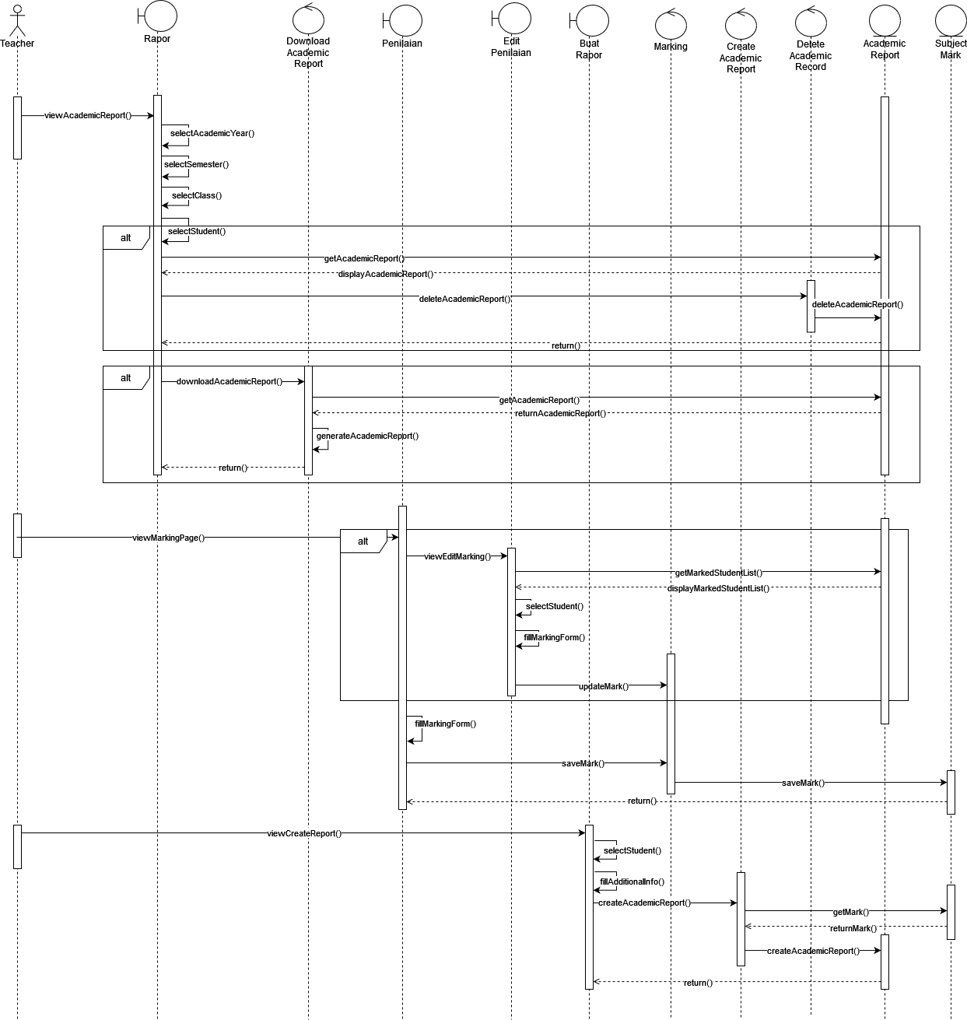

Figure 4.2: Sequence diagram of UC002 – Manage Academic Report

The figure above depicts how the users interact with object in the system through UC002. There are two alternatives that can be done by the teacher when viewing academic report which are deleting them or downloading the academic report. The Teacher can also go to the marking interface to mark student or they can edit the mark in the edit mark page. The last action that the teacher can do in this use case is to create the academic report. After all the action done indicated by the arrow going into the entity and return back to the boundary.

* + - 1. **Activity Diagram**

Activity diagram is used to demonstrate the flow of a certain functions. All of the involved actor will start at the same time and destination and also end at the same destination. UC015-Manage User will be used as the activity diagram in this part. Other activity diagram can be found in appendix A.

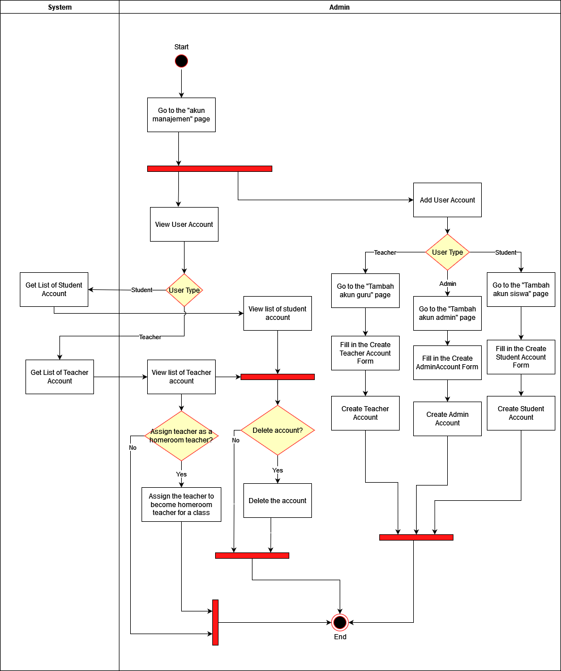

Figure 4.3: Activity diagram of UC0015-Manage User

In this UC, the admin can go to account management page to manage all user account. The admin has a few conditions from the start when viewing user account, they can choose to view students account or teacher account. They can also delete the user account when the system displays the user list. Additionally, when viewing the teacher account list, they can assign them to classes to act as a homeroom teacher.

The admin can also add new account since this is the only way for user to be added to the system. Once again, the admin can choose what type of user account they want to create. When creating student account, they can assign the semester and academic year of that student.

* + 1. **Non-functional Requirements**

Different from functional requirements, non-functional requirements act as the constraints of the system. Non-functional requirements more focused toward the system itself on what it can do to improve the functionality of the system. The system must achieve the requirements that are listed below.

1. Availabilty – The user should be able to access the system at any moment thus, the system must be available all day every day.
2. Security – The system should only allow authorized user from SMAS Muhammadiyah 1 to access the system. The system must provide protection to all of the data exist in the system.
3. Usability – The user should be able to explore the system with ease after inspecting the system a little bit. The system must be simple to use and comprehend.
4. Portability – The system should work with any web browser. The user shall be able to access the system from their preferred web browser
   1. **Project Design**

The architecture used for this proposed system is MVC or Model-View- Controller. In this model the code structure separated into different part which are mode, view and controller. The model in MVC is used as a bridge to transfer data between view and controller. As the name suggest the view in the MVC is for the user interface. And the controller is used for calling the functions.

One of the most important benefits of using MVC in a web-based app is how flexible it is which led to faster process when developing. Since its flexible, it means that changes made will not entirely affect other part of the system. Additionally, it has the benefit of helping the developers repeating the same code because model which represents data is separated from the logic in the controller. All of these benefits will greatly help developing SAMS. Following is the MVC diagram of SAMS.

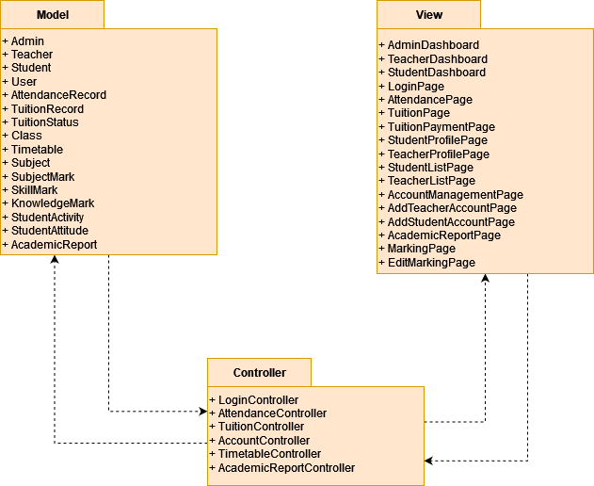

Figure 4.4: Architecture model diagram for SAMS

* 1. **Database Design**

In this part of the chapter, the design of the database for SAMS will be explored. Since database is a crucial part when developing the proposed system, an excellent database design is required. Following is the Entity Relationship Diagram (ERD) of Student Academic Management System.

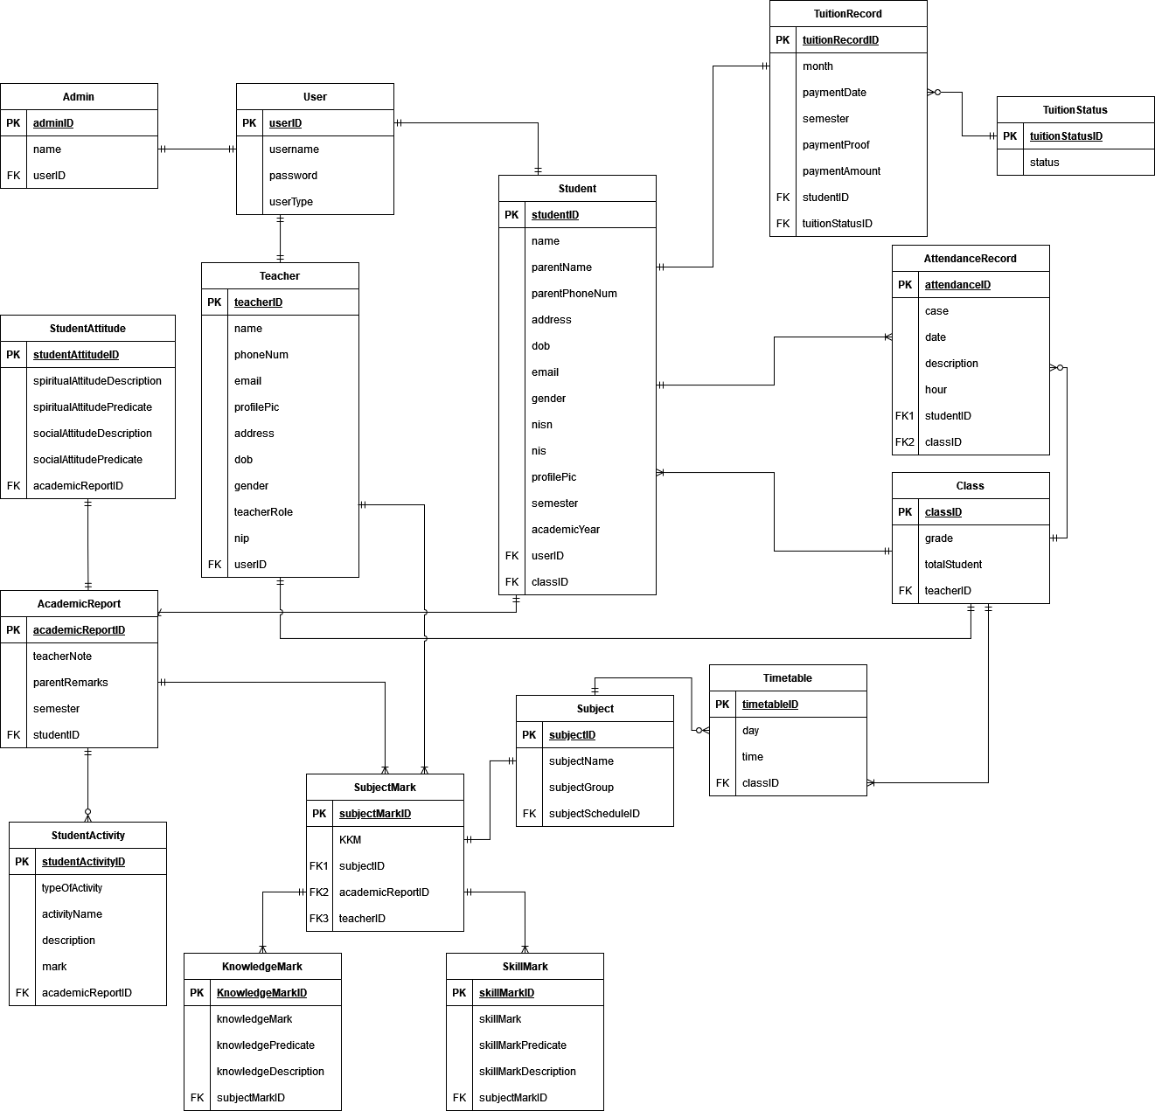

Figure 4.5: ERD of Student Academic Management System

From the ERD figure above, there are total of 16 entities. The purpose of the user entity is to store username and password from all of the different type of users. The academic report table will hold all of the marks of a student when all of the teacher finished marking and the creation of academic report can begin. The mark itself separated into two tables which are knowledge mark and skill mark. The subject mark table then will collect both type of mark and store it until the teacher create the academic report. The attendance table is used for the attendance checking function while the tuition record table is used for managing student’s tuition payment. The timetable table will store the timetable created by teacher.

* + 1. **Data Dictionary**

Data dictionary provide description about the attributes from the figure above. Here are the data dictionary for two entities which are academic report and knowledge mark.

Table 4.2: Data dictionary of AcademicReport Table

|  |  |  |  |
| --- | --- | --- | --- |
| AcademicReport Table | | | |
| Field Name | Datatype | Constraint | Description |
| academicReportID | BIGINT | Primary Key | Unique ID of the AcademicReport table |
| teacherNote | TEXT | not null | Note from the teacher about the student |
| semester | VARCHAR | not null | The semester of the student |
| studentID | BIGINT | Foreign Key | Unique ID of the Student table |

Table 4.3: Data dictionary of KnowledgeMark Table

|  |  |  |  |
| --- | --- | --- | --- |
| KnowledgeMark table | | | |
| Field Name | Datatype | Constraint | Description |
| knowledgeMarkID | BIGINT | Primary Key | Unique ID of the KnowledgeMark table |
| knowledgeMark | INT | not null | Knowledge mark of a student for a subject |
| knowledgePredicate | CHAR | not null | The predicate of the knowledge mark that the student got for a subject |
| knowledgeDescription | TEXT | nullable | The Description of the knowledge mark that the student got for a subject |
| subjectMarkID | BIGINT | Foreign Key | Unique ID of the SubjectMark table |

* 1. **Interface Design**

Interface design will be shown in this section. The section will be separated into two parts, Site map or page navigation diagram and the mock up user interface design.

* + 1. **Page Navigation Design**

There are three users/actors in the system which mean there will be three different dashboards for each user. The following figures are the page navigation design for teacher, student and admin.

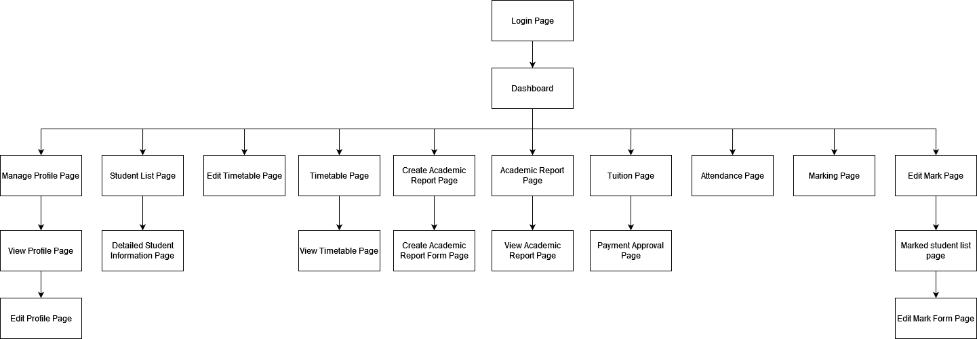

Figure 4.6: Page Navigation for Teacher in SAMS

After entering the system successfully through login, the teacher will be redirect to their own dashboard. From this dashboard the teacher can access all kind of different functions from creating academic report page to managing their profile.

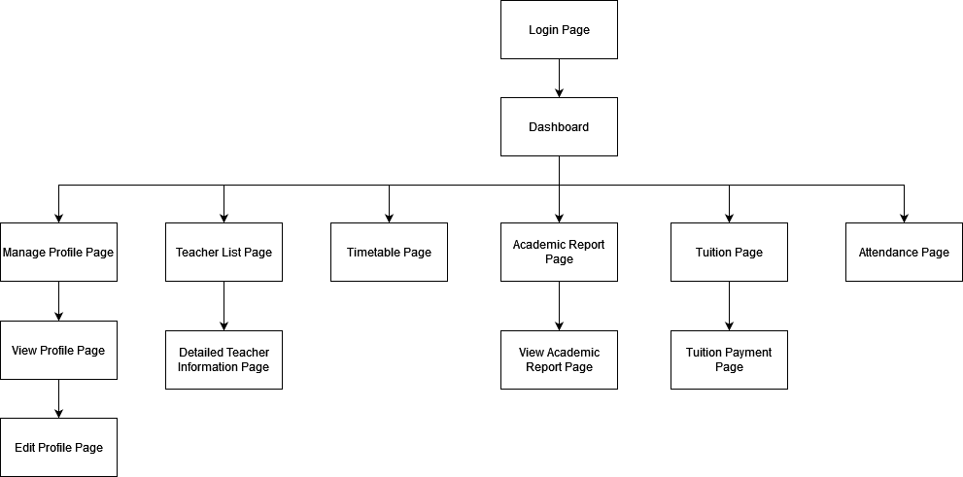

Figure 4.7: Page Navigation for Student in SAMS

After the student login into the system, they also welcomed with their own dashboard. From the dashboard the student can access manage profile page, teacher list page, timetable page, academic report page, tuition page and attendance page.

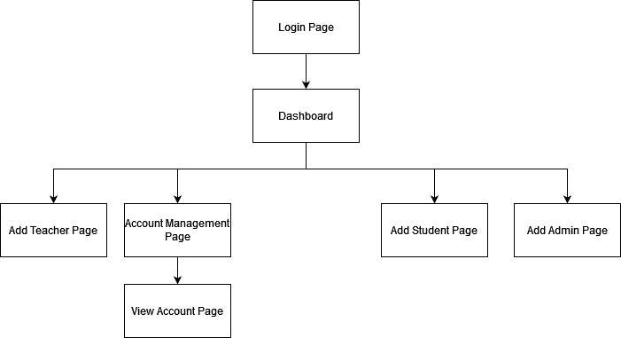

Figure 4.8: Page Navigation for Admin in SAMS

From the figure above, the admin can access to multiple pages after successfully enter the system. These pages are added teacher page, account management page, add student page and add admin page.

* + 1. **User Interface Design**

In this part, some of the mockup UI design will be shown, the complete mockup design can be found in the SDD in appendix B.

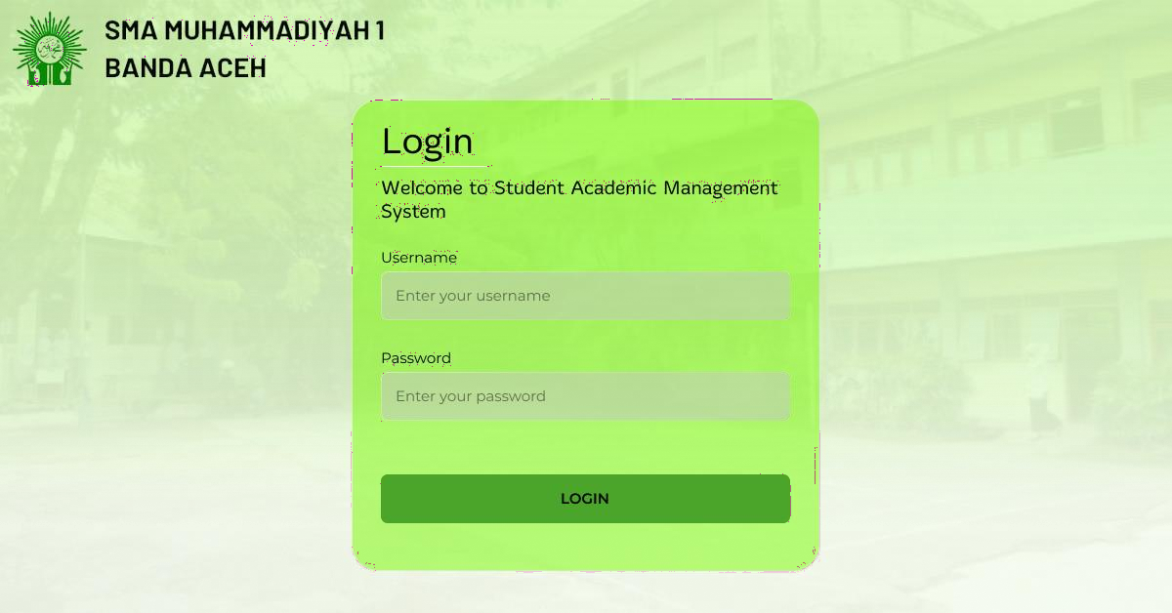

Figure 4.9: Login Page for SAMS

This page is used for the user to enter the system. The username and password will be provided by the admin since they are the only one who can make users account. After successfully login using valid credentials, each user will be redirected to their own dashboard.

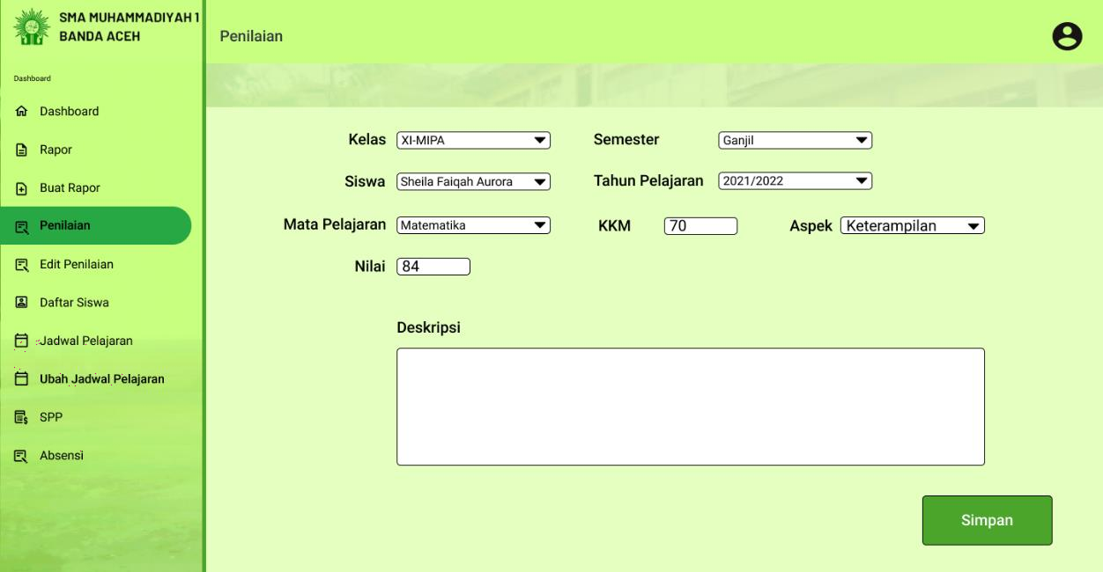

Figure 4.10: Marking Page for Teacher in SAMS

In this page, the teacher can begin marking students. They can select between two type of marks which are knowledge mark and skill mark. They can also set the KKM which mean passing grade.

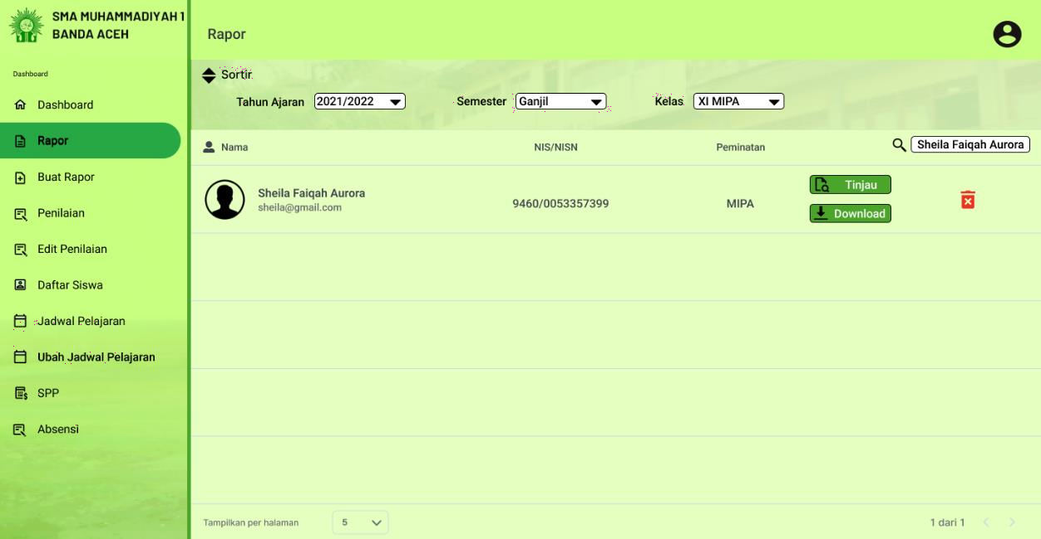

Figure 4.11: Academic Report Page for Teacher in SAMS

In this page the teacher can sort and search the student that they want to view or download their academic report. The view academic report page is available under appendix B.

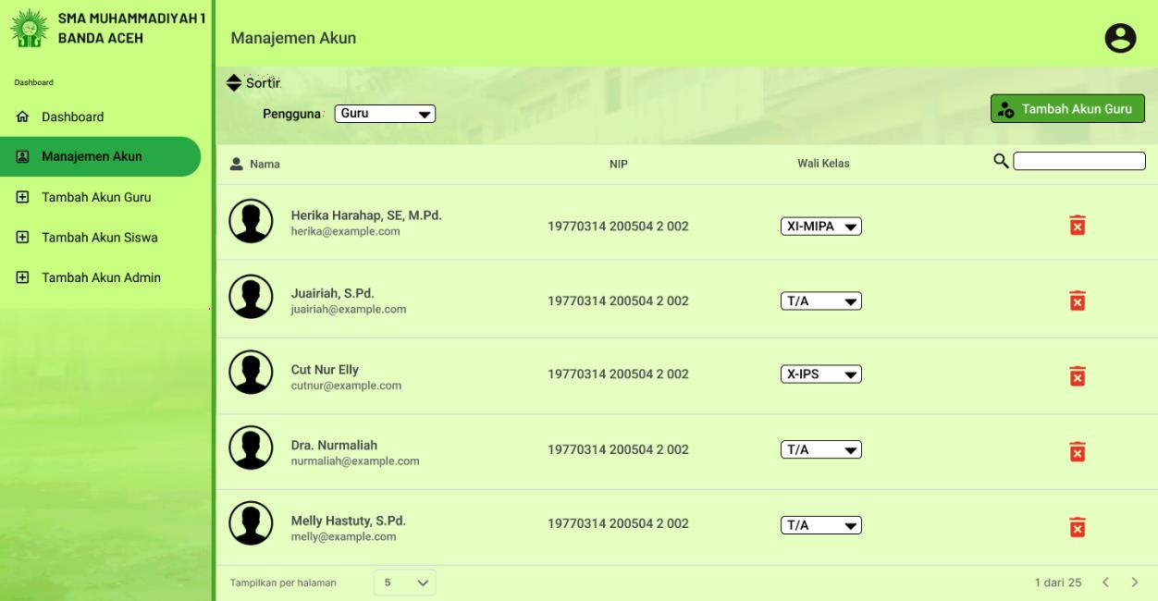

Figure 4.12: Account Management for Admin in SAMS

An admin can choose which user to view in this page. In this case the teacher account list is displayed. The admin then can set the teacher to be a homeroom teacher for a specific class or they can delete unused teacher account.

* 1. **Chapter Summary**

This chapter consist of requirement and designs for the proposed system. The requirement stated whether functional or non-functional will act as a standard for the system. The Model-View-Controller based system architecture design, database design and mockup interface design are also included in the chapter that will provide some basis for when developing the system later.

**CHAPTER 5**

**IMPLEMENTATION AND TESTING**

* 1. **Introduction**

In this chapter the implementation of the system along with the testing will be discussed. The chapter will provide the looks and explanation of the coding and interfaces of the system’s main functions. The testing that are done to the system such as Black box testing, White box testing and User testing will also be discussed.

* 1. **Coding of System Main Functions**

Below are some of the main functions in the system

* + 1. **Login Function**

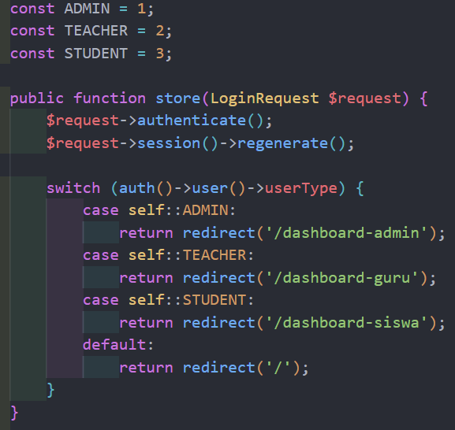

Figure 5.1: Login Function for Users

* + 1. **Logout Function**

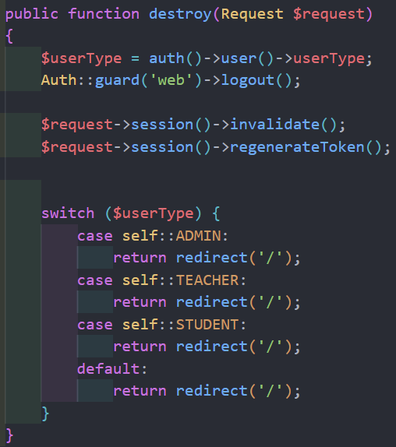

Figure 5.2: Logout Function for Users

* + 1. **Add Teacher Account Function (Admin)**

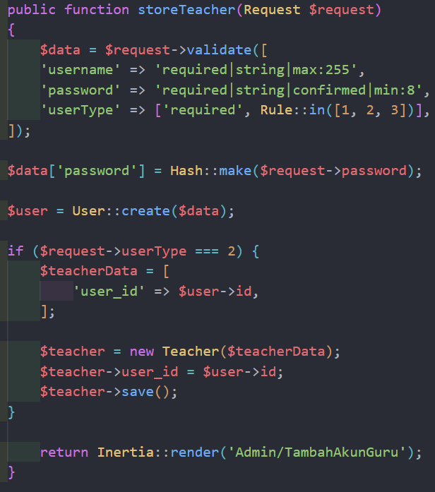

Figure 5.3: Add Teacher AccountFunction for Users

* + 1. **Add Admin Account (Admin)**

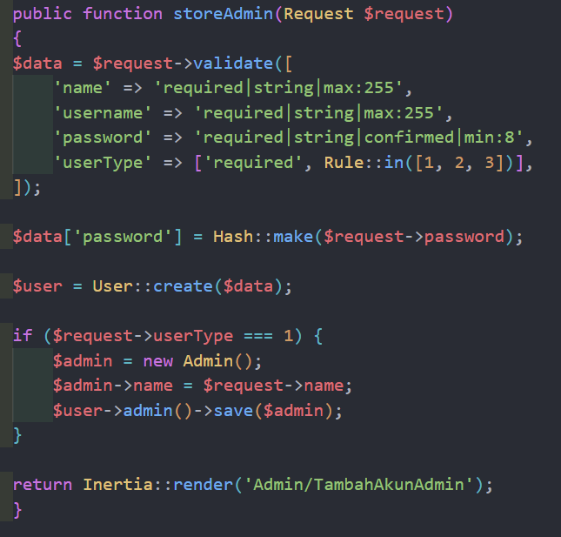

Figure 5.4: Add Admin Account Function for Admin

* + 1. **Add Student Account (Admin)**

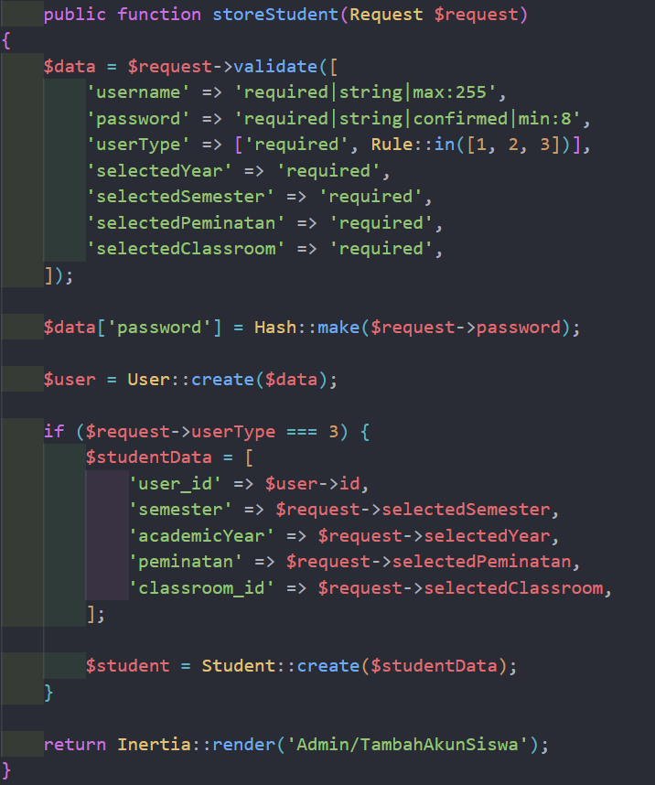

Figure 5.5: Add Student Account Function for Users

* + 1. **Display User Based on Roles Function (Admin)**

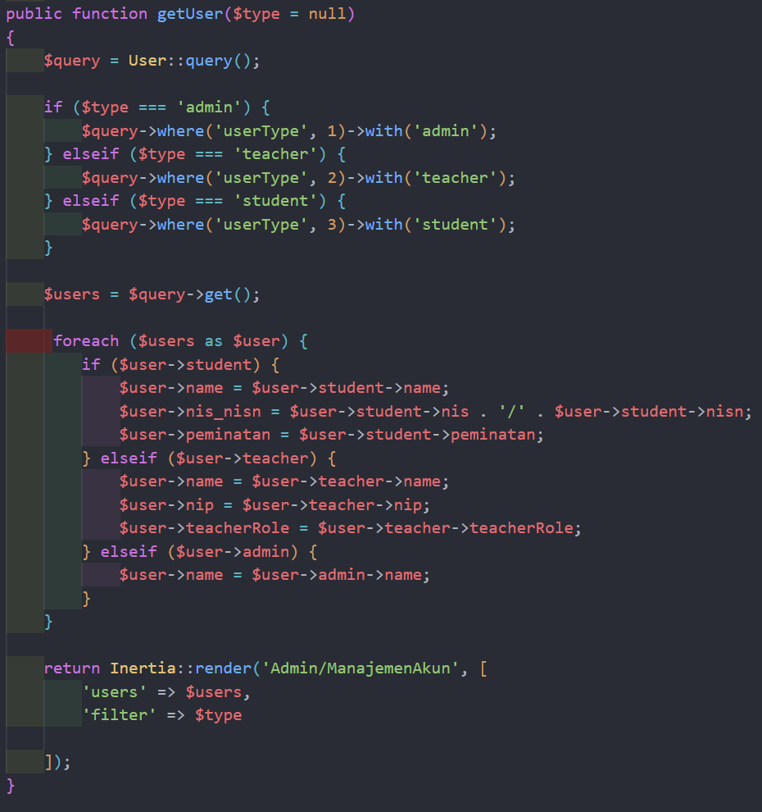

Figure 5.6: Display User Function for Admin

* + 1. **Teacher List Function (Student)**

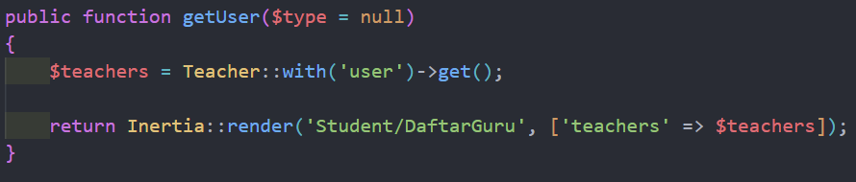

Figure 5.7: Teacher List Function for Student

* + 1. **Update Profile Function (Student)**

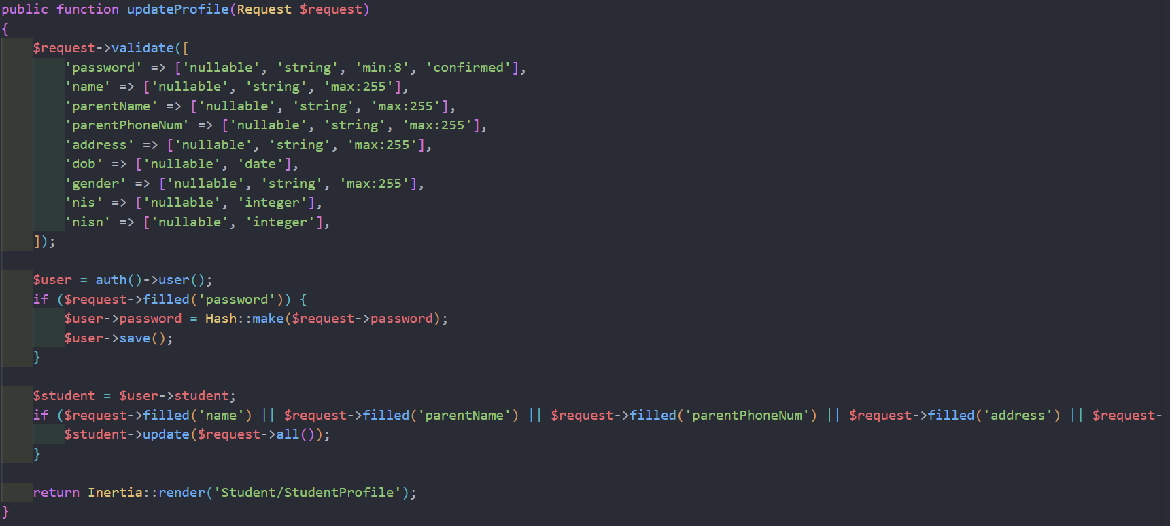

Figure 5.8: Update Profile Function for Student

* + 1. **View Profile (Student)**

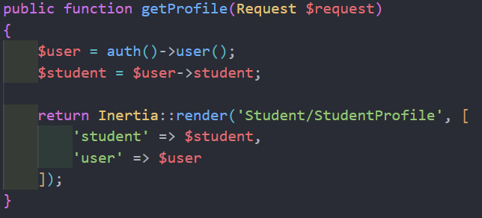

Figure 5.9: View Profile Function for Student

* + 1. **View Tuition Record (Student)**

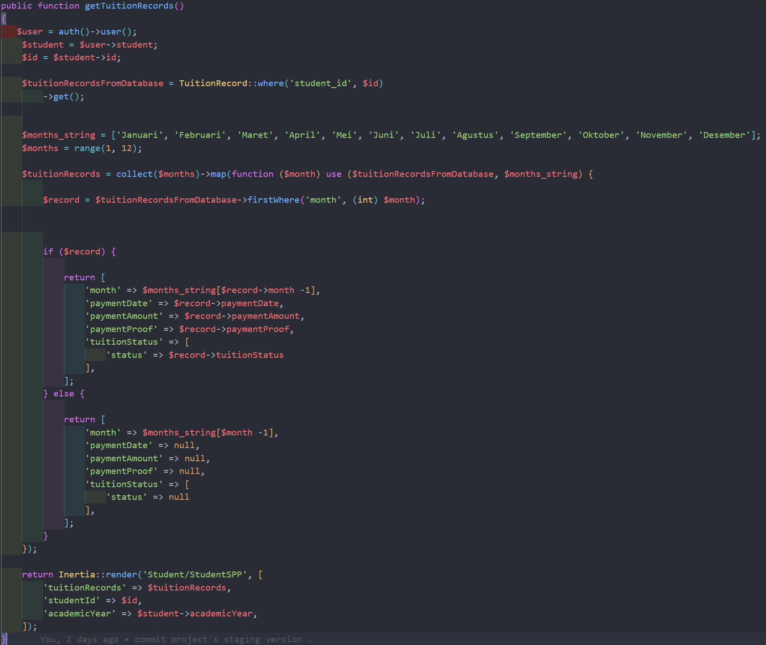

Figure 5.10: View Tuition Function for Student

* + 1. **Save Tuition Record (Student)**

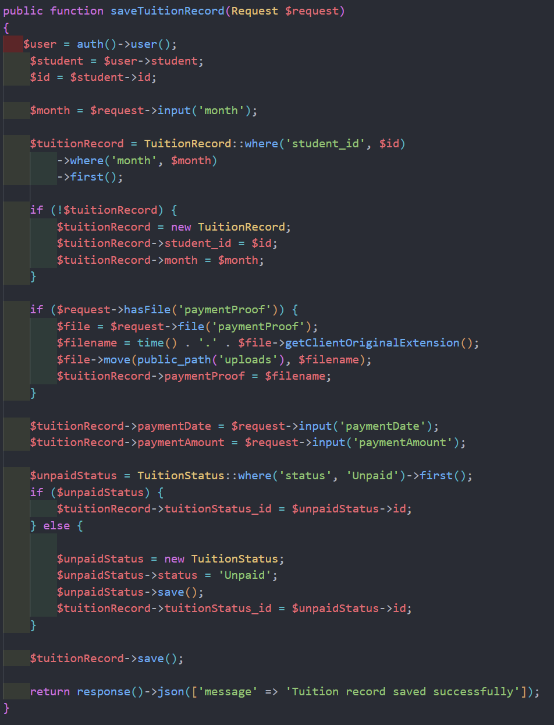

Figure 5.11: Save Tuition Function for Student

* + 1. **View Academic Report (Student)**

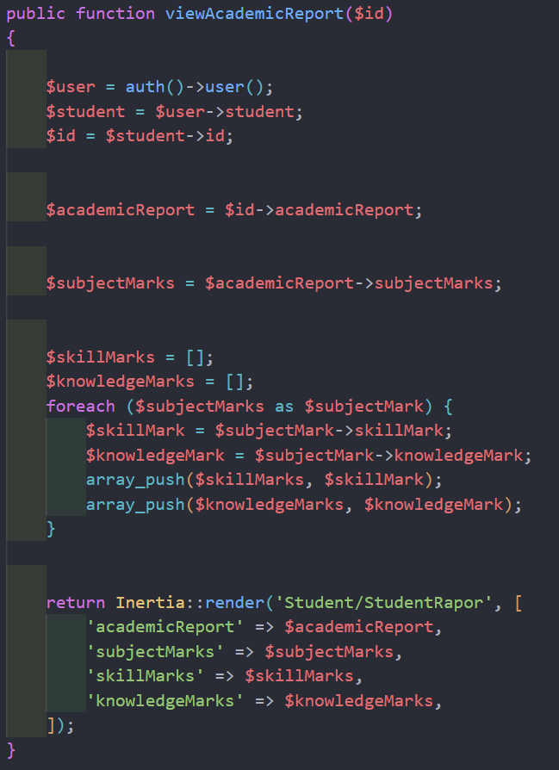

Figure 5.7: View Academic Report Function for Student

* + 1. **View Student (Teacher)**

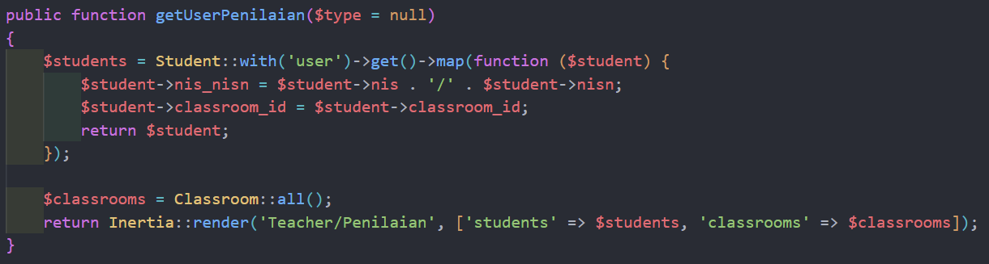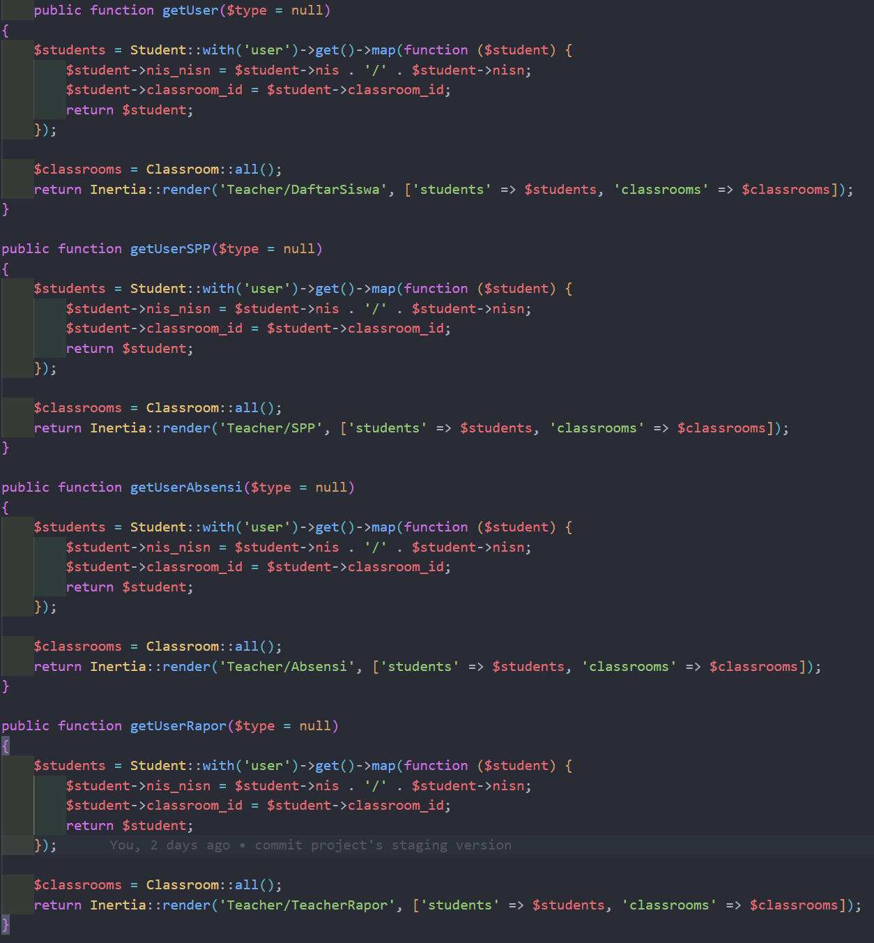

Figure 5.13: View Student Function for Teacher in various pages

* + 1. **View Input Mark (Teacher)**

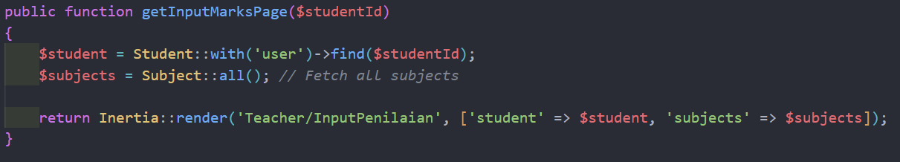

Figure 5.14: View Input Mark Function for Teacher

* + 1. **View Tuition Record (Teacher)**

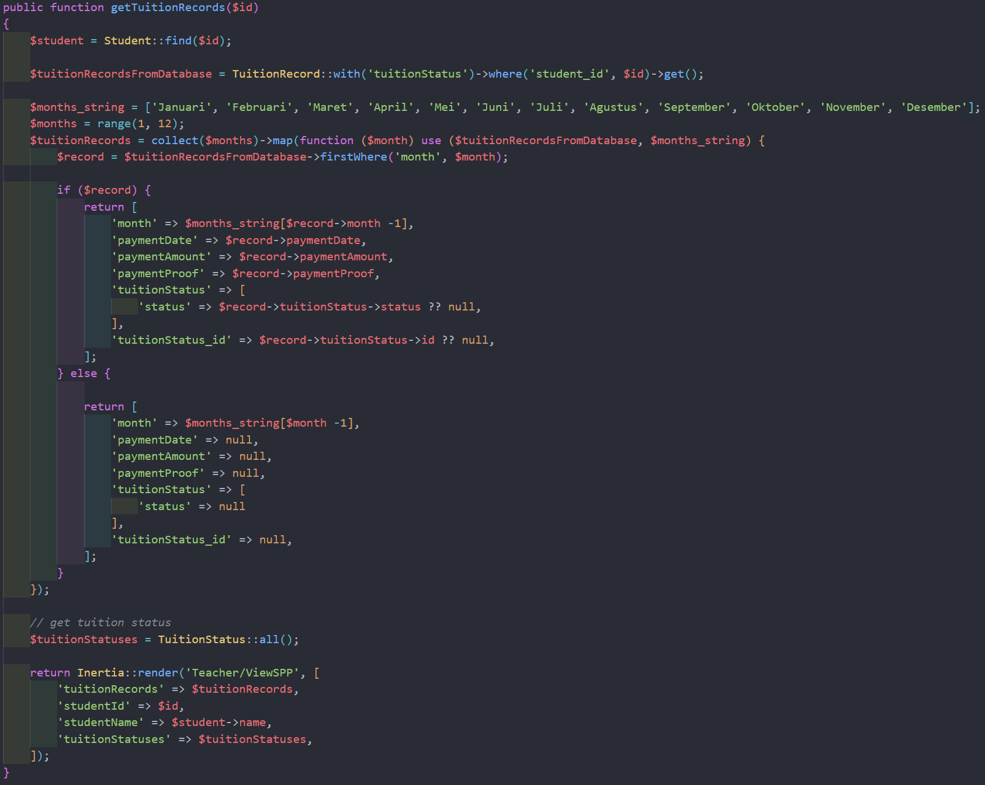

Figure 5.15: View Tuition Record Function for Teacher

* + 1. **Update Tuition Status (Teacher)**

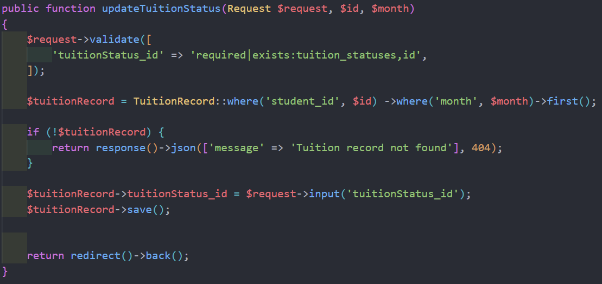

Figure 5.16: View Tuition Status Function for Teacher

* + 1. **View Profile Page (Teacher)**

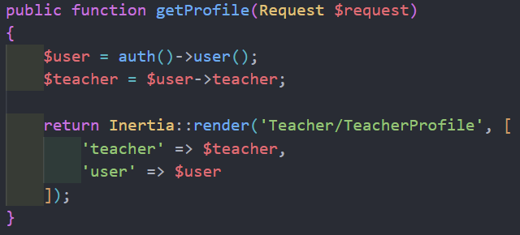

Figure 5.17: View Profile Function for Teacher

* + 1. **View Edit Profile Page (Teacher)**

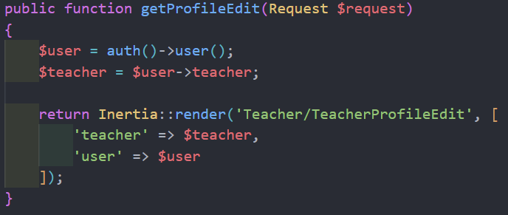

Figure 5.18: View Edit Profile Function for Teacher

* + 1. **Update Profile (Teacher)**

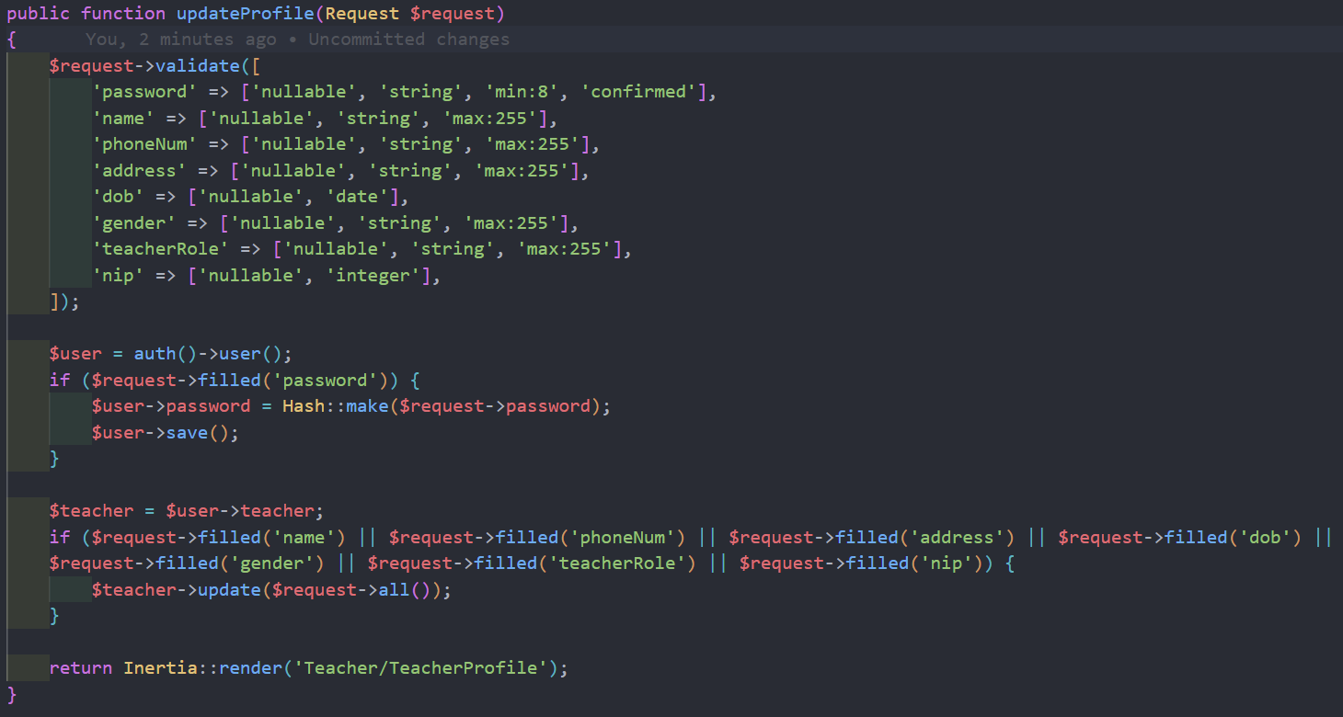

Figure 5.19: Update Profile Function for Teacher

* + 1. **Save Mark (Teacher)**

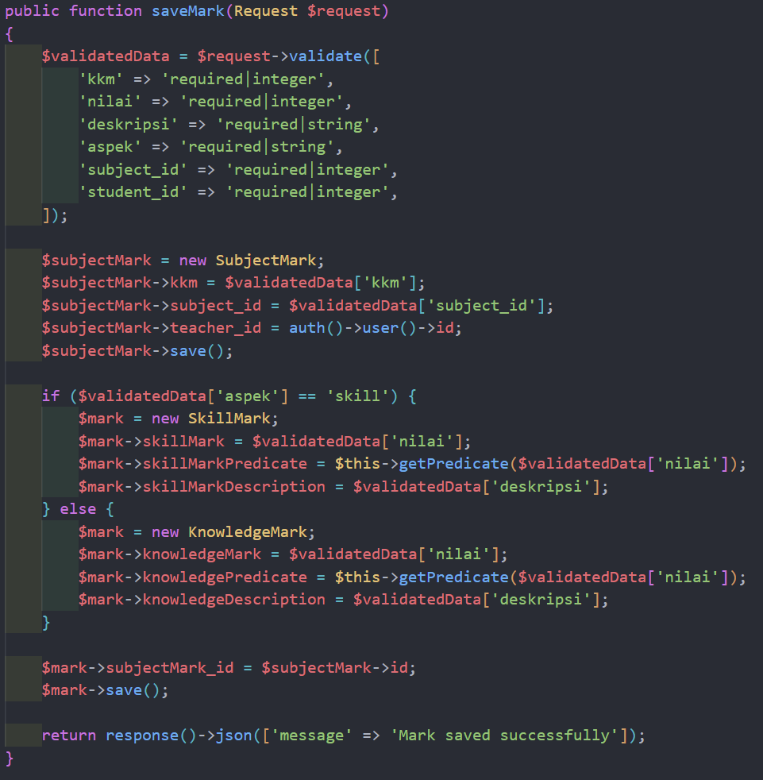

Figure 5.20: Save Mark Function for Teacher

* + 1. **View Timetable (Teacher)**

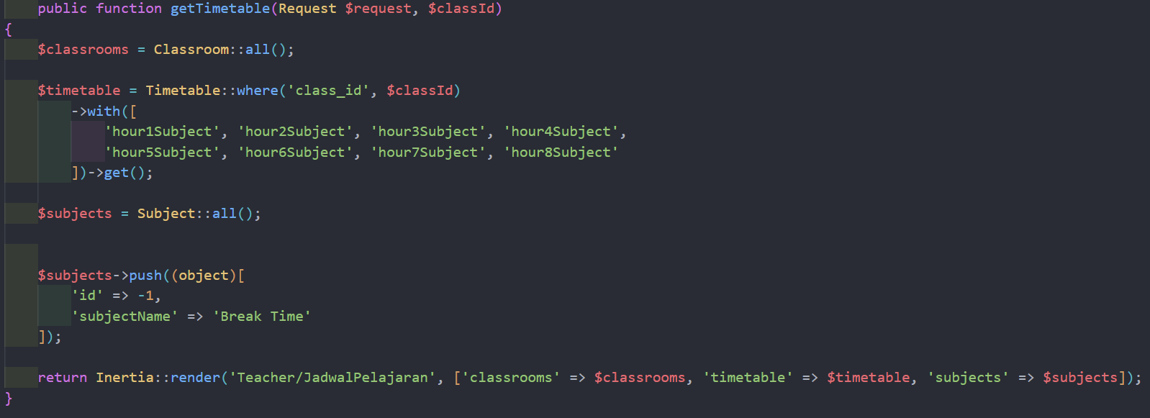

Figure 5.21: View Timetable Function for Teacher

* + 1. **View Timetable (Student)**

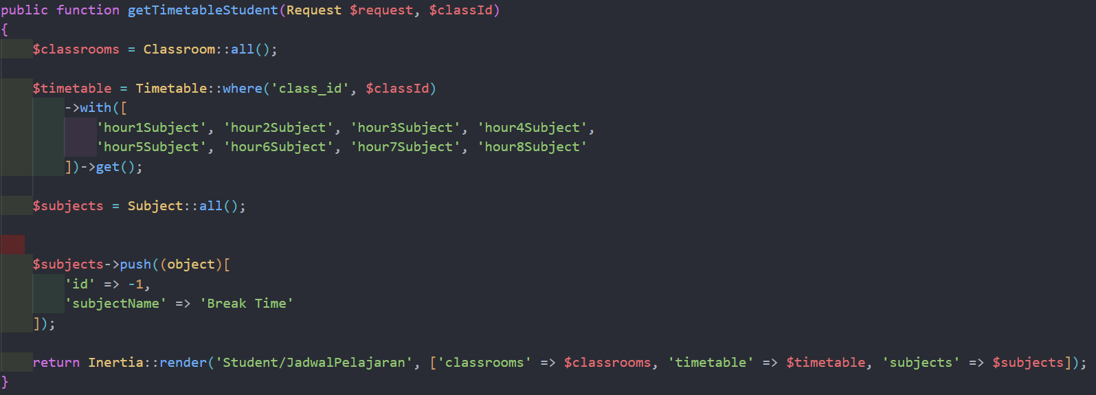

Figure 5.22: View Timetable Function for Student

* + 1. **Search Function (General)**

The search function is implemented in the front end. Below is one of the example of the implementation.

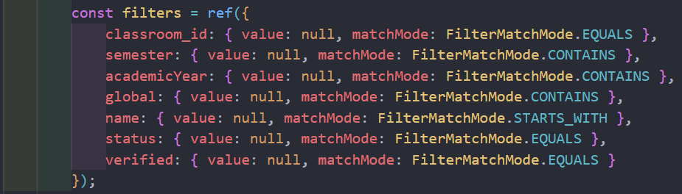

Figure 5.23: Search Function in General

* 1. **Interfaces of System Main Functions**

Below are some of the main functions interfaces of the system.

* + 1. **Login Page**

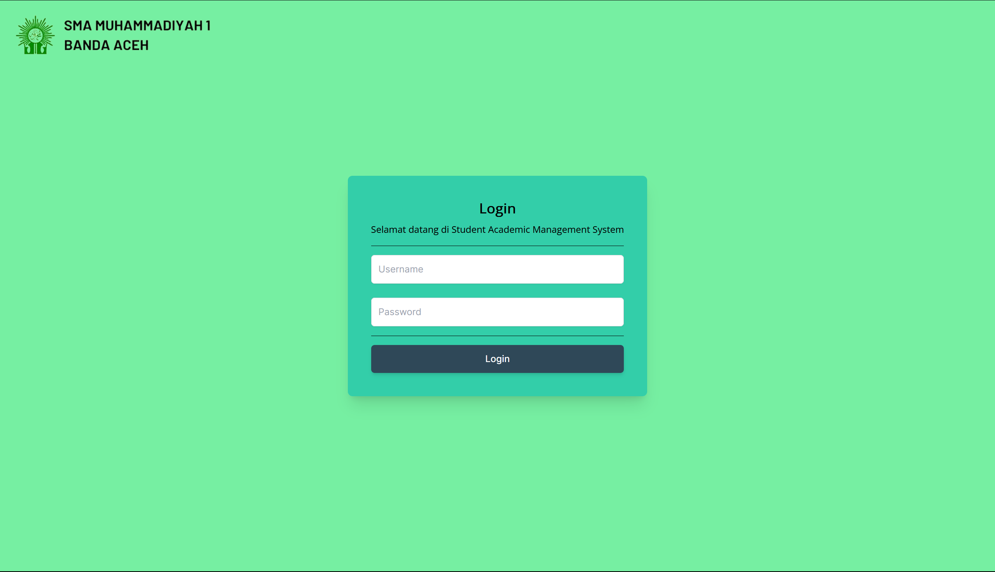

Figure 5.24: Login Page for All Users

* + 1. **Admin Dashboard Page**

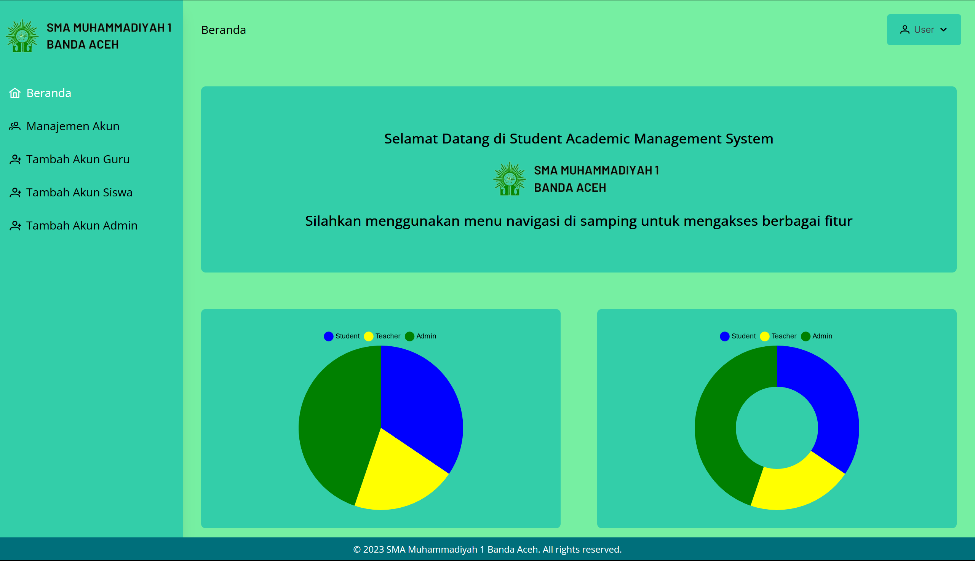

Figure 5.25: Dashboard Page for Admin

* + 1. **Account Management Page**

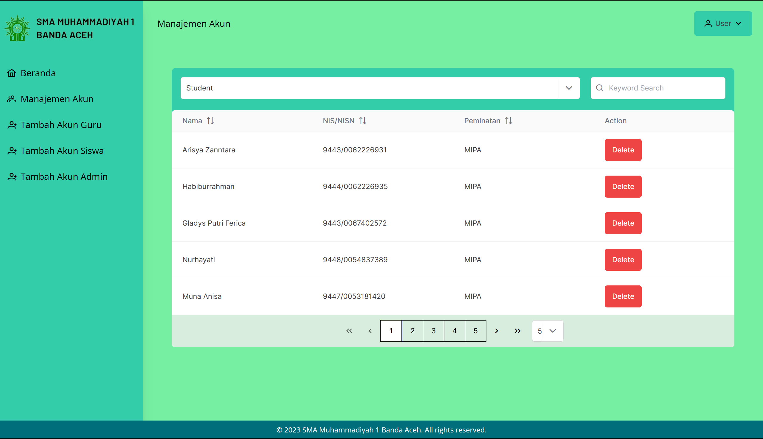

Figure 5.26: Account Management Page for Admin

* + 1. **Add Teacher Account Page**

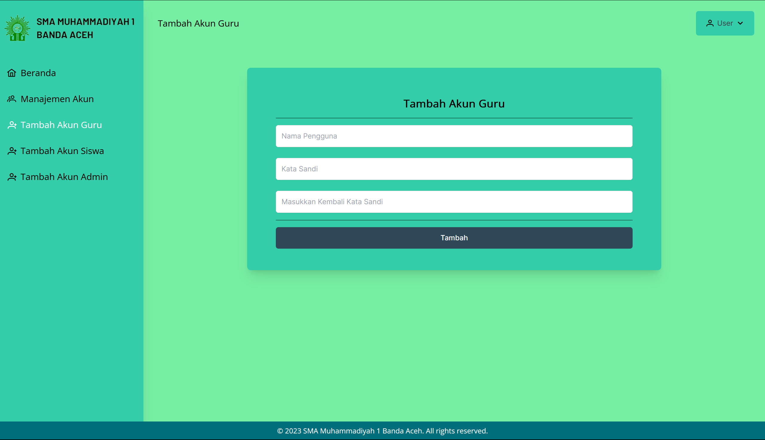

Figure 5.27: Add Teacher Page for Admin

* + 1. **Add Student Account Page**

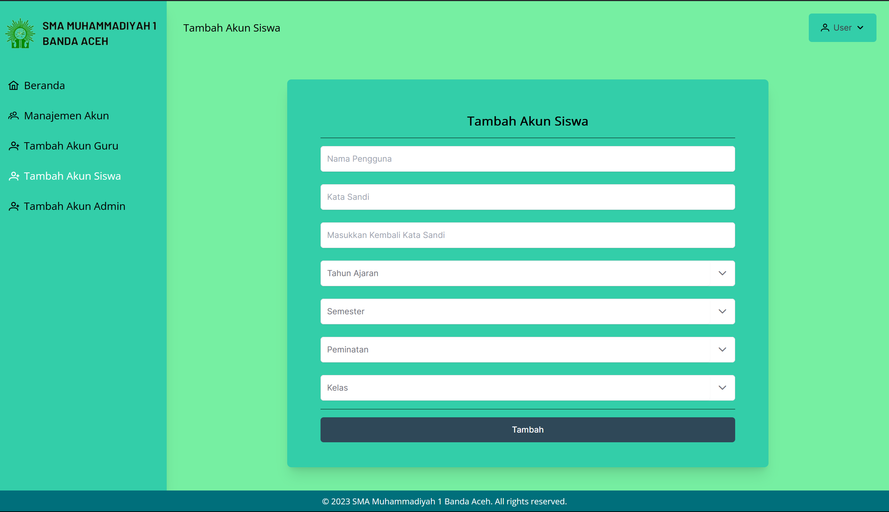

Figure 5.28: Add Student Page for Admin

* + 1. **Add Admin Account Page**

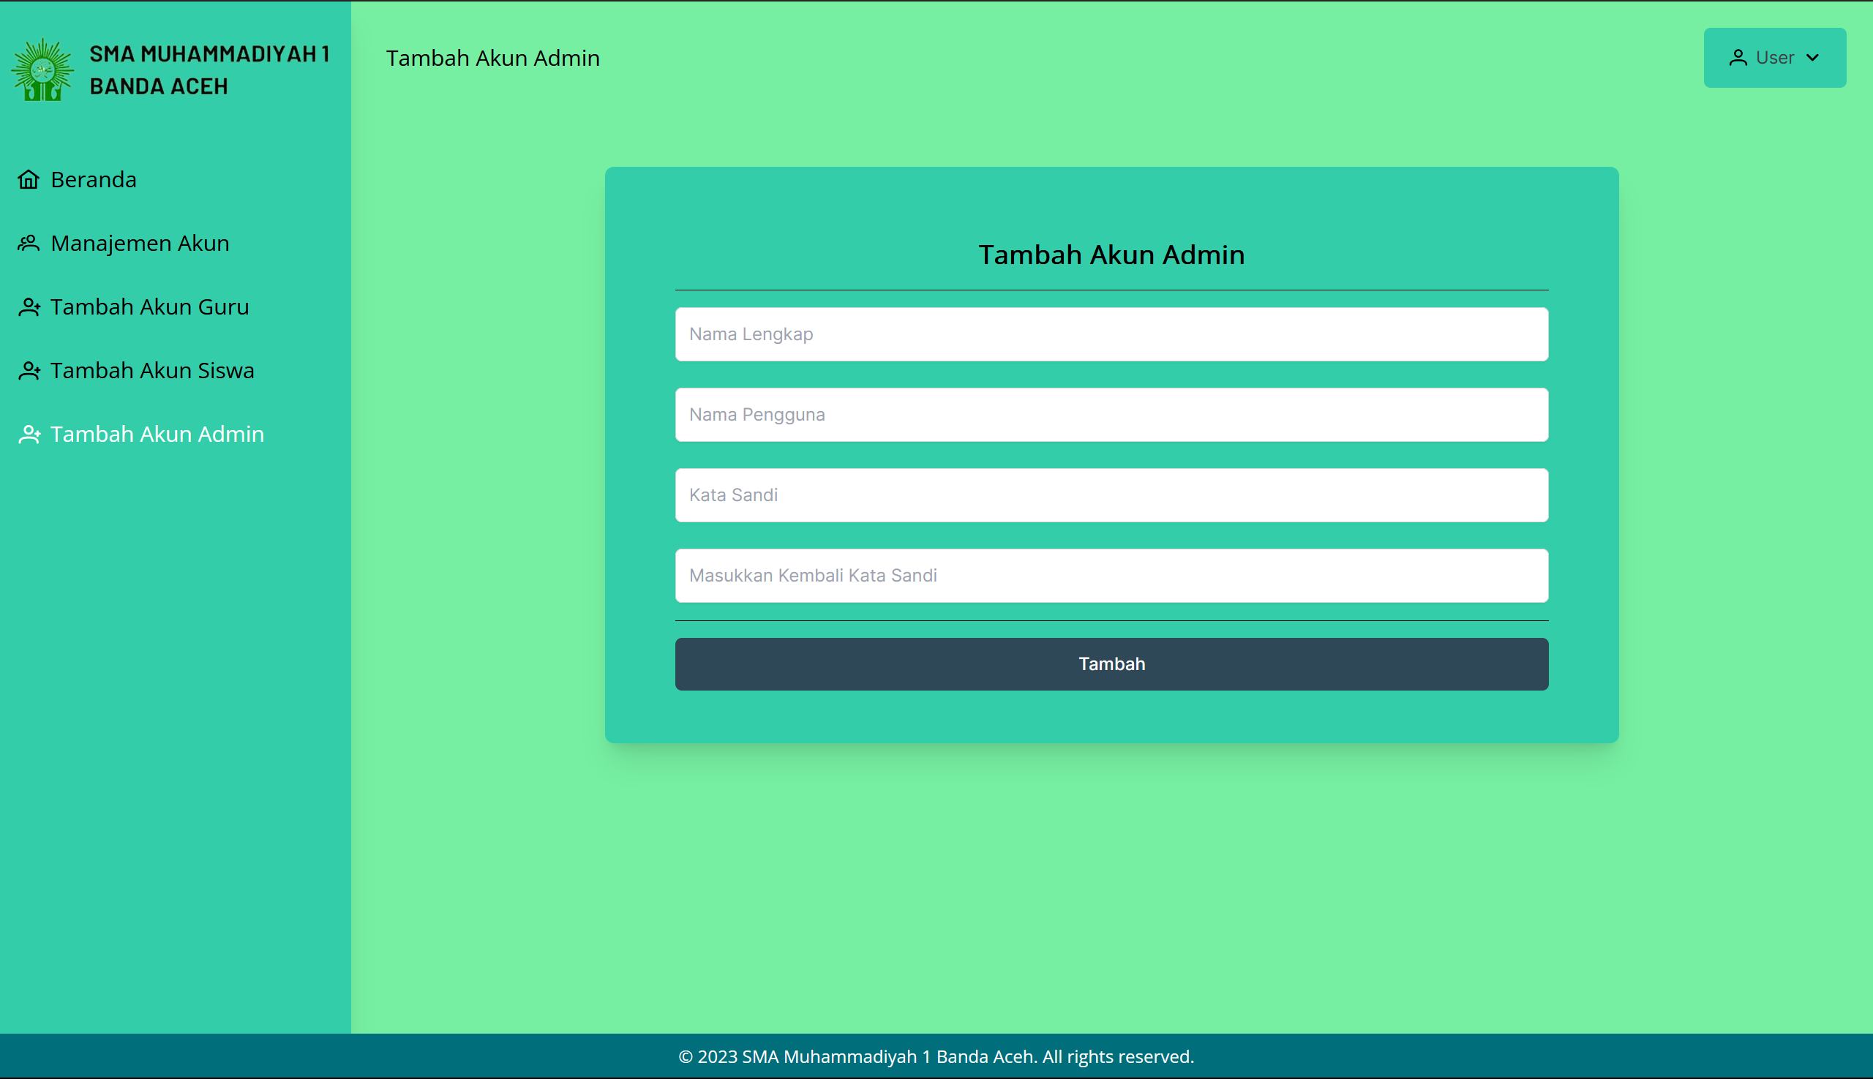

Figure 5.29: Add Admin Page for Admin

* + 1. **Student Dashboard Page**

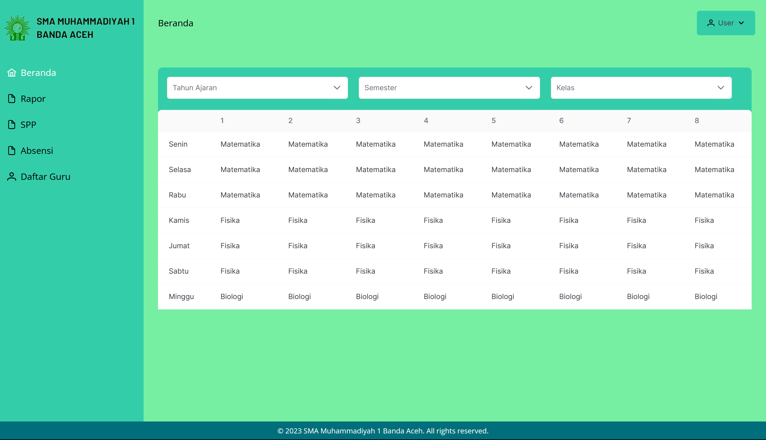

Figure 5.30: Dashboard Page for Student

* + 1. **Student Academic Report Page**

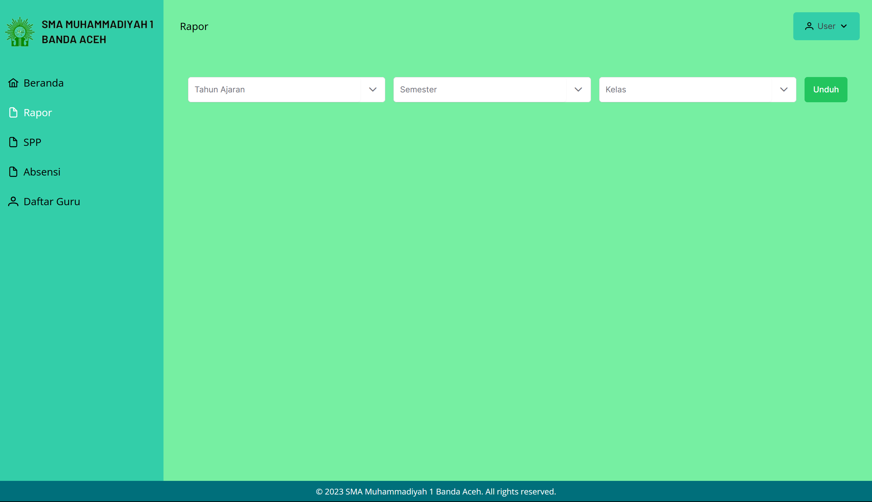

Figure 5.31: Academic Report Page for Student

* + 1. **Student Tuition Page**

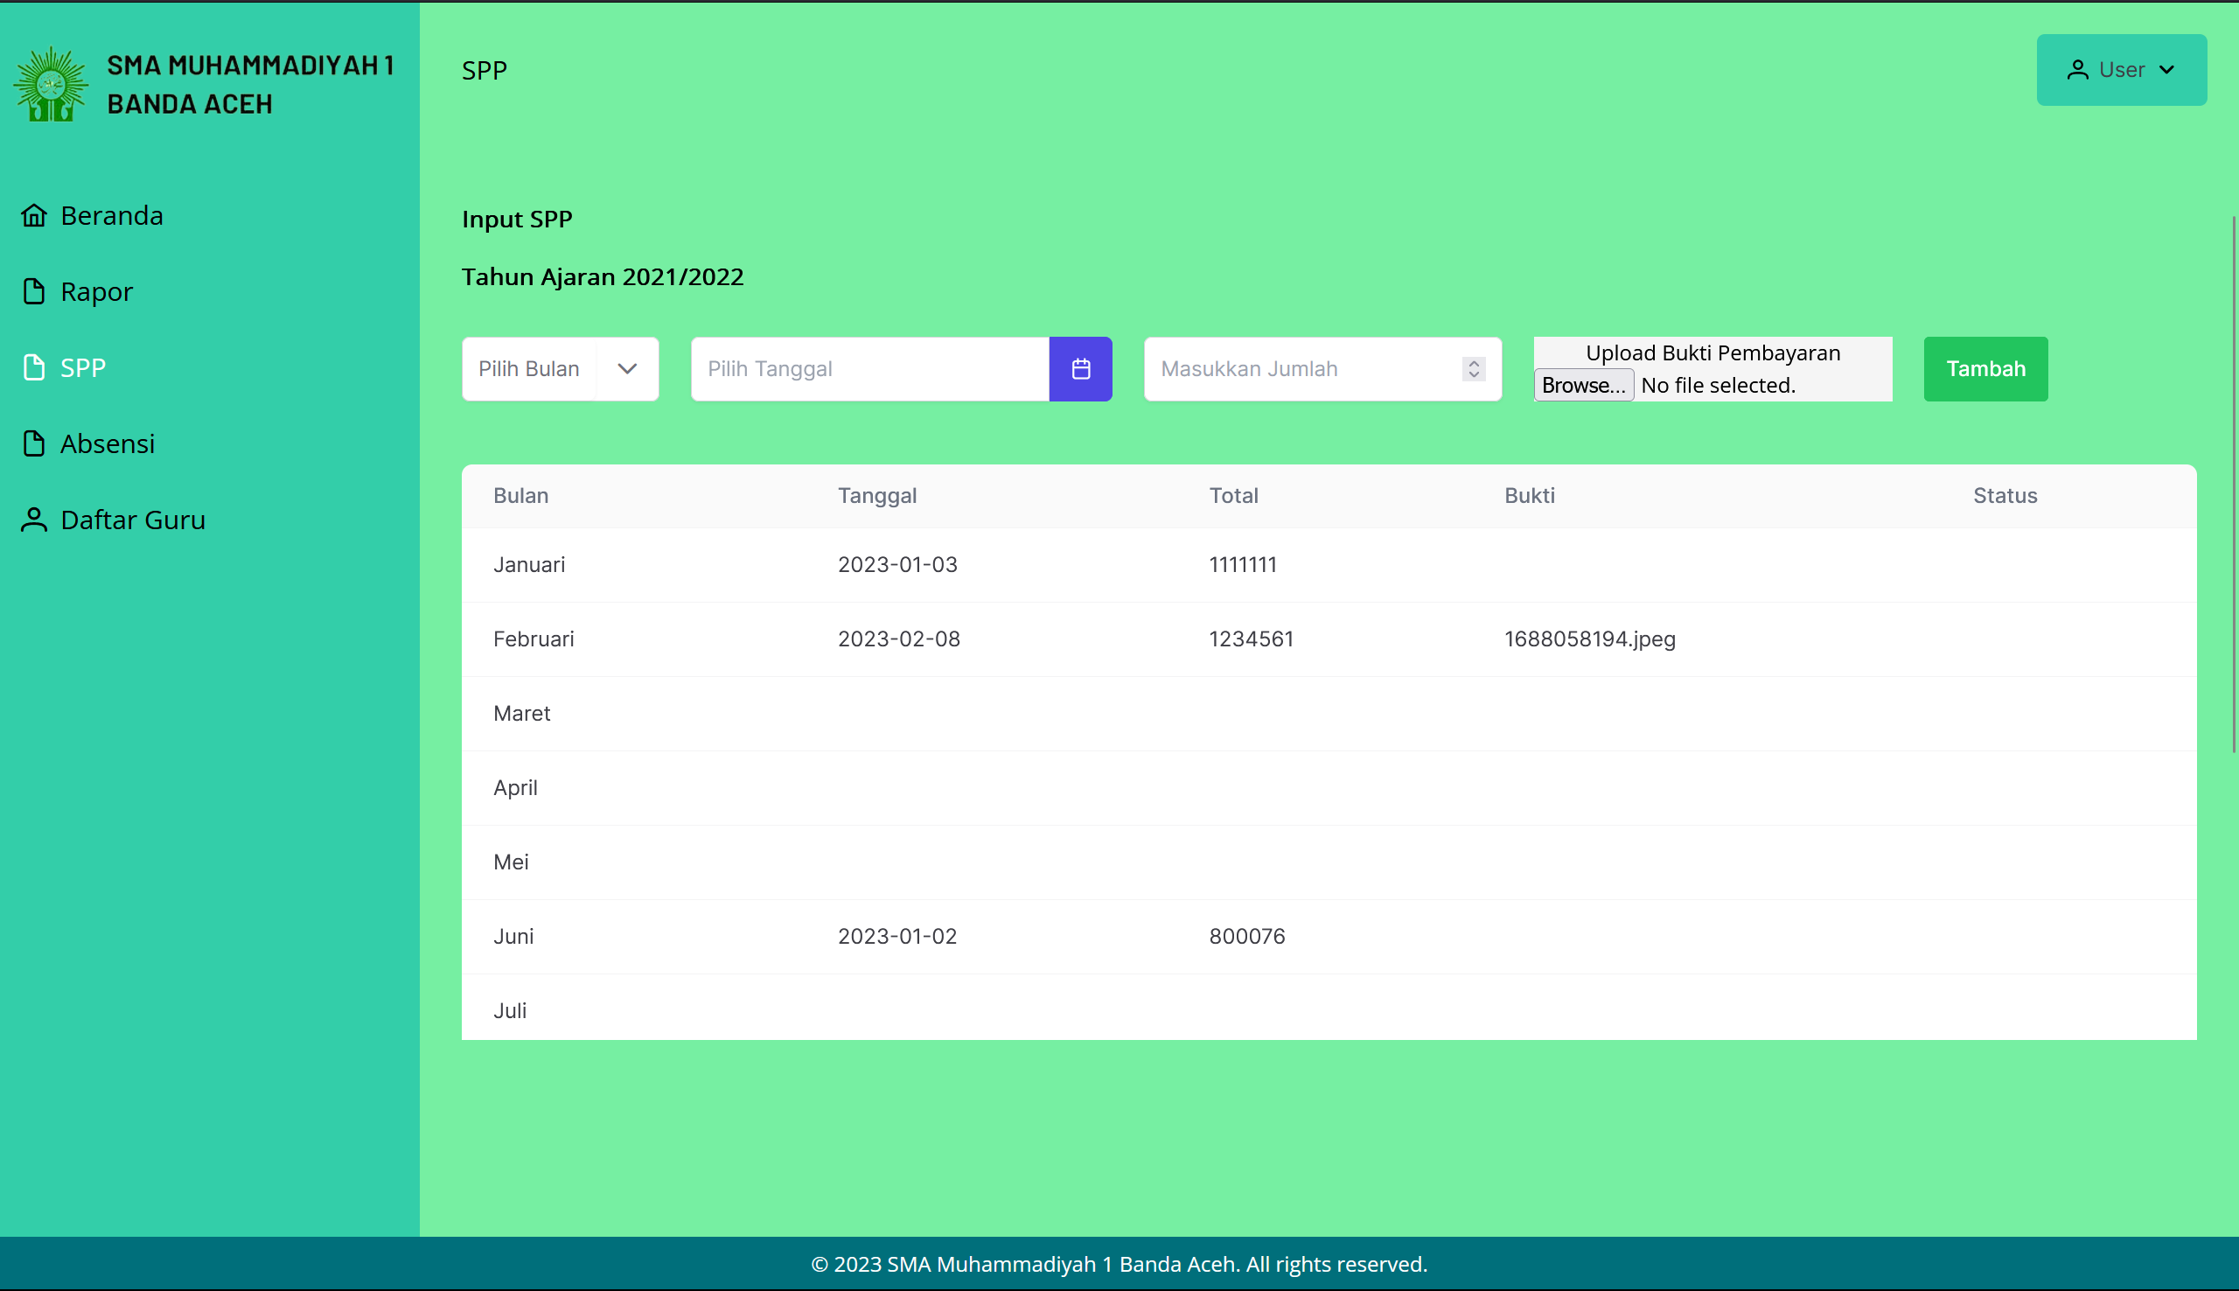

Figure 5.32: Tuition Page for Student

* + 1. **Student Attendance Page**

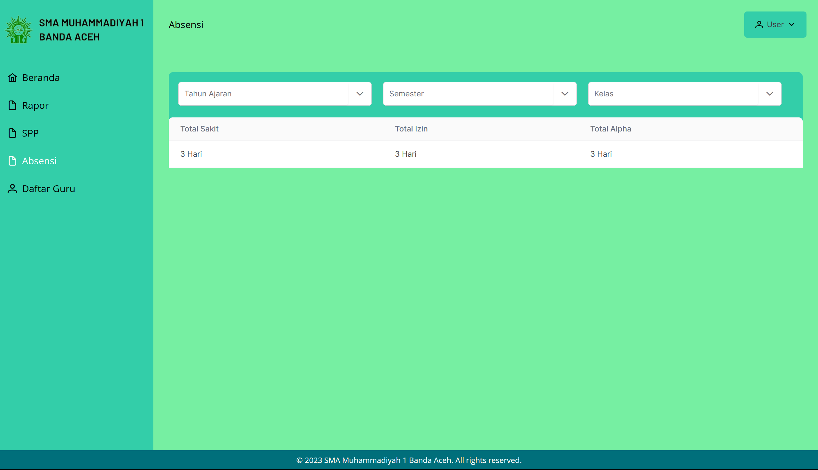

Figure 5.33: Attendance Page for Student

* + 1. **Teacher List Page**

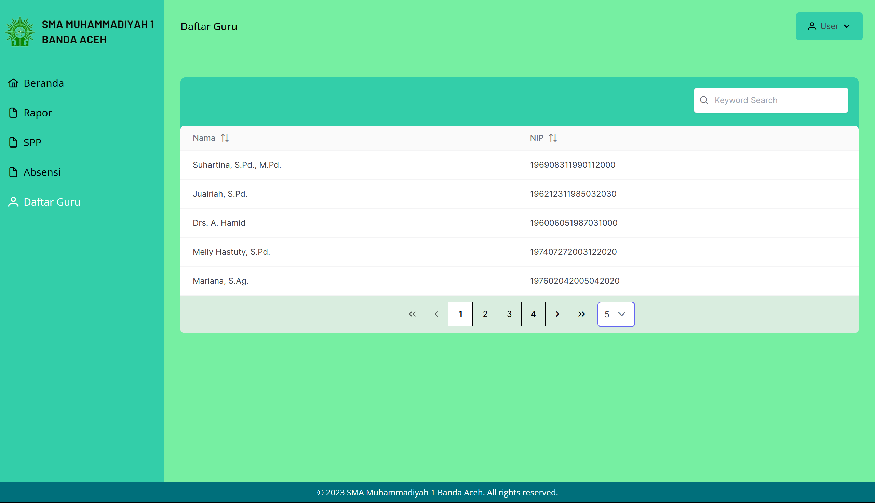

Figure 5.34: Teacher List Page for Student

* + 1. **Teacher Manage Academic Report Page**

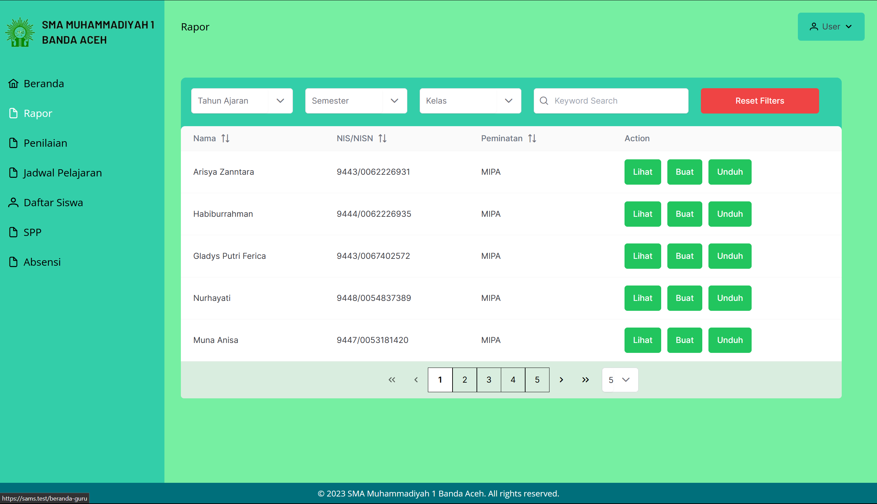

Figure 5.35: Manage Academic Record Page for Teacher

* + 1. **Teacher Manage Marks Page**

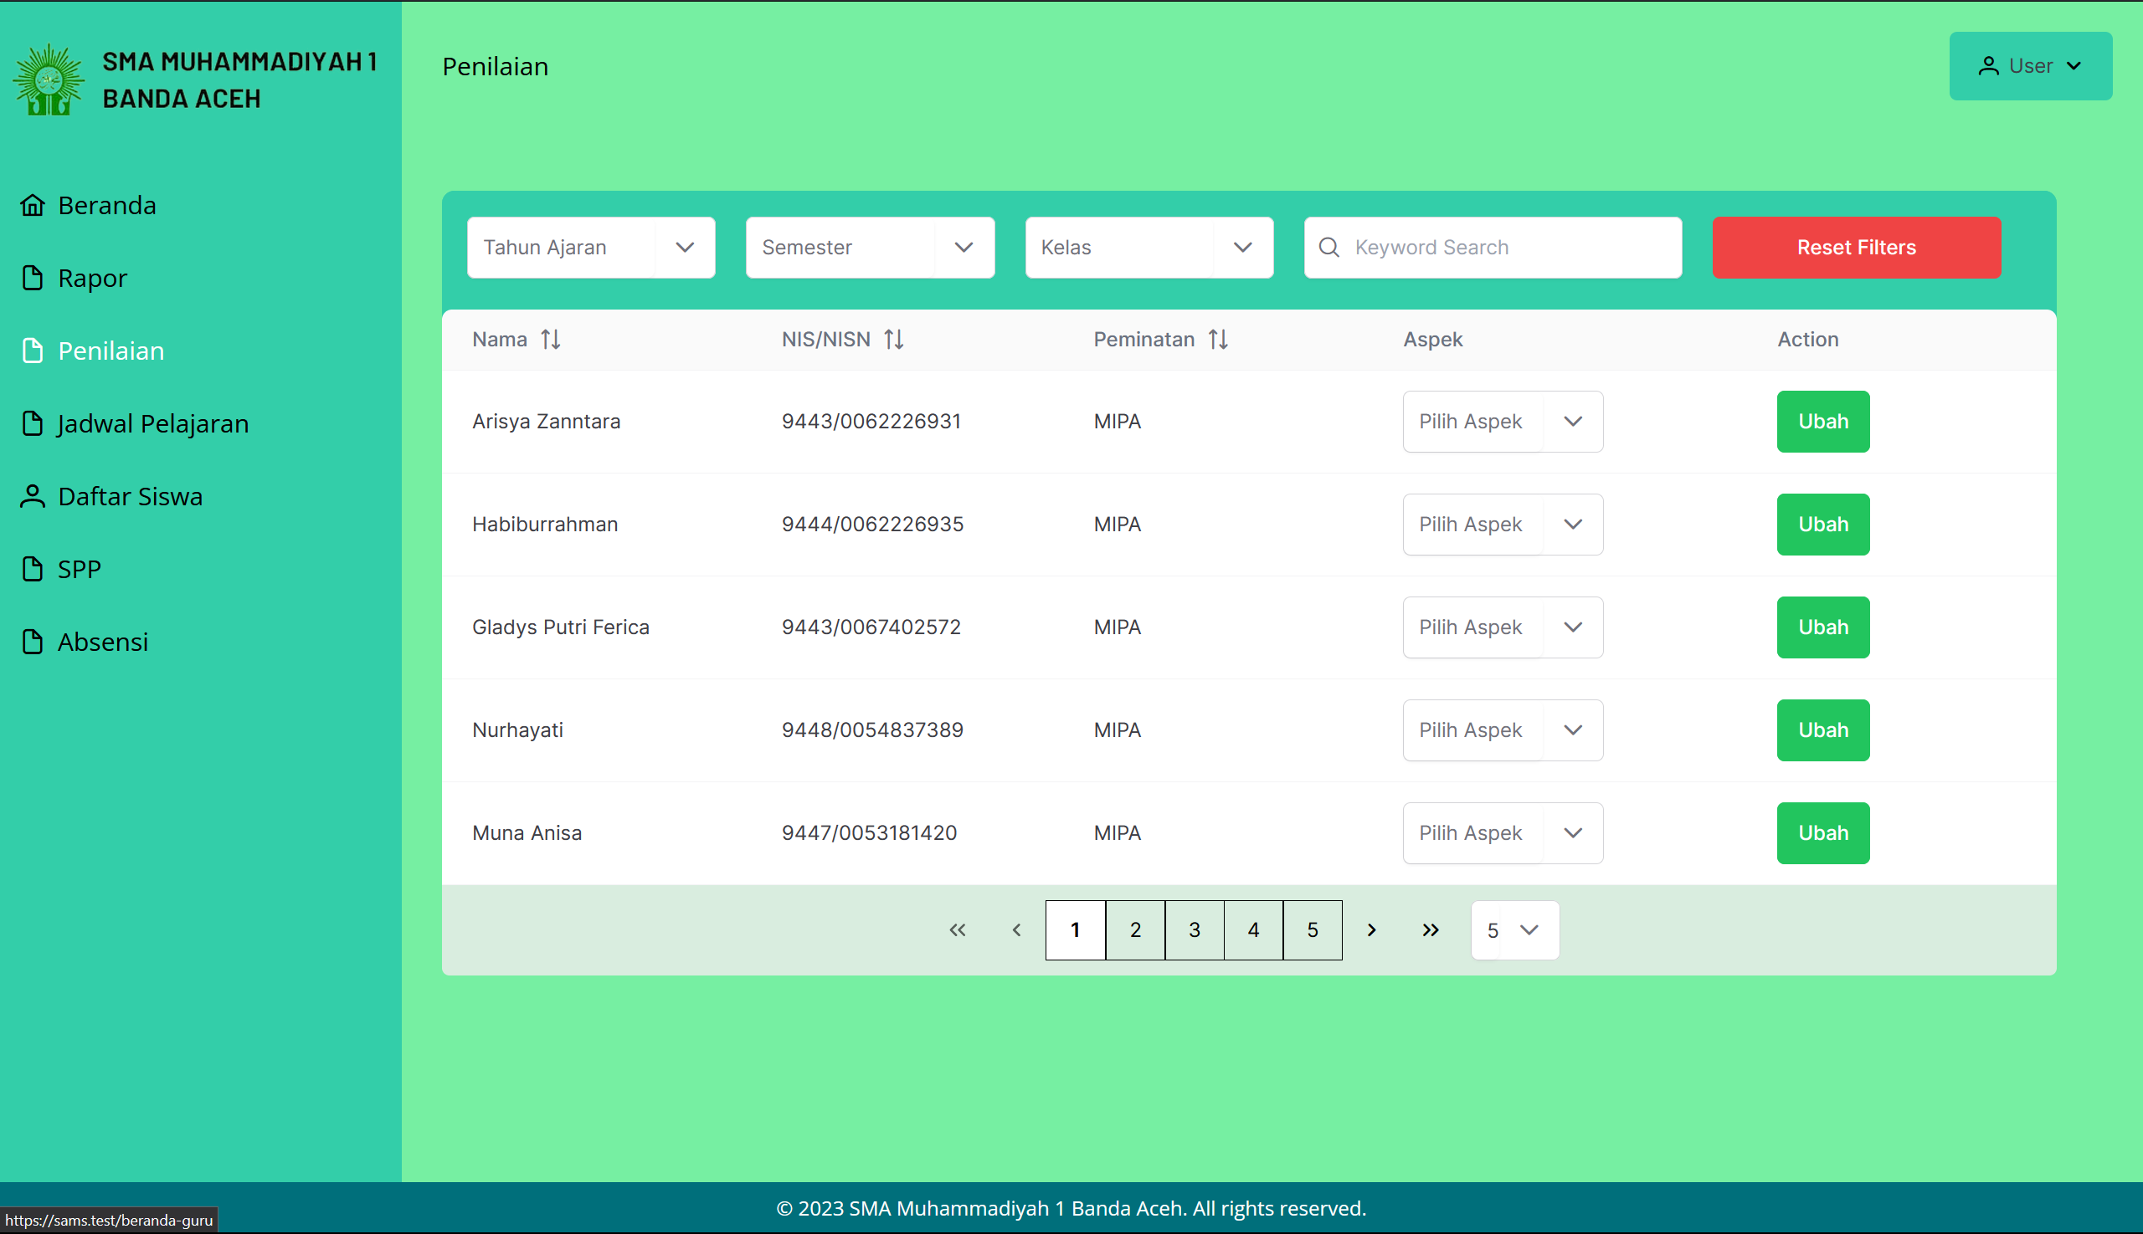

Figure 5.36: Manage Marks Page for Teacher

* + 1. **Teacher Manage Timetable Page**

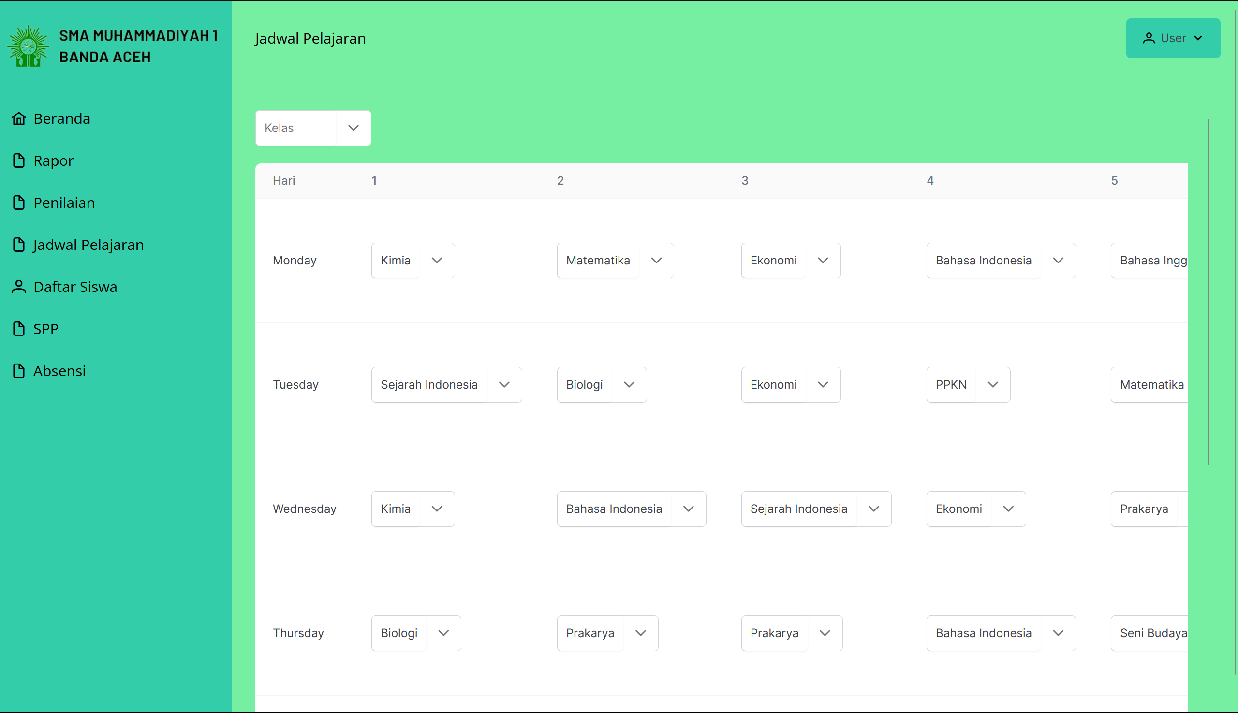

Figure 5.37: Manage Timetable Page for Teacher

* + 1. **Teacher Student List Page**

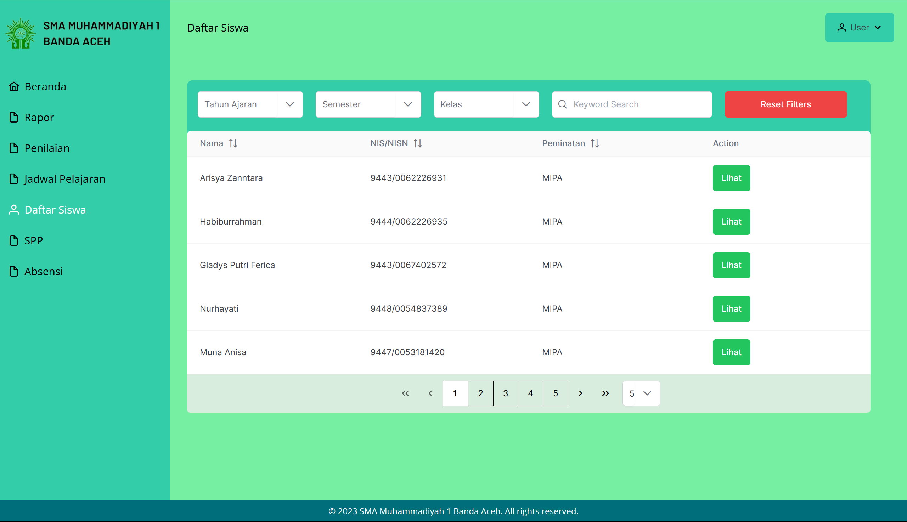

Figure 5.38: Student List Page for Teacher

* + 1. **Teacher Manage Tuition Page**

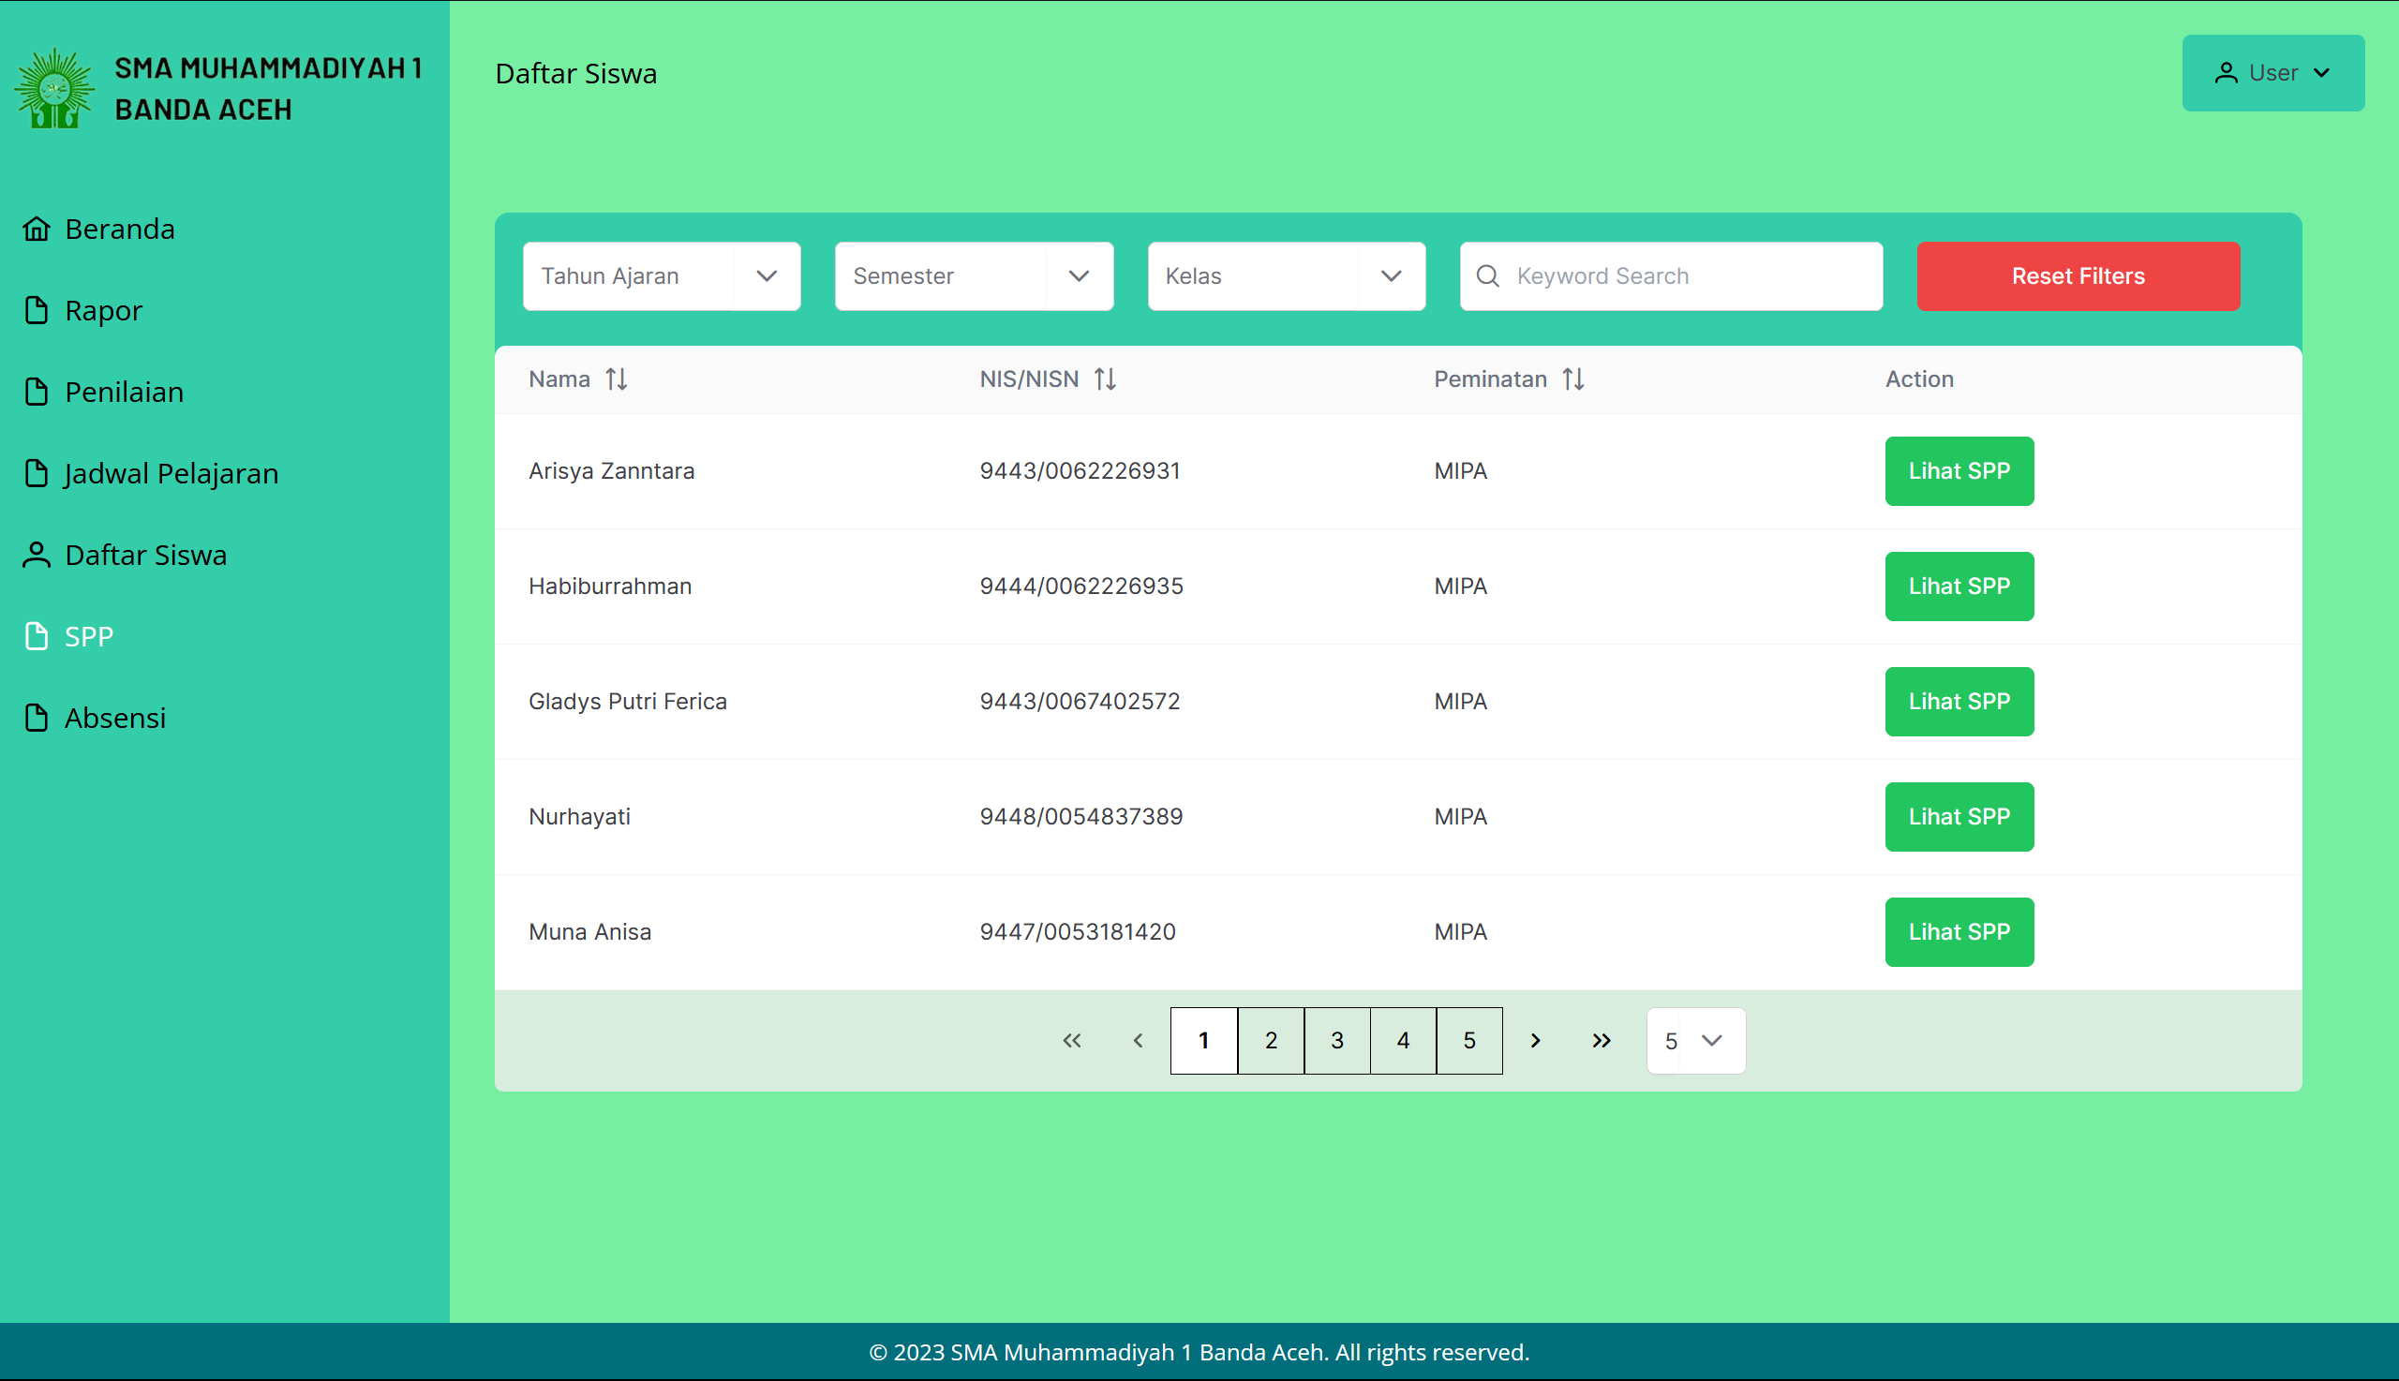

Figure 5.39: Manage Tuition Page for Teacher

* + 1. **Teacher Manage Attendance Page**

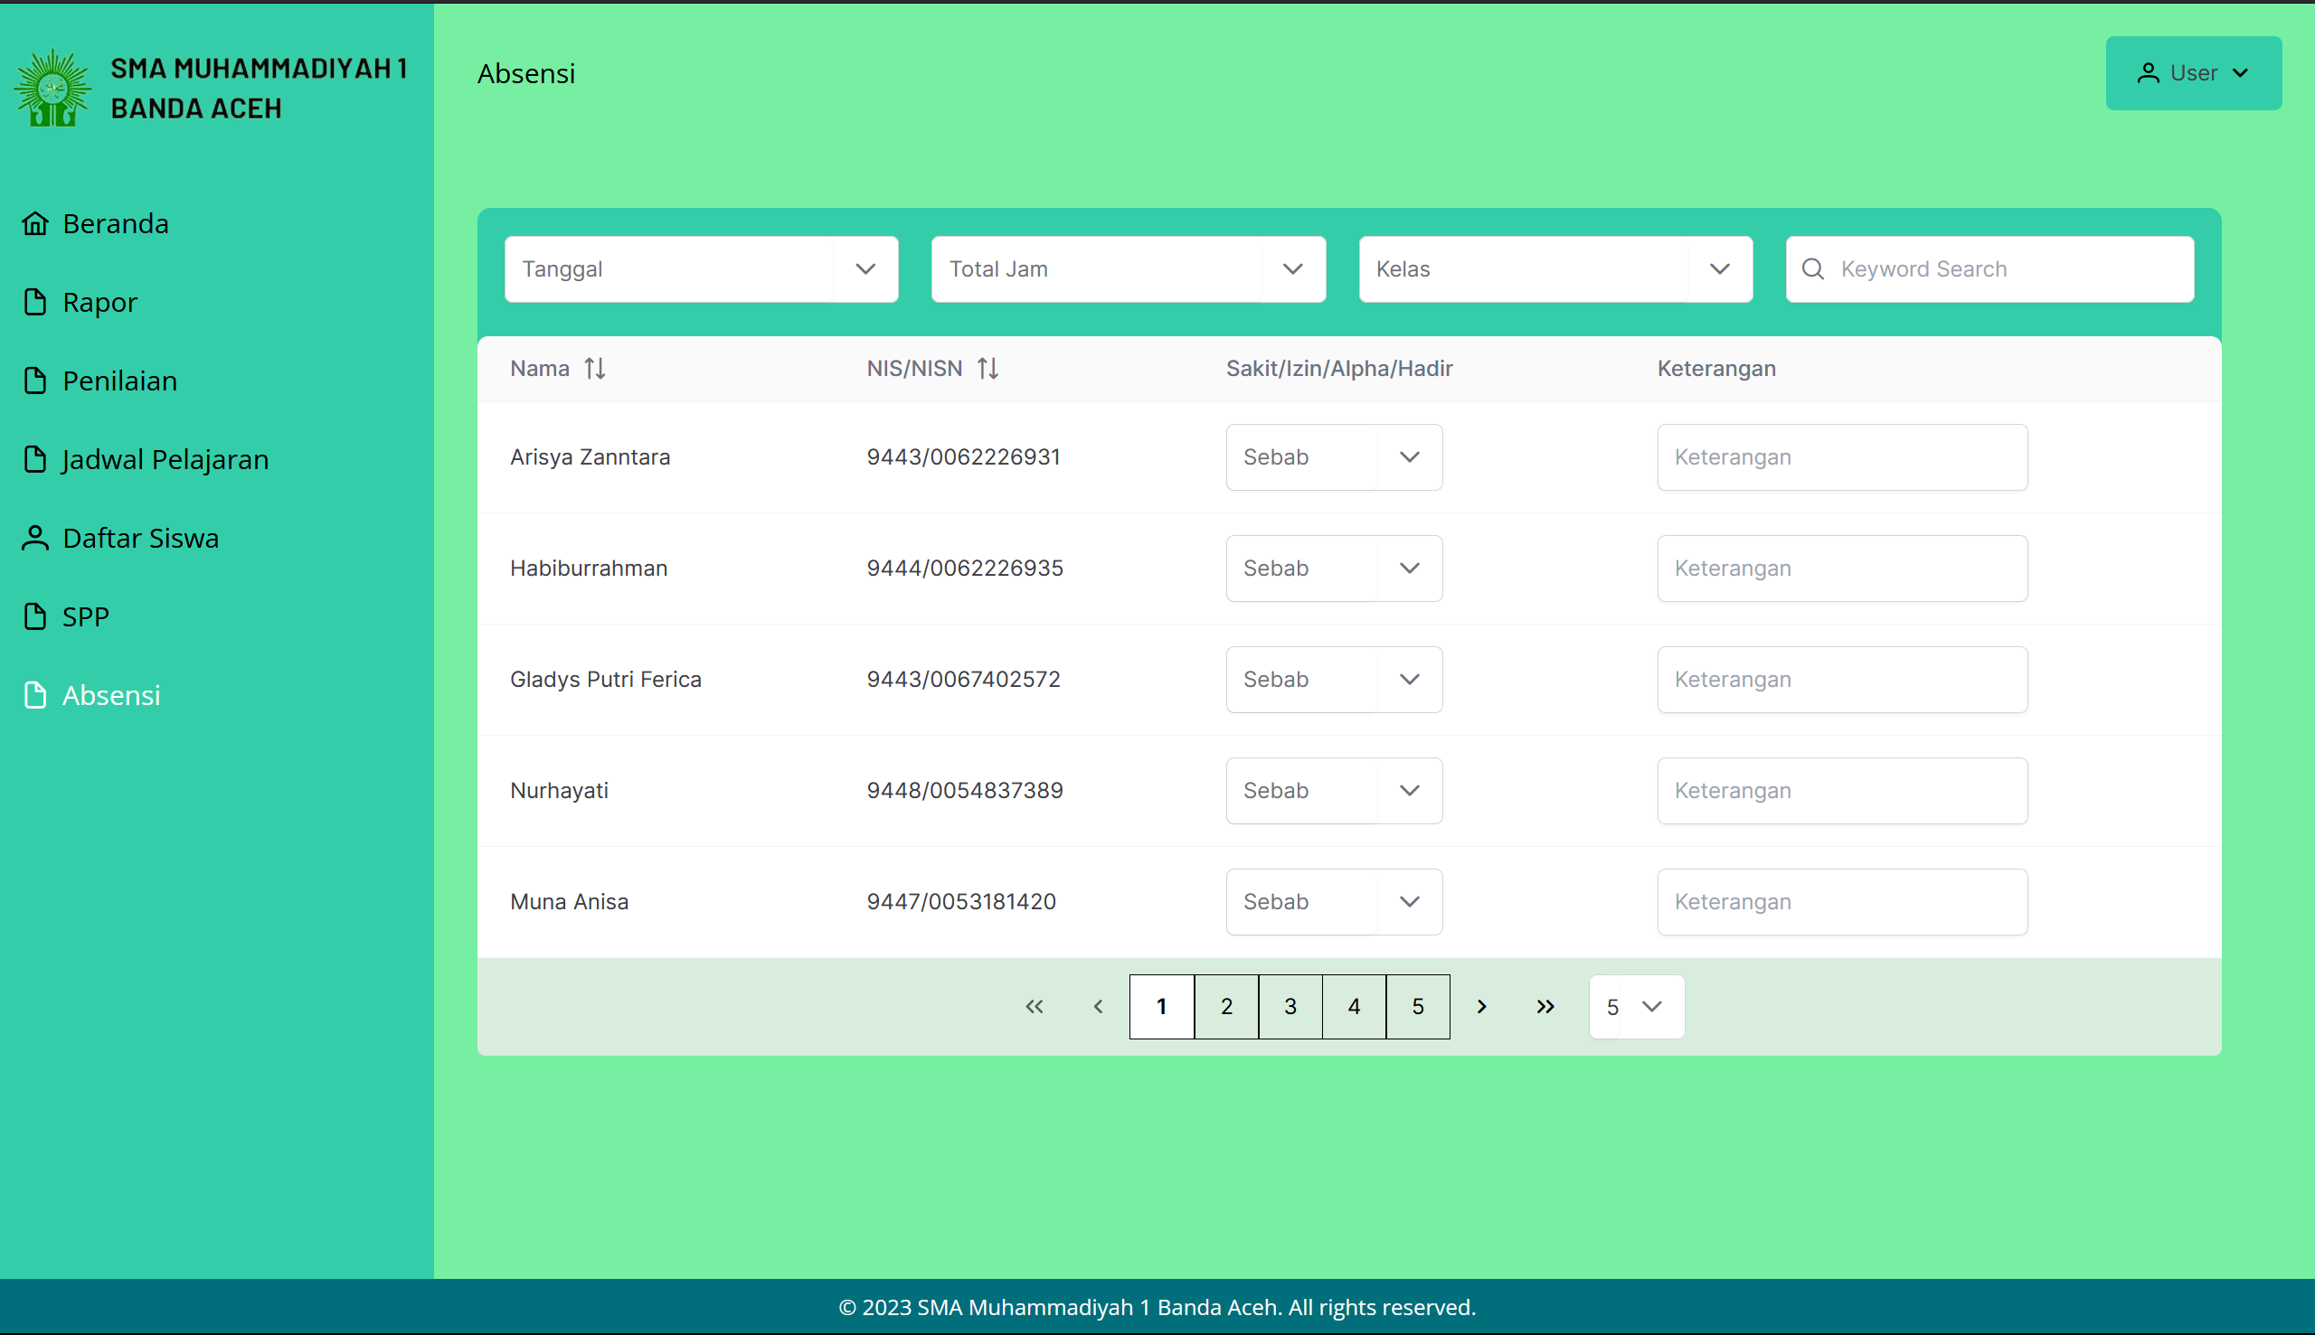

Figure 5.40: Manage Attendance Page for Teacher

* 1. **Testing**

There is a couple testing method that will be done to the system. They are black box testing, white box testing and user testing. Testing is an important process of the system development since it can identify errors and bugs. This establish the system to be as close as possible to the requirement.

* + 1. **Black box Testing**

Black box testing is a method of software testing that examines the functionality of an application without peering into its internal structures or workings. In black box testing, the test done is more focused towards the input and output of the system without knowing how the application receive the input and produce the output. Black box testing also done from the perspective of the user to ensure that the functions works and follow the stated requirements

* + - 1. **System Flow**

The system flow of an application refers to the sequence of events or operations that a system undergoes when performing specific tasks. In black box testing, testers observe and evaluate whether the system behaves as expected when performing a particular sequence of actions.

* + - 1. **Input Output Verification**

Input Output Verification in black box testing focuses on testing the system's response to given inputs and whether the output is as expected. Testers provide various types of valid and invalid inputs and verify if the system produces the correct and expected output. This process helps in identifying any discrepancies in the system's functionality.

* + - 1. **Error Message**

Error message testing in black box testing focuses on the system's response to erroneous conditions or inputs. This involves deliberately inputting incorrect or invalid data and verifying the system's error messages. The objective is to ensure that the system correctly detects errors and handles them

* + 1. **White box Testing**

In white box testing, the tester that conducts the testing has information on the system's internal structure, design, and implementation. The goal of white box testing is to verify a system's internal operations, focusing on internal testing of code structures, code flows, and internal system logic. Some of example of this type of testing are provided below in the User Testing subchapter.

* + 1. **User Testing**

User Testing will be performed by real users to evaluate the system. User Testing provides direct input on how real users use a system, thereby helping to understand where the system stands from the user's perspective. The user testing results show average user satisfaction with the system. The user testing has been done to the system, and the result of the test can be seen in the table 5.1.

Table 5.1 User Testing Result

|  |  |
| --- | --- |
| **User Acceptance Testing Result** | |
| **Questions** | Average Satisfaction |
| 1. Does the system effectively perform all the functions requirements? | 8.5/10 |
| 2. Is the user interface of the system intuitive and easy to navigate? | 9/10 |
| 3. Does the system handle errors effectively and provide meaningful error messages? | 7.5/10 |
| 4. Is the system's performance satisfactory under various loads? | 8/10 |
| 5. Are the system's security measures effective and reliable? | 8/10 |

Table 5.2 Admin Add Student Account

|  |  |
| --- | --- |
| **Tester Name** | RAHMAWATI |
| **Date** | 23 June 2023 |
| **Module** | Account Module |
| **Instruction**   * + 1. Login with Admin Account     2. Click “Tambah Akun Siswa”     3. Enter the required input     4. Click “Tambah”     5. Logout by clicking the top right menu and click “Keluar” button | |
| **Expected Result**   1. Should be able to logged in as Admin 2. Should be able to view the “Tambah Akun Siswa” Page 3. Should be able to input all the required fields 4. Should be able to create the student account with the provided input 5. Should be able to logged out from the sytem | |
| **Actual Result**   1. Successfully logged in as Admin 2. Successfully view the “Tambah Akun Siswa” Page 3. Successfully input all the required fields 4. Successfully create the student account with the provided input 5. Successfully logged out from the system | |

Table 5.3 Admin Add Teacher Account

|  |  |
| --- | --- |
| **Tester Name** | RAHMAWATI |
| **Date** | 23 June 2023 |
| **Module** | Account Module |
| **Instruction**   1. Login with Admin Account 2. Click “Tambah Akun Guru” 3. Enter the required input 4. Click “Tambah” 5. Logout by clicking the top right menu and click “Keluar” button | |
| **Expected Result**   1. Should be able to logged in as Admin 2. Should be able to view the “Tambah Akun Guru” Page 3. Should be able to input all the required fields 4. Should be able to create the student account with the provided input 5. Should be able to logged out from the system | |
| **Actual Result**   1. Successfully logged in as Admin 2. Successfully view the “Tambah Akun Guru” Page 3. Successfully input all the required fields 4. Successfully create the student account with the provided input 5. Successfully logged out from the system | |

Table 5.4 Teacher Marking Student

|  |  |
| --- | --- |
| **Tester Name** | YULIANA |
| **Date** | 23 June 2023 |
| **Module** | Report Module |
| **Instruction**   1. Login with Teacher Account 2. Click “Penilaian” 3. Select the filter to view the desired student 4. Click the “Nilai” button 5. Input the required field 6. Click the “Save” button 7. Logout by clicking the top right menu and click “Keluar” button | |
| **Expected Result**   1. Should be able to logged in as Teacher 2. Should be able to view the “Penilaian” Page 3. Should be able to view the desired student 4. Should be able to view the input mark page 5. Should be able to save the mark for the student 6. Should be able to logged out from the system | |
| **Actual Result**   1. Successfully logged in as Teacher 2. Successfully view the “Penilaian” Page 3. Successfully view the desired student 4. Successfully view the input mark page 5. Successfully save the mark for the student 6. Successfully logged out from the system | |

Table 5.5 Student View Academic Report

|  |  |
| --- | --- |
| **Tester Name** | ARISYA ZANNTARA |
| **Date** | 23 June 2023 |
| **Module** | Report Module |
| **Instruction**   1. Login with Student Account 2. Click “Rapor” 3. Select the filter to preview the desired Academic Report 4. Click “Unduh” 5. Logout by clicking the top right menu and click “Keluar” button | |
| **Expected Result**   1. Should be able to logged in as Student 2. Should be able to view the “Rapor” Page 3. Should be able to view the desired Academic Report 4. Should be able to download the Academic Report 5. Should be able to logged out from the system | |
| **Actual Result**   1. Successfully logged in as Student 2. Successfully view the “Rapor” Page 3. Successfully view the desired Academic Report 4. Successfully download the Academic Report 5. Successfully logged out from the system | |

* 1. **Chapter Summary**

This chapter conclude the implementation and testing of the Student Academic Management System. All of the codes and interfaces main function are discussed and showed thoroughly. The testing done which are Black box testing, White box testing and User testing was also provided and explained.

**CHAPTER 6**

**CONCLUSION**

* 1. **Introduction**

The final chapter for this report will consist of recap from the discovery and findings from previous chapters. Overall, the requirement from the stakeholder for developing the system has been analyzed thoroughly and correct actions has been taken during the development phase. This chapter also provides the achievement during PSM 2 and the suggestions for improvement of the system.

* 1. **Achievement of Project Objectives**

First and foremost, all of the problems that the stakeholders faced have been identified. After identifying carefully, the problems, the proposed solution appears which is to make a web app for managing the students’ academic data. With the proposed solution in mind, gathering all of the requirements from stakeholders then began. Before listing the requirements, conducting research on similar existing systems is also important. From gathering data from similar systems and analyzing the current system the methodology for developing the system is chosen. Along with the methodology came the required technology, software, and hardware for developing the system. Then, the stakeholders provide requirements for the proposed system which include mockup interfaces and STD that can be used as a reference in PSM 2.

In PSM 2, the system has been successfully developed. The development phase consisted of various stages such as system design, coding, and testing. Each stage was meticulously carried out to ensure that the system meets the requirements provided by the stakeholders. The system also implements all the required function stated in PSM 1. The system has been implemented in a test environment such as User Acceptance Testing to ensure its proper functioning and fixing bugs as much as possible.

* 1. **Suggestions for Future Improvement**

While the project has been successfully developed, there are still some improvement that can be made for it. Below are some of the things that needed to be improved for the system:

1. Integrated payment system for tuition payment, so that the payment system is more efficient and secure
2. Integration with third party LMS (Learning Management System)
3. Integration with email services such as notification.

**REFERENCES**

*My.utm.my*. (n.d.). Retrieved May 16, 2022, from <https://my.utm.my/home>

*Aplikasi Rapor online - solusi*. Sekawan Media. (2022, May 16). Retrieved May 16, 2022, from <https://www.sekawanmedia.co.id/solusi/aplikasi-rapor-online/>

Miller, J., Kostogriz, A., & Gearon, M. (Eds.). (2009). Culturally and linguistically diverse classrooms: New dilemmas for teachers. Bristol, UK: Multilingual Matters.

Dinustek. (n.d.). *Solusi Rapor Sekolah online*. evaluation. Retrieved May 16, 2022, from <https://evaluation.id/>

**Appendix A Software Requirement Specification**

**Software Requirements Specification**

Student Academic Management System

Version 1.0

23 June 2022

School of Computing, Faculty of Engineering

**Revision Page**

* + 1. **Overview**

This is the first draft of the Software Requirements Specification (SRS) for Student Academic Management System (SAMS).

* + 1. **Target Audience**

The target audience are students, teachers, and admin of SMAS Muhammadiyah 1 Banda Aceh

* + 1. **Project Team Members**

Muhammad Darlen Sava

* + 1. **Version Control History**

|  |  |  |  |
| --- | --- | --- | --- |
| **Version** | **Primary Author(s)** | **Description of Version** | **Date Completed** |
| 1.0 | Muhammad Darlen Sava | First Draft | 23 June 2022 |

**Note:**

This Software Requirements Specification (SRS) template is based on IEEE Std 830-1998, organized by modules according to system features (Appendix A.5 of the IEEE Std, 830-1998, Section 5) and customized to meet the need of SCSJ2203 course at Faculty of Computing, UTM. Compiled and checked by Shahida Sulaiman, PhD on 20 March 2016. Examples of models are from Satzinger (2011).

**Table of Contents**

|  |  |  |  |  |
| --- | --- | --- | --- | --- |
| **1** | **Introduction** | |  | 6 |
|  | 1.1 | Purpose |  | 6 |
|  | 1.2 | Scope |  | 6 |
|  | 1.3 | Definitions, Acronyms and Abbreviations | | 6 |
|  | 1.4 | References | | 6 |
|  | 1.5 | Overview |  | 7 |
| **2** | **Overall Description** | | | 8 |
|  | 2.1 | Product Perspective | | 8 |
|  |  | 2.1.1 | System Interfaces | 8 |
|  |  | 2.1.2 | User Interfaces | 8 |
|  |  | 2.1.3 | Hardware Interfaces | 9 |
|  |  | 2.1.4 | Software Interfaces | 9 |
|  |  | 2.1.5 | Communication Interfaces | 9 |
|  |  | 2.1.6 | Memory | 9 |
|  |  | 2.1.7 | Operations | 10 |
|  |  | 2.1.8 | Site Adaptations Requirements | 10 |
|  | 2.2 | Product Functions | | 10 |
|  | 2.3 | User Characteristic | | 12 |
|  | 2.4 | Constraints | | 12 |

|  |  |  |  |
| --- | --- | --- | --- |
|  | 2.5 | Assumption and Dependencies | 13 |
| 2.6 | Apportioning of Requirements | 13 |
| **3** | **Specific** | **Requirements** | 14 |
|  | 3.1 | External Interface Requirements | 14 |
|  |  | 3.1.1 User Interfaces | 15 |
|  |  | 3.1.2 Hardware Interfaces | 16 |
|  |  | 3.1.3 Software Interfaces | 16 |
|  |  | 3.1.4 Communication Interfaces | 16 |
|  | 3.2 | System Features |  |
|  | | | 17 |
| 17 |
| 20 |
| 20 |
| 24 |
| 26 |
| 28 |
| 29 |

|  |  |  |
| --- | --- | --- |
| 3.2.1 | Module Authentication | |
|  | 3.2.1.1 | UC001: Use Case Sign In |
| 3.2.2 | Module Report | |
|  | 3.2.2.1 | UC002: Use Case Manage Academic Report |
|  | 3.2.2.2 | UC003: Use Case View Academic Report |
|  | 3.2.2.3 | UC004: Use Case Download Academic Report |
| 3.2.3 | Module Attendance | |
|  | 3.2.3.1 | UC005: Use Case Manage Attendance Record |

|  |  |  |  |
| --- | --- | --- | --- |
|  | 3.2.3.2 | UC006: Use Case View Attendance Record | 32 |
| 3.2.4 | Module Schedule | | 35 |
|  | 3.2.4.1 | UC007: Use Case Manage Timetable | 35 |
|  | 3.2.4.2 | UC008: Use Case View Timetable | 38 |
|  | 3.2.4.3 | UC009: Use Case Download Timetable | 40 |
| 3.2.5 | Module Account | | 42 |
|  | 3.2.5.1 | UC010: Use Case Manage Tuition Record | 42 |
|  | 3.2.5.2 | UC011: Use Case View Tuition Record | 45 |
|  | 3.2.5.3 | UC012: Use Case Download Tuition Record | 47 |
|  | 3.2.5.4 | UC013: Use Case Make a Payment | 49 |
|  | 3.2.5.5 | UC014: Use Case Manage Profile | 51 |
|  | 3.2.5.6 | UC015: Use Case Manage User | 54 |
|  | 3.2.5.7 | UC016: Use Case View Student Info | 58 |
|  | 3.2.5.8 | UC017: Use Case View Teacher Info | 60 |

|  |  |  |
| --- | --- | --- |
| 3.3 | Performance Requirements | 111 |
| 3.4 | Design Constraints | 111 |
| 3.5 | Software System Attributes | 111 |
| 3.6 | Other Requirements | 111 |

Appendices (if any)

1. **Introduction**
   1. **Purpose**

This SRS describes the requirement for the Student Academic Management System which is a system dedicated to SMAS Muhammadiyah 1 Banda Aceh. This SRS is required to determine the requirements of the stakeholder, it also acts as a reference point for the development of the project.

* 1. **Scope**

The current system of SMAS Muhammadiyah is still involving manual task execution with a decentralized database. So this project only focused on the conversion of manually managing student data to a website that stores all of the student’s data, which can be accessed by teachers, students, and their parents. As such, SMAS Muhammadiyah will only provide the student’s data throughout the development of the project. The users in this system will be the teachers, students/parents, and admins of SMAS Muhammadiyah. The goal of this project is to create an effective solution to enable the institution to convert its manual student management system into a computerized system.

* 1. **Definitions, Acronyms, and Abbreviation**

1. SRS - Software Requirements Specification
2. SAMS - Student Academic Management System
   1. **References**

*My.utm.my*. (n.d.). Retrieved May 16, 2022, from <https://my.utm.my/home>

*Aplikasi Rapor online - solusi*. Sekawan Media. (2022, May 16). Retrieved May 16, 2022, from https:/[/www](http://www.sekawanmedia.co.id/solusi/aplikasi-rapor-).[sekawanmedia.co.id/solusi/aplikasi-rapor-](http://www.sekawanmedia.co.id/solusi/aplikasi-rapor-) online/

Miller, J., Kostogriz, A., & Gearon, M. (Eds.). (2009). Culturally and linguistically diverse classrooms: New dilemmas for teachers. Bristol, UK: Multilingual Matters.

Dinustek. (n.d.). *Solusi Rapor Sekolah online*. evaluation. Retrieved May 16, 2022, from <https://evaluation.id/>

* 1. **Overview**

This SRS is divided into three chapters. The first chapter is the introduction which consists of the purpose and scope of the project. It also includes all the acronyms/abbreviation descriptions and references that exist in this SRS and a short overview of the whole project. For the second chapter, The SRS focused on the overall description of the project. This chapter delves into the general requirement for the project/product as it only provides some background requirements for the overall product. In the final chapter, the specific requirements for the project are stated. It is the most important part of this SRS since it contains the domain model, state machine diagram, and modules for each of the use cases.

1. **Overall Description**

**Figure 2.1: Use Case Diagram of Student Academic Management System**

* 1. 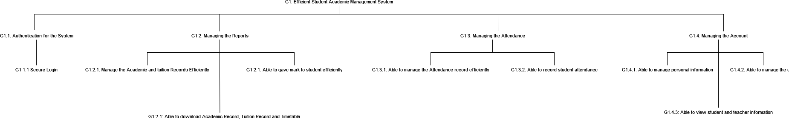**Product Perspective**

Attached is the goal model for the system. It described the perspective from the stakeholders on how they want the system to be

* + 1. **System Interfaces**

SAMS will be developed as a web-based. The development will be implemented using Larvel and Tailwind. As for the database, PostgreSQL is used along with PgAdmin as its interface for managing the database

* + 1. **User Interfaces**

SAMS is designed to be as intuitive as possible so that it will be user-friendly. The system also uses the Indonesian language because the users are Indonesian so it can make navigating the system easier

* + - 1. **Login Interface**

All of the users will have to go through this interface to enter the system. After the user logs in using valid credentials they will be redirected to each respective main interface

* + - 1. **Main Interface for Student**

This interface will be displayed after the student successfully logs in to the system. Here they can access to multiple function such as view academic reports, timetables and more.

* + - 1. **Main Interface for Teacher**

This interface will be displayed after the teacher successfully logs in to the system. Here they can access multiple functions such as creating academic reports, editing timetables, and more.

* + - 1. **Main Interface for Admin**

This interface will be displayed after the teacher successfully logs in to the system. Here they can access multiple functions such as creating a student account, creating a teacher account, creating an admin account, and more.

* + 1. **Hardware Interfaces**

The system will work on any personal computer or laptop that can run the web browser required to access the system.

* + 1. **Software Interfaces**

The software that is required to access the system can be any modern web browser. Options such as google chrome, Mozilla Firefox, and Opera are recommended

* + 1. **Communication Interfaces**

Reliable TCP/IP protocols such as HTTP and FTP are used for communication over the internet to maintain maximum compatibility and reliability.

* + 1. **Memory**

RAM: Windows or Linux with 512MB of RAM / 2GB of RAM for the 64-bit version or Mac computer with 512 MB of RAM.

* + 1. **Operations**

The user's account can only be created by the admin thus making the system isolated from the public. After creating the account the admin will give the login information to the users. The same goes for the link, it will be a special link made for SMAS Muhammadiyah 1. The only way to log in is through this

* + 1. **Site Adaptation Requirements**

Since the system is a web-based system there are no particular adaptation requirements needed. It can run on handful number of platforms

* 1. **Product Functions**

1. UC001 – Sign In: This use case is used for every user in the system to enter the system
2. UC002 – Manage Academic Report: This use case is used for teacher to manage the academic report and marking of students
3. UC003 - View Academic Report: This use case is used for student to view their academic report
4. UC004 – Download Academic Report: This use case is used for student to download their academic report
5. UC005 – Manage Attendance Record: This use case is used for teacher to manage the attendance record including to take attendance during class
6. UC006 – View Attendance Record: This use case is used for student to views the attendance record
7. UC007 – Manage Timetable: This use case is used for student to manage the attendance record including to take attendance during class
8. UC008 – View Timetable: This use case is used for student to views the timetable
9. UC009 – Download Timetable: This use case is used for student to download the timetable
10. UC010 – Manage Tuition Record: This use case is used for teacher to manage the tuition record including approving or rejecting tuition payment
11. UC011 – View Tuition Record: This use case is used for student to view the tuition record
12. UC012 – Download Tuition Record: This use case is used for student to download the tuition record
13. UC013 – Make a Payment: This use case is used for student to download the tuition record
14. UC014 – Manage Profile: This use case is used for student and teacher to view and edit their profile
15. UC015 – Manage User: This use case is used for admin to manage user account both student and teacher
16. UC016 – View Student Info: This use case is used for teacher to view list of students and their detailed information
17. UC017 – View Teacher Info: This use case is used for student to view list of students and their detailed information
    1. **User Characteristics**

Actors involved in the system are Student, Teacher and Admin. For student they will get access to most of their data by viewing or downloading it. As for teacher they mostly have access to managing use case means that they gain access to a lot of CRUD operations. Lastly, the admin has a role to manage all of the user account since creating users account is done by the admin. So, they have quite an important role in the system.

* 1. **Constraints**

Different from functional requirements, non-functional requirements act as the constraints of the system. Non-functional requirements more focused toward the system itself on what it can do to improve the functionality of the system. The system must achieve the requirements that are listed below.

1. Availabilty – The user should be able to access the system at any moment thus, the system must be available all day every day.
2. Security – The system should only allow authorized user from SMAS Muhammadiyah 1 to access the system. The system must provide protection to all of the data exist in the system.
3. Usability – The user should be able to explore the system with ease after inspecting the system a little bit. The system must be simple to use and comprehend.
4. Portability – The system should work with any web browser. The user shall be able to access the system from their preferred web browser
   1. **Assumption and Dependencies**

The system can only be accessed by devices that can run a web browser. It is also recommended to access using a stable internet connection. In some rare cases if the system can not operate normally assumption can be made that the database might be the problem.

* 1. **Apportioning of Requirements**

If the requirements could not be made because of the project delayed it can be moved on to the next iteratio

1. **Specific Requirements**



**Figure 3.1: Domain Model of Student Academic Management System**

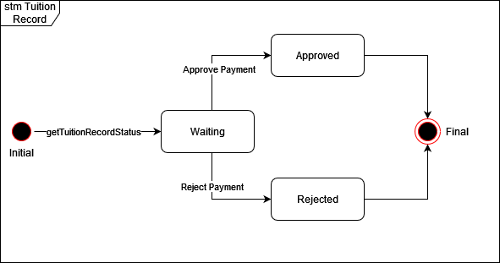

**Figure 3.2: State Machine Diagram of Manage Tuition Record**

* 1. **External Interface Requirements**
     1. **User Interfaces**

SAMS is designed to be as intuitive as possible so that it will be user-friendly. The system also uses the Indonesian language because the users are Indonesian so it can make navigating the system easier

* + - 1. **Login Interface**

All of the users will have to go through this interface to enter the system. After the user logs in using valid credentials they will be redirected to each respective main interface

* + - 1. **Main Interface for Student**

This interface will be displayed after the student successfully logs in to the system. Here they can access to multiple function such as view academic reports, timetables and more.

* + - 1. **Main Interface for Teacher**

This interface will be displayed after the teacher successfully logs in to the system. Here they can access multiple functions such as creating academic reports, editing timetables, and more.

* + - 1. **Main Interface for Admin**

This interface will be displayed after the teacher successfully logs in to the system. Here they can access multiple functions such as creating a student account, creating a teacher account, creating an admin account, and more.

* + 1. **Hardware Interfaces**

The system will work on any personal computer or laptop that can run the web browser required to access the system.

* + 1. **Software Interfaces**

The software that is required to access the system can be any modern web browser. Options such as google chrome, Mozilla Firefox, and Opera are recommended

* + 1. **Communication Interfaces**

Reliable TCP/IP protocols such as HTTP and FTP are used for communication over the internet to maintain maximum compatibility and reliability.

* 1. **System Features**
     1. **Module Authentication**

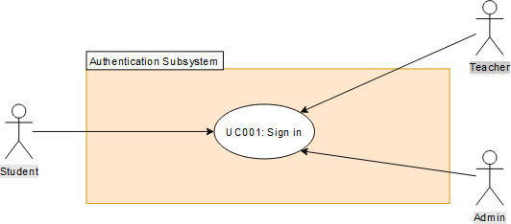

* + - 1. **UC001: Use Case Sign In**

**Table 3.1: Use Case Description for Sign In**

|  |  |
| --- | --- |
| **Use Case ID:** | UC-001 |
| **Use Case**  **Name:** | Sign In |
| **Actors:** | Admin/Teacher/Student |
| **Description:** | This use case is used for every user in the system to enter the system |
| **Pre-conditions:** | 1. Existing User |
| **Normal Flow:** | 1. Go to the login page 2. Fill in the username and password 3. Click “Login” button |
| **Alternative**  **Flow:** | - |
| **Exception:** | * 1. **Error during validation**      1. an error message will be displayed by the system      2. Users try to login again using the correct credentials or request a new account from an admin |
| **Post-condition**  **s:** | The user successfully enters the system. |
| **Related**  **Requirement:** | **-** |

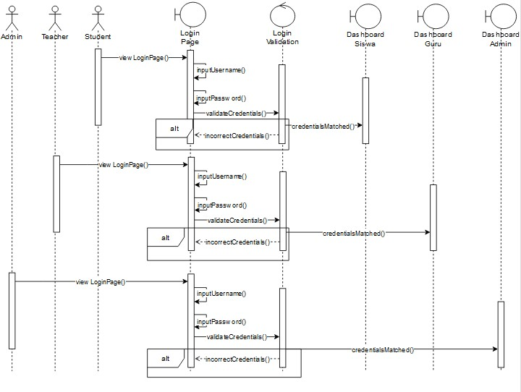

**Figure 3.3: System Sequence Diagram of Sign In**

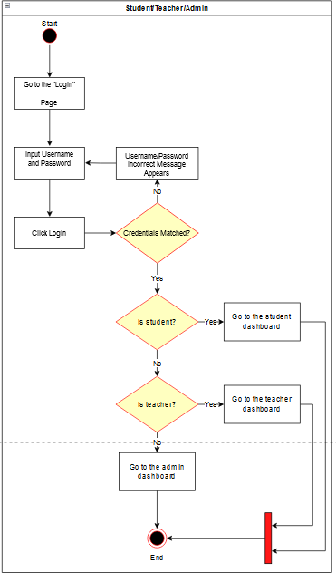

**Figure 3.4: Activity Diagram of Sign In**

* + 1. **Module Report**

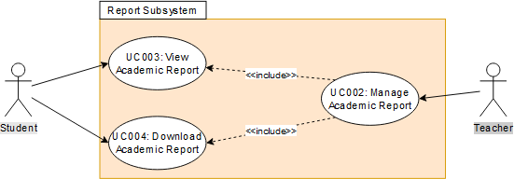

* + - 1. **UC002: Use Case Manage Academic Record**

**Table 3.2: Use Case Description for Manage Academic Report**

|  |  |
| --- | --- |
| **Use Case ID:** | UC-002 |
| **Use Case**  **Name:** | Manage Academic Report |
| **Actors:** | Teacher |
| **Description:** | This use case is used for teacher to manage the academic report and marking of students |
| **Pre-conditions:** | 2. Logged in to the system |
| **Normal Flow:** | 1. Go to the “Rapor” page 2. If the teacher clicks “Penilaian” performs AF1 3. If the teacher clicks “Edit Penilaian” performs AF2 4. Select academic year 5. Select semester 6. Select class 7. Select student 8. The system displays the academic report 9. If the teacher wants to download the academic report performs AF3 10. If the teacher is a homeroom teacher and clicks “Buat Rapor” page performs AF4 11. If the teacher wants to delete the academic report performs AF5 |
| **Alternative**  **Flow:** | 6. Marking   * 1. System redirects teacher to “Peniliain” page   2. System display the marking form   3. Fill in the marking form   4. System saves student mark  1. Edit Marking    1. System redirects teacher to “Edit Penilaian” page    2. System displays the student that the teacher already marked    3. Select student    4. System displays the marking form    5. Edit the mark 2. Download Academic Report   3.1 Click the “Unduh” button to download   1. Create Academic Report    1. System redirects teacher to “Buat Rapor” page    2. Select Student    3. Teacher fills in additional information    4. Teacher clicks “Buat Rapor” button 2. Delete Academic Report   5.1 Click “Trash” icon to delete the academic report |
| **Exception:** | * 1. **Required field(s) is/are empty in marking form**      1. an error message will be displayed by the system      2. Performs NF2/AF1   2. **Required field(s) is/are empty when creating Academic Report**      1. an error message will be displayed by the system |

|  |  |
| --- | --- |
|  | 2. Performs NF9/AF4 |
| **Post-condition**  **s:** | 1. Teacher successfully views the academic report 2. Teacher successfully downloads the academic report 3. Teacher successfully marks the student 4. Teacher successfully edits the marks of the student 5. Teacher successfully creates the academic report |
| **Related Requirement:** | **-** |

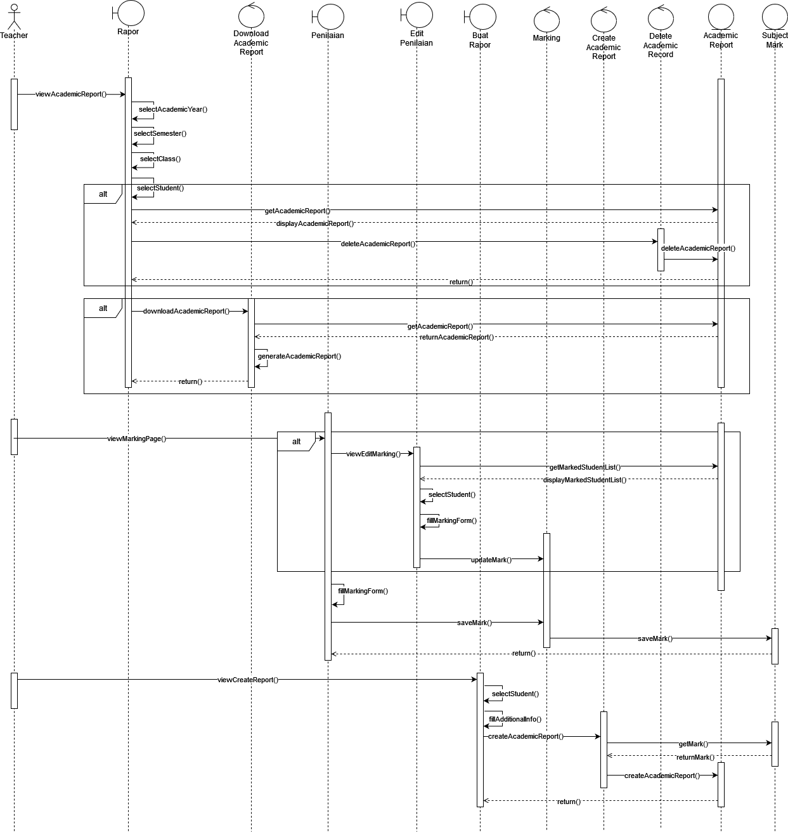

**Figure 3.5: System Sequence Diagram of Manage Academic Report**

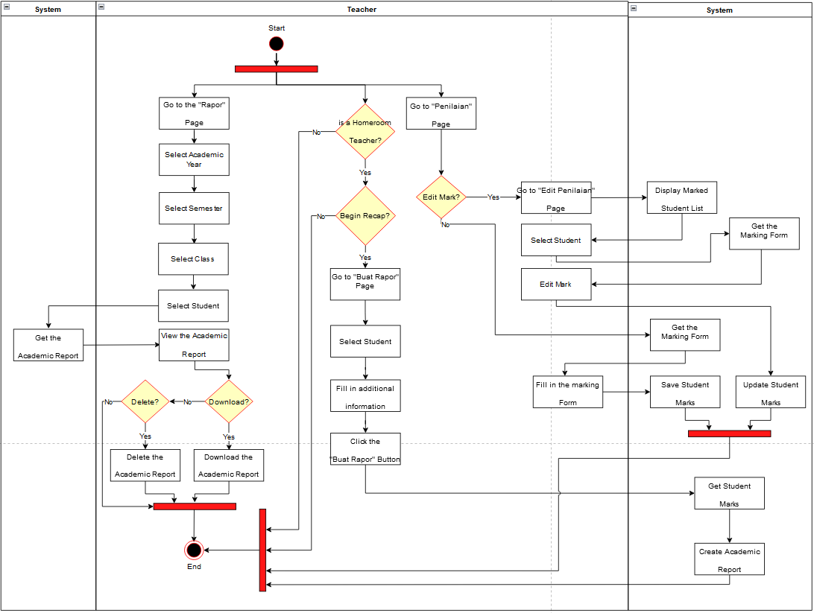

**Figure 3.6: System Sequence Diagram of Manage Academic Report**

* + - 1. **UC003: Use Case View Academic Report**

**Table 3.3: Use Case Description for Sign In**

|  |  |
| --- | --- |
| **Use Case ID:** | UC-003 |
| **Use Case**  **Name:** | View Academic Report |
| **Actors:** | Student |
| **Description:** | This use case is used for student to view their academic report |
| **Pre-conditions:** | 1. Logged in to the system |
| **Normal Flow:** | 1. Go to the “Rapor” page 2. Select academic year 3. Select semester 4. Select class 5. The system displays the academic report |
| **Alternative**  **Flow:** | - |
| **Exception:** | **-** |
| **Post-condition**  **s:** | 1. Student successfully views the academic report |
| **Related**  **Requirement:** | **-** |

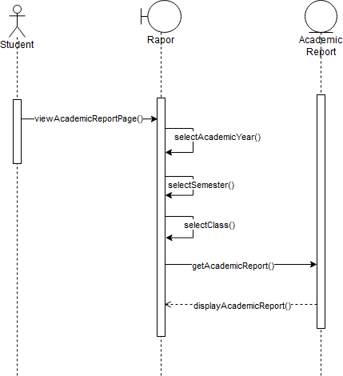

**Figure 3.7: System Sequence Diagram of View Academic Report**

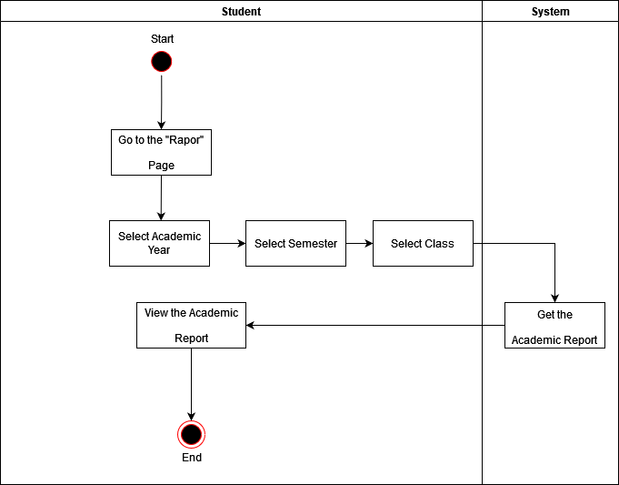

**Figure 3.8: Activity Diagram of View Academic Report**

**3.2.2.2 UC004: Use Case Download Academic Report**

**Table 3.4: Use Case Description for Download Academic Report**

|  |  |
| --- | --- |
| **Use Case ID:** | UC-004 |
| **Use Case**  **Name:** | Download Academic Report |
| **Actors:** | Student |
| **Description:** | This use case is used for student to download their academic report |
| **Pre-conditions:** | 1. Logged in to the system |
| **Normal Flow:** | 1. Go to the “Rapor” page 2. Select academic year 3. Select semester 4. Select class 5. The system displays the academic report 6. Click the “Unduh” Button to download |
| **Alternative**  **Flow:** | - |
| **Exception:** | **-** |
| **Post-condition**  **s:** | 1. Student successfully downloads the academic report |

|  |  |
| --- | --- |
| **Related**  **Requirement:** | **-** |

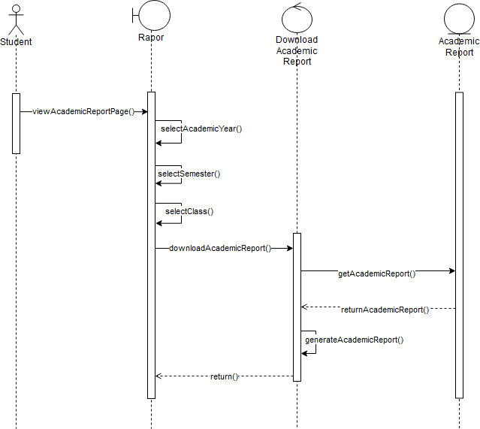

**Figure 3.9: System Sequence Diagram of Download Academic Report**

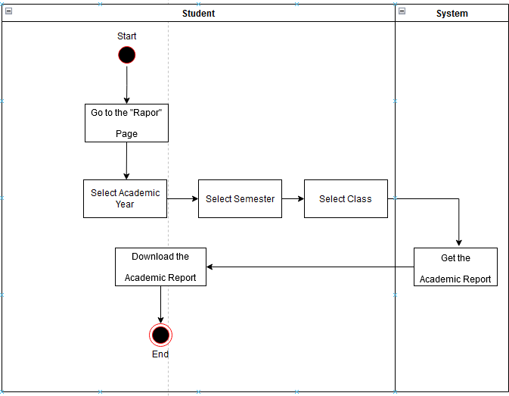

**Figure 3.10: Activity Diagram of Download Academic Report**

* + 1. **Module Attendance**

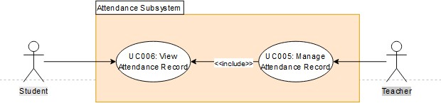

* + - 1. **UC005: Use Case Manage Attendance Record**

**Table 3.5: Use Case Description for Manage Attendance Record**

|  |  |
| --- | --- |
| **Use Case ID:** | UC-005 |
| **Use Case**  **Name:** | Manage Attendance Record |
| **Actors:** | Teacher |
| **Description:** | This use case is used for teacher to manage the attendance record including to take attendance during class |
| **Pre-conditions:** | 1. Logged in to the system |
| **Normal Flow:** | 1. Go to the “Absensi” page 2. Select date and hour 3. Select class 4. The system displays the attendance record 5. If the teacher wants to take attendance go to AF1 6. If the teacher clicks the “Ubah” button go to AF2 |
| **Alternative**  **Flow:** | 1. Attendance Checking    1. Teacher begins attendance checking    2. Fill in the case and description field for each student 2. Edit Attendance    1. Teacher edit the attendance record |
| **Exception:** | * 1. **Required field(s) is/are empty when attendance checking**      1. an error message will be displayed by the system      2. Performs NF5/AF1 |
| **Post-condition**  **s:** | 1. Teacher successfully checking student attendance 2. Teacher successfully edits the attendance record 3. Teacher successfully views the attendance record |
| **Related**  **Requirement:** | **-** |

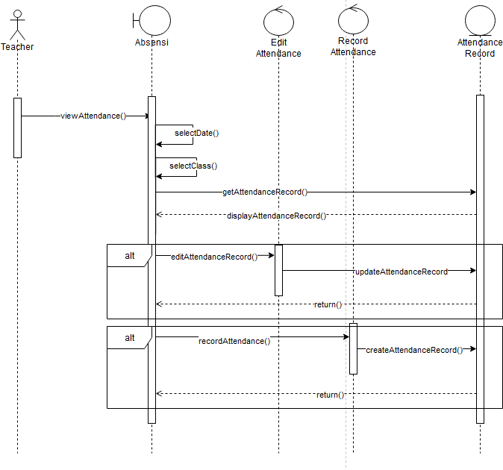

**Figure 3.11: System Sequence Diagram of Manage Attendance Record**

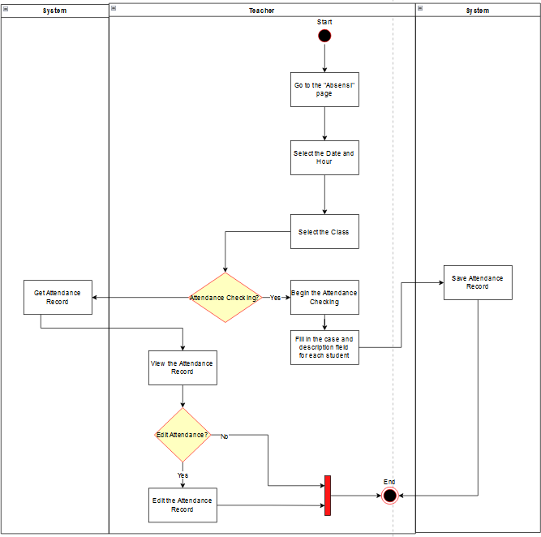

**Figure 3.12: Activity Diagram of Manage Attendance Record**

* + - 1. **UC006: Use Case View Attendance Record**

**Table 3.6: Use Case Description for View Attendance Record**

|  |  |
| --- | --- |
| **Use Case ID:** | UC-006 |
| **Use Case**  **Name:** | View Attendance Record |
| **Actors:** | Student |
| **Description:** | This use case is used for student to views the attendance record |
| **Pre-conditions:** | 1. Logged in to the system |
| **Normal Flow:** | 1. Go to the “Absensi” page 2. Select date 3. Select class 4. The system displays the attendance record |
| **Alternative**  **Flow:** | - |
| **Exception:** | - |
| **Post-condition**  **s:** | 1. Student successfully views the attendance record |
| **Related**  **Requirement:** | **-** |

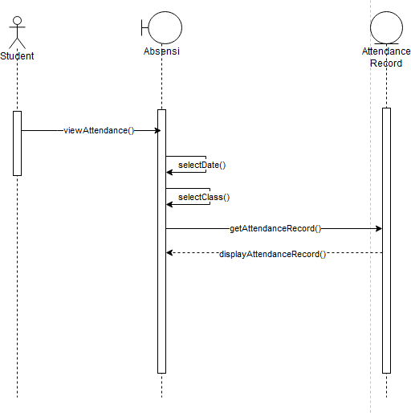

**Figure 3.13: System Sequence Diagram of View Attendance Record**

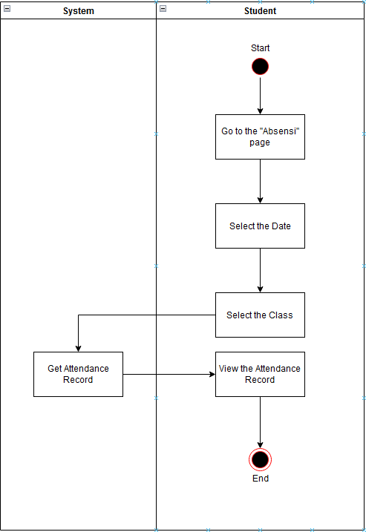

**Figure 3.14: Activity Diagram of View Attendance Record**

* + 1. **Module Schedule**

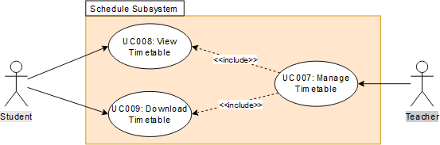

* + - 1. **UC007: Use Case Manage Timetable**

**Table 3.7: Use Case Description for Manage Timetable**

|  |  |
| --- | --- |
| **Use Case ID:** | UC-007 |
| **Use Case**  **Name:** | Manage Timetable |
| **Actors:** | Teacher |
| **Description:** | This use case is used for student to manage the attendance record including to take attendance during class |
| **Pre-conditions:** | 1. Logged in to the system |
| **Normal Flow:** | 1. Go to the “Jadwal Pelajaran” page 2. Select class 3. The system displays the timetable 4. If the teacher wants to download timetable performs AF1 5. If the teacher is a homeroom teacher and want to edit timetable go to AF2 |
| **Alternative**  **Flow:** | 1. Create Timetable    1. Click “Ubah Jadwal Pelajaran” page    2. Select Class    3. Select subject    4. Select Day and Time    5. Click “Simpan” button 2. Download Timetable    1. The teacher clicks “Unduh” button |
| **Exception:** | * 1. **Required field(s) is/are empty when editing Timetable**      1. an error message will be displayed by the system      2. Performs NF5/AF2 |

|  |  |
| --- | --- |
| **Post-condition**  **s:** | 1. Teacher successfully views the timetable 2. Teacher successfully edits the timetable 3. Teacher successfully downloads the timetable |
| **Related**  **Requirement:** | **-** |

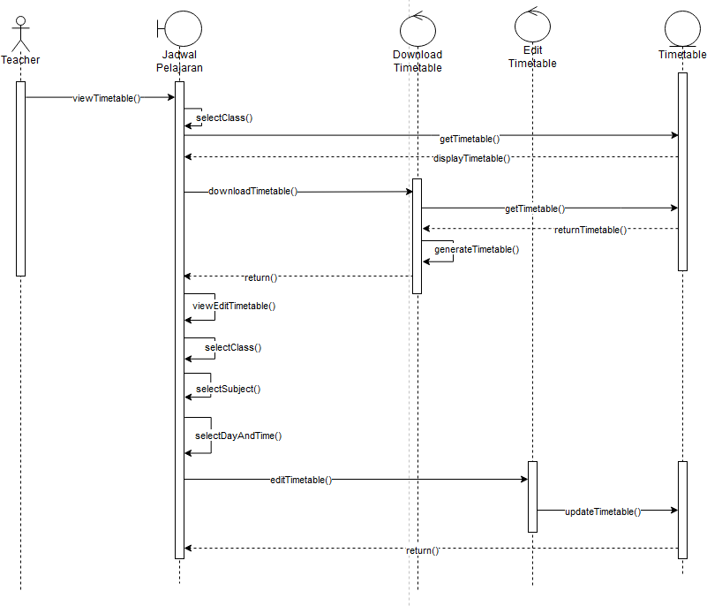

**Figure 3.15: System Sequence Diagram of Manage Timetable**

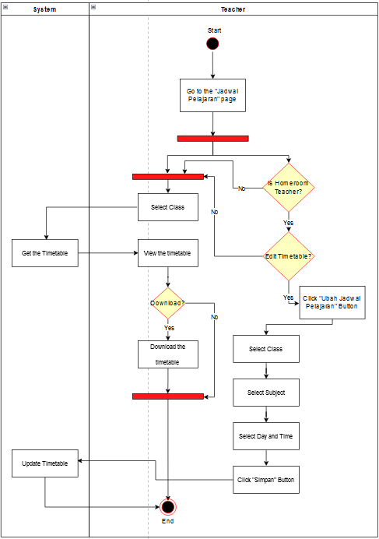

**Figure 3.16: Activity Diagram of Manage Timetable**

* + - 1. **UC008: Use Case View Timetable**

**Table 3.8: Use Case Description for View Timetable**

|  |  |
| --- | --- |
| **Use Case ID:** | UC-008 |
| **Use Case**  **Name:** | View Timetable |
| **Actors:** | Student |
| **Description:** | This use case is used for student to views the timetable |
| **Pre-conditions:** | 1. Logged in to the system |
| **Normal Flow:** | 1. Go to the “Jadwal Pelajaran” page 2. The system displays the timetable |
| **Alternative**  **Flow:** | - |
| **Exception:** | **-** |
| **Post-condition**  **s:** | 1. Student successfully views the timetable |
| **Related Requirement:** | **-** |

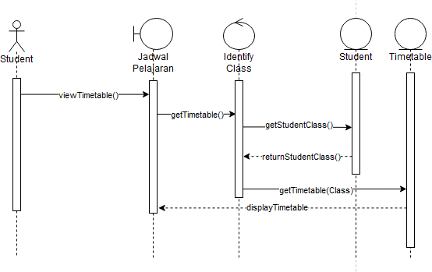

**Figure 3.17: System Sequence Diagram of View Timetable**

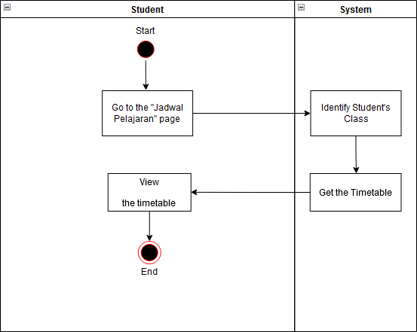

**Figure 3.18: Activity Diagram of View Timetable**

* + - 1. **UC009: Use Case Download Timetable**

**Table 3.9: Use Case Description for Download Timetable**

|  |  |
| --- | --- |
| **Use Case ID:** | UC-009 |
| **Use Case**  **Name:** | Download Timetable |
| **Actors:** | Student |
| **Description:** | This use case is used for student to download the timetable |
| **Pre-conditions:** | 1. Logged in to the system |
| **Normal Flow:** | 1. Go to the “Jadwal Pelajaran” page 2. The student clicks “Unduh” button |
| **Alternative**  **Flow:** | - |
| **Exception:** | **-** |
| **Post-condition**  **s:** | 1. Student successfully download the timetable |
| **Related**  **Requirement:** | **-** |

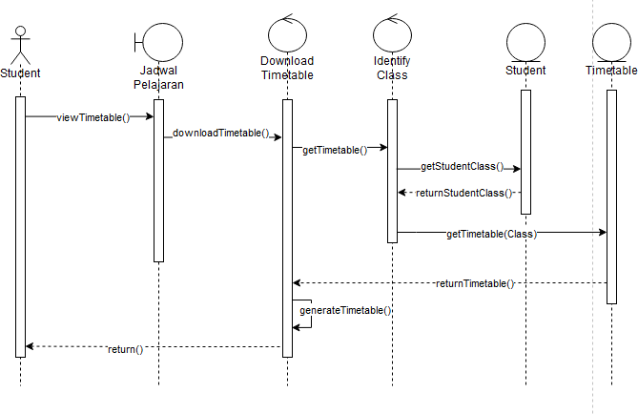

**Figure 3.19: System Sequence Diagram of Download Timetable**

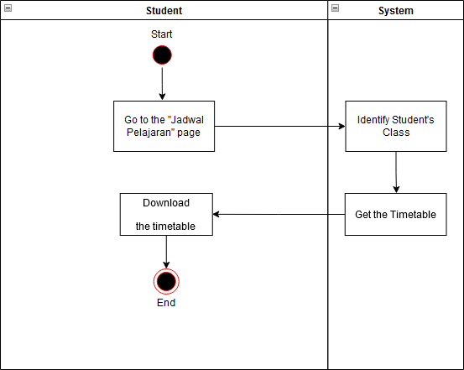

**Figure 3.20: Activity Diagram of Download Timetable**

* + 1. **Module Account**

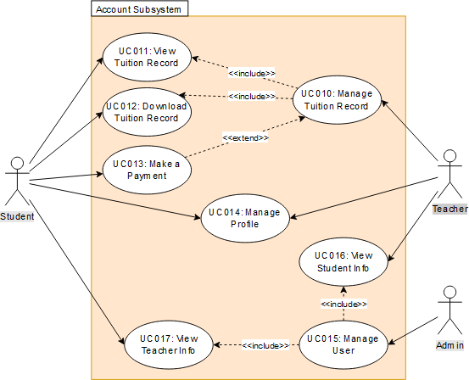

* + - 1. **UC010: Use Case Manage Tuition Record**

|  |  |
| --- | --- |
| **Use Case ID:** | UC-010 |
| **Use Case**  **Name:** | Manage Tuition Record |
| **Actors:** | Teacher |
| **Description:** | This use case is used for teacher to manage the tuition record including approving or rejecting tuition payment |
| **Pre-conditions:** | 1. Logged in to the system |
| **Normal Flow:** | 1. Go to the “SPP” page 2. Select academic year 3. Select class 4. Select student 5. The system displays the tuition record 6. If the teacher wants to approve the payment performs AF1 7. If the teacher wants to reject the payment performs AF2 |
| **Alternative**  **Flow:** | 1. Approve payment    1. Change the status to paid 2. Download Timetable    1. Change the status to outstanding |
| **Exception:** | **-** |

|  |  |
| --- | --- |
| **Post-condition**  **s:** | 1. Teacher successfully views the tuition record 2. Teacher successfully approves or reject the payment |
| **Related**  **Requirement:** | **-** |

**Table 3.10: Use Case Description for Manage Tuition Record**

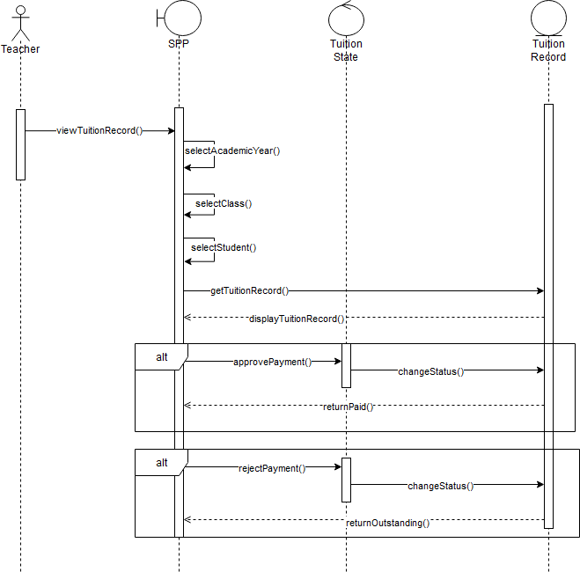

**Figure 3.21: System Sequence Diagram of Manage Tuition Record**

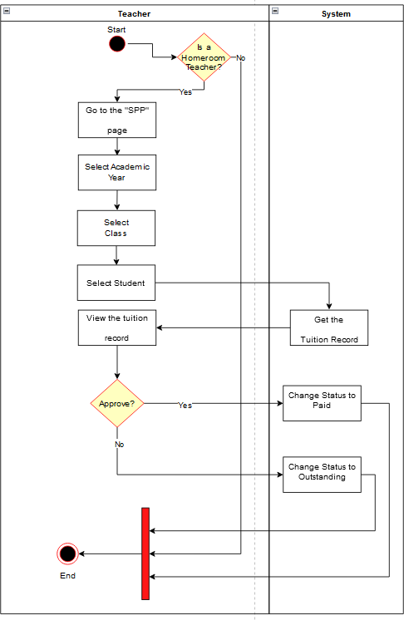

**Figure 3.22: Activity Diagram of Manage Tuition Record**

* + - 1. **UC011: Use Case View Tuition Record**

**Table 3.11: Use Case Description for View Tuition Record**

|  |  |
| --- | --- |
| **Use Case ID:** | UC-011 |
| **Use Case**  **Name:** | View Tuition Record |
| **Actors:** | Student |
| **Description:** | This use case is used for student to view the tuition record |
| **Pre-conditions:** | 1. Logged in to the system |
| **Normal Flow:** | 1. Go to the “SPP” page 2. Select academic year 3. Select class 4. Select student 5. The system displays the tuition record |
| **Alternative**  **Flow:** | - |
| **Exception:** | **-** |
| **Post-condition**  **s:** | 1. Student successfully views the tuition record |
| **Related**  **Requirement:** | **-** |

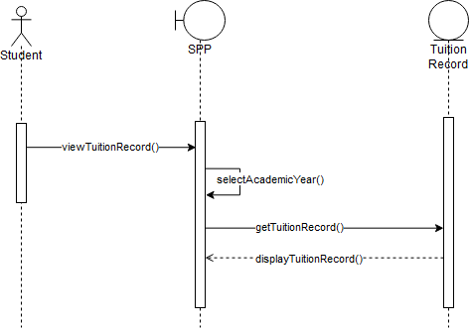

**Figure 3.23: System Sequence Diagram of View Tuition Record**

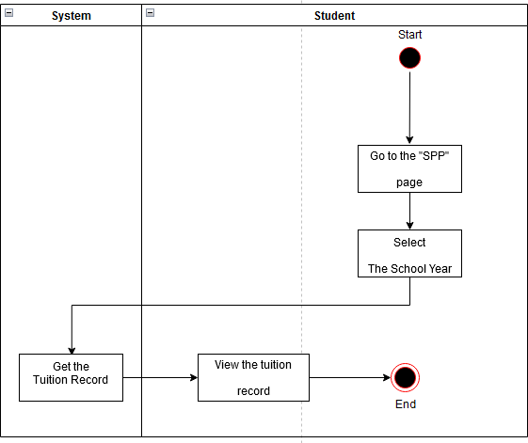

**Figure 3.24: Activity Diagram of View Tuition Record**

* + - 1. **UC012: Use Case Download Tuition Record**

**Table 3.12: Use Case Description for Download Tuition Record**

|  |  |
| --- | --- |
| **Use Case ID:** | UC-012 |
| **Use Case**  **Name:** | Download Tuition Record |
| **Actors:** | Student |
| **Description:** | This use case is used for student to download the tuition record |
| **Pre-conditions:** | 1. Logged in to the system |
| **Normal Flow:** | 1. Go to the “SPP” page 2. Select academic year 3. Select class 4. Select student 5. Click the “Unduh” button to download the tuition record |
| **Alternative**  **Flow:** | - |
| **Exception:** | **-** |
| **Post-condition**  **s:** | 1. Student successfully download the tuition record |
| **Related**  **Requirement:** | **-** |

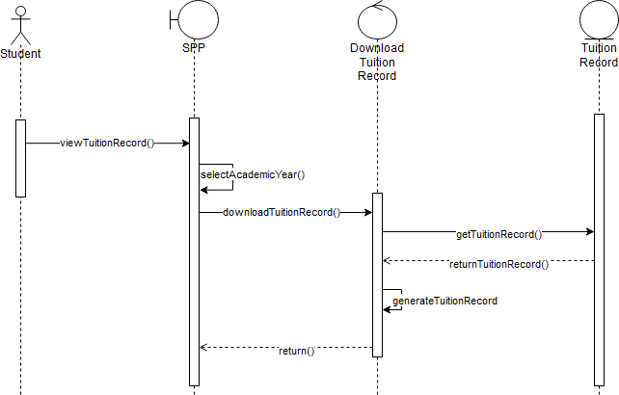

**Figure 3.25: System Sequence Diagram of Download Tuition Record**

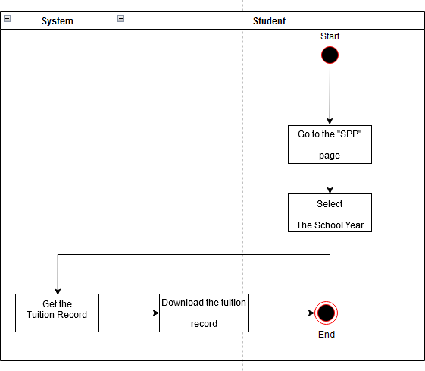

**Figure 3.26: Activity Diagram of Download Tuition Record**

* + - 1. **UC013: Use Case Make a Payment**

**Table 3.13: Use Case Description for Make a Payment**

|  |  |
| --- | --- |
| **Use Case ID:** | UC-013 |
| **Use Case**  **Name:** | Make A Payment |
| **Actors:** | Student |
| **Description:** | This use case is used for student to download the tuition record |
| **Pre-conditions:** | 1. Logged in to the system |
| **Normal Flow:** | 1. Go to the “SPP” page 2. Select “Pembayaran SPP” 3. Select the month to be paid 4. Upload proof of payment |
| **Alternative**  **Flow:** | - |
| **Exception:** | * 1. **Unsupported uploaded file extension**      1. An error message will be displayed by the system      2. Performs NF4 |
| **Post-condition**  **s:** | 1. Student successfully uploads the proof of payment |
| **Related**  **Requirement:** | **-** |

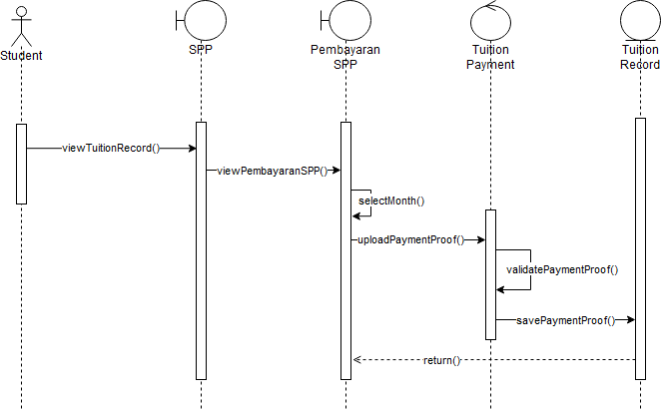

**Figure 3.27: System Sequence Diagram of Make a Payment**

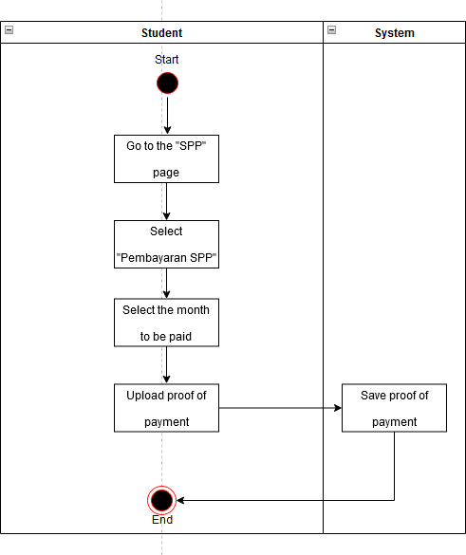

**Figure 3.28: Activity Diagram of Make a Payment**

* + - 1. **UC014: Use Case Manage Profile**

**Table 3.14: Use Case Description for Manage Profile**

|  |  |
| --- | --- |
| **Use Case ID:** | UC-014 |
| **Use Case**  **Name:** | Manage Profile |
| **Actors:** | Student/Teacher |
| **Description:** | This use case is used for student and teacher to view and edit their profile |
| **Pre-conditions:** | 1. Logged in to the system |
| **Normal Flow:** | 1. Go to the “Profil” page 2. The system display user profile 3. If the user wants to edit their profile performs AF1 |
| **Alternative**  **Flow:** | - |
| **Exception:** | **-** |
| **Post-condition**  **s:** | 1. Student/teacher successfully views their profile info 2. Student/teacher successfully edit their profile info |
| **Related**  **Requirement:** | **-** |

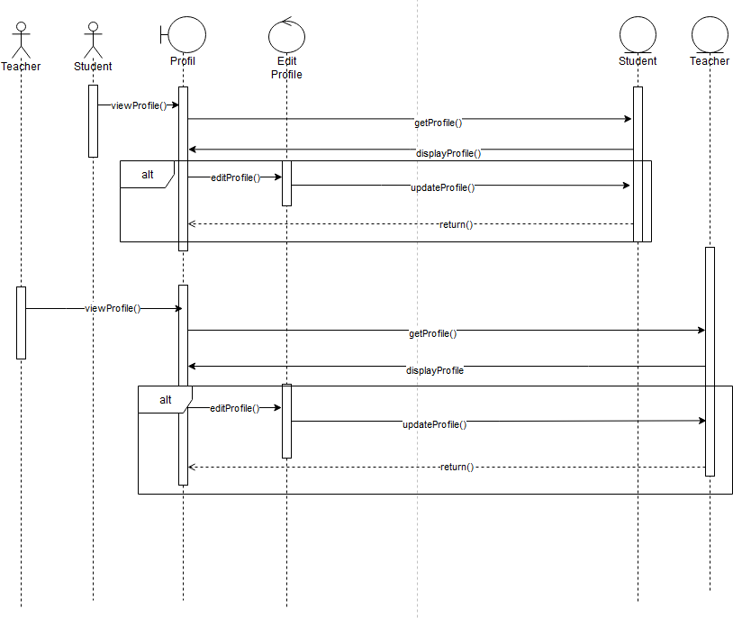

**Figure 3.29: System Sequence Diagram of Manage Profile**

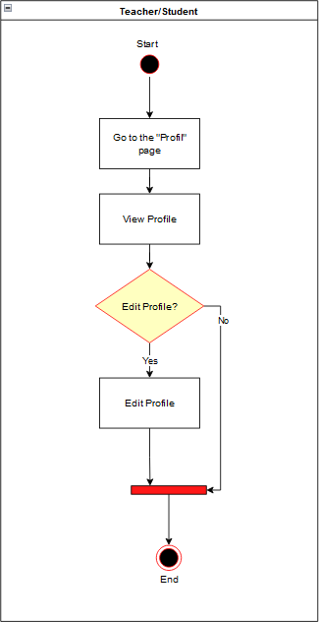

**Figure 3.30: Activity Diagram of Manage Profile**

* + - 1. **UC015: Use Case Manage User**

|  |  |
| --- | --- |
| **Use Case ID:** | UC-015 |
| **Use Case**  **Name:** | Manage User |
| **Actors:** | Admin |
| **Description:** | This use case is used for admin to manage user account both student and teacher |
| **Pre-conditions:** | 1. Logged in to the system |
| **Normal Flow:** | 1. Go to the “Akun Manajemen” page 2. The system displays the list of user page 3. If the selected user type is Teacher performs AF1 4. If the selected user type is student performs AF2 5. If admin want to add a new student account performs AF3 6. If admin want to add a new teacher account performs AF4 7. If admin want to add a new admin account performs AF5 |
| **Alternative**  **Flow:** | 1. View Teacher List    1. The system display teacher account list    2. If the admin wants to delete the account performs AF7    3. If the admin wants to assign the teacher as a homeroom teacher performs AF6 2. View Student List    1. The system display student account list    2. If the admin wants to delete the account performs AF7 3. Add student account    1. Go to “Tambah Akun Siswa” page    2. Fill in the Create Student Account Form    3. Click “Tambah” to create the student account 4. Add teacher account    1. Go to “Tambah Akun Guru” page    2. Fill in the Create Teacher Account Form    3. Click “Tambah” to create the student account 5. Add admin account    1. Go to “Tambah Akun Admin” page    2. Fill in the Create Admin Account Form    3. Click “Tambah” to create the student account 6. Assign homeroom teacher    1. Click the dropdown button to select which class will the teacher assigned to 7. Delete account    1. Delete the users account by clicking the “Trash” icon |
| **Exception:** | * 1. **The required fields when creating user account is empty**      1. An error message will be displayed by the system      2. Performs NF5/NF6/NF7   2. **Validation error during creating user account**      1. An error message will be displayed by the system      2. Performs NF5/NF6/NF7 |

|  |  |
| --- | --- |
| **Post-condition**  **s:** | 1. Admin successfully create user account 2. Admin successfully views user list 3. Admin successfully assign teacher as a homeroom teacher |

**Table 3.15: Use Case Description for Manage User**

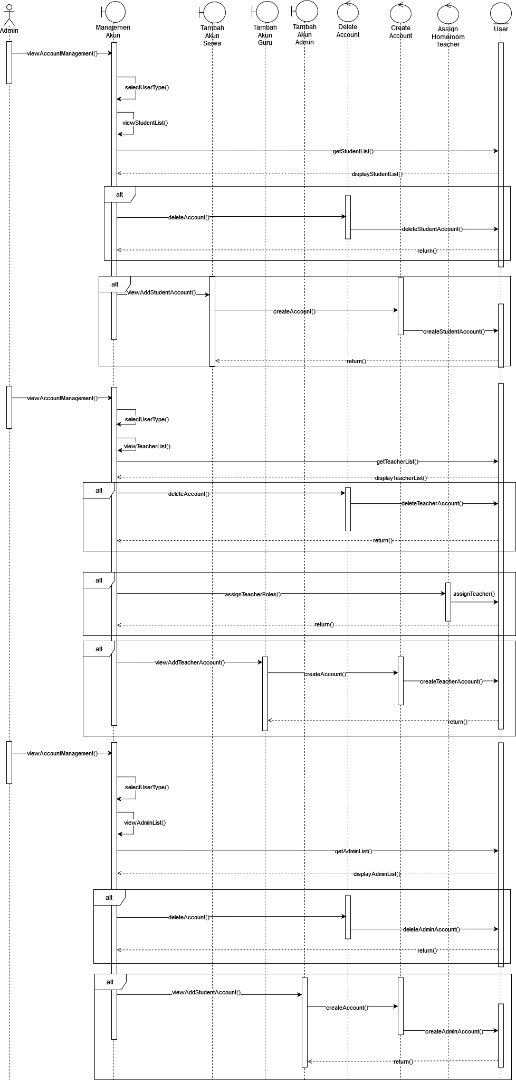

**Figure 3.31: System Sequence Diagram of Manage User**

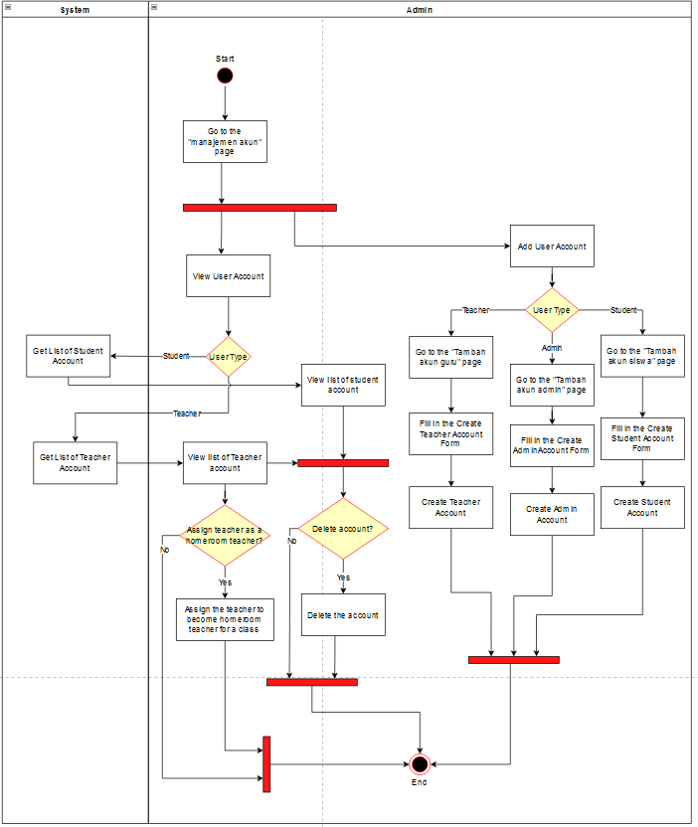

**Figure 3.32: Activity Diagram of Manage User**

* + - 1. **UC016: Use Case View Student Info**

**Table 3.16: Use Case Description for View Student Info**

|  |  |
| --- | --- |
| **Use Case ID:** | UC-016 |
| **Use Case**  **Name:** | View Student Info |
| **Actors:** | Teacher |
| **Description:** | This use case is used for teacher to view list of students and their detailed information |
| **Pre-conditions:** | 1. Logged in to the system |
| **Normal Flow:** | 1. Go to the “Daftar Siswa” page 2. Select the class 3. Select the academic year 4. Select the semester 5. The system display student list 6. If the teacher wants to view detailed information of the student performs AF1 |
| **Alternative**  **Flow:** | 1. View Student Detailed Info    1. Select one of the students from the list    2. The system displays the detailed information about the selected student |
| **Exception:** | **-** |
| **Post-condition**  **s:** | 1. Teacher successfully views student list 2. Teacher successfully views the detailed information of a student |
| **Related**  **Requirement:** | **-** |

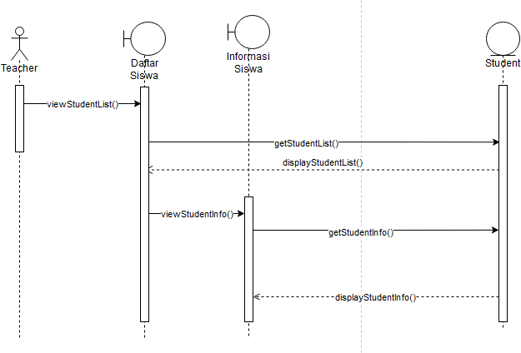

**Figure 3.33: System Sequence Diagram of View Student Info**

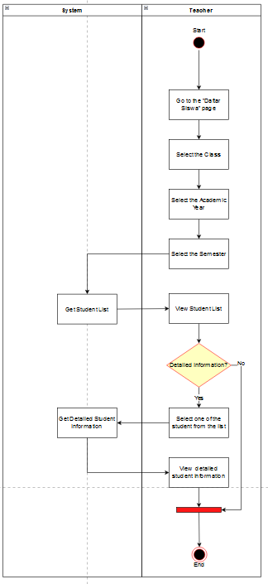

**Figure 3.34: Activity Diagram of View Student Info**

* + - 1. **UC017: Use Case View Teacher Info**

**Table 3.17: Use Case Description for View Teacher Info**

|  |  |
| --- | --- |
| **Use Case ID:** | UC-017 |
| **Use Case**  **Name:** | View Teacher Info |
| **Actors:** | Student |
| **Description:** | This use case is used for student to view list of students and their detailed information |
| **Pre-conditions:** | 1. Logged in to the system |
| **Normal Flow:** | 1. Go to the “Daftar Guru” page 2. The system displays teacher list 3. If the student wants to view detailed information of the teacher performs AF1 |
| **Alternative**  **Flow:** | 1. View Teacher Detailed Info    1. Select one of the teachers from the list    2. The system displays the detailed information about the selected teacher |
| **Exception:** | **-** |
| **Post-condition**  **s:** | 1. Student successfully views teacher list 2. Student successfully views the detailed information of a teacher |
| **Related Requirement:** | **-** |

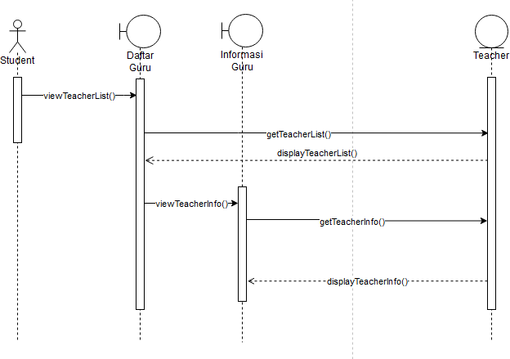

**Figure 3.35: System Sequence Diagram of View Teacher Info**

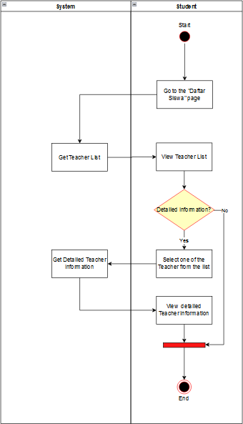

**Figure 3.36: Activity Diagram of View Teacher Info**

* 1. **Performance Requirements**
     1. Workload – The system should be able to support all of the students, teachers and admin of SMAS Muhammadiyah 1
     2. Scalability – The system should be able to scale up based on the demand and workload
     3. Response Time – The system should be able to load fast and with minimum delay
     4. Safety – The system should be able to protect the data during any action that requires the data to be transferred.
  2. **Design Constraints**

The system should be accessible with any web browser using internet connection

* 1. **Software System Attributes**
     1. Availabilty – The user should be able to access the system at any moment thus, the system must be available all day every day.
     2. Security – The system should only allow authorized user from SMAS Muhammadiyah 1 to access the system. The system must provide protection to all of the data exist in the system.
     3. Usability – The user should be able to explore the system with ease after inspecting the system a little bit. The system must be simple to use and comprehend.
     4. Portability – The system should work with any web browser. The user shall be able to access the system from their preferred web browser
  2. **Other Requirements**

No other requirements for this project

**Appendix B Software Design Document**



SCSJ3323: Software Design and Architecture

**Software Design Document** Student Academic Management System Version 1.0

23 June 2022 Department and Faculty

Prepared by: Muhammad Darlen Sava

**Revision Page**

1. **Overview**

This is the first draft of the Software Requirements Specification (SRS) for Student Academic Management System (SAMS).

1. **Target Audience**

Student, Teacher and Admin of SMAS Muhammadiyah 1

1. **Project Team Members**

Muhammad Darlen Sava

1. **Version Control History**

|  |  |  |  |
| --- | --- | --- | --- |
| **Version** | **Primary Author(s)** | **Description of Version** | **Date Completed** |
| 1.0 | **Muhammad Darlen Sava** | **Initial Draft** | **23 June 2022** |

**Note:**

This template is an annotated outline for a software design document adapted from the IEEE Recommended Practice for Software Design Descriptions. The IEEE Recommended Practice for Software Design Descriptions have been reduced in order to simplify this assignment while still retaining the main components and providing a general idea of a project definition report. Please refer to IEEE Std 1016•1998 1 for the full IEEE Recommended Practice for Software Design Descriptions. Examples of models are from Satzinger (2011). Compiled by Shahliza Abdul Halim, PhD and checked by Shahida Sulaiman, PhD on 2 May 2016.

**Table of Contents**

# Introduction 1

* + 1. Purpose 1
    2. Scope 1
    3. Definitions, Acronyms and Abbreviations 1
    4. Reference Materials 1
    5. System Overview 2

# System Architectural Design 3

* + 1. Architectural Style and Rationale 3
    2. Component Model 4
    3. Use Case Diagram 5

# Detailed Description of Modules 7

* + 1. Complete Package Diagram 7
    2. Modules Detailed Descriptions 8

8

|  |  |  |
| --- | --- | --- |
| 3.2.1 | Module Authentication | |
|  | 3.2.1.1 | Package Diagram |
|  | 3.2.1.2 | Class Diagram |
|  | 3.2.1.3 | Sequence Diagrams |
| 3.2.2 | Module Report | |
|  | 3.2.2.1 | Package Diagram |
|  | 3.2.2.2 | Class Diagram |
|  | 3.2.2.3 | Sequence Diagrams |
| 3.2.3 | Module Attendance | |
|  | 3.2.3.1 | Package Diagram |
|  | 3.2.3.2 | Class Diagram |
|  | 3.2.3.3 | Sequence Diagrams |

8

9

9

10

11

12

13

15

16

17

17

19

|  |  |  |
| --- | --- | --- |
| 3.2.4 | Module Schedule | |
|  | 3.2.4.1 | Package Diagram |
|  | 3.2.4.2 | Class Diagram |
|  | 3.2.4.3 | Sequence Diagrams |
| 3.2.5 | Module Account | |
|  | 3.2.5.1 | Package Diagram |
|  | 3.2.5.2 | Class Diagram |
|  | 3.2.5.3 | Sequence Diagrams |

20

21

21

23

24

25

26

# Data Design 32

* + 1. Data Description 32
    2. Data Dictionary 35

# User Interface Design 43

* + 1. Overview of User Interface 43
    2. Screen Images 45

# Requirements Matrix 63

# Appendices 65

Appendices (if any)

1. **Introduction**
   1. **Purpose**

This SDD describes the design for the Student Academic Management System which is a system dedicated to SMAS Muhammadiyah 1 Banda Aceh. This SDD is required to determine the design requirements of the stakeholder, it also acts as a reference point for the development of the project.

* 1. **Scope**

The current system of SMAS Muhammadiyah is still involving manual task execution with a decentralized database. So, this project only focused on the conversion of manually managing student data to a website that stores all of the student’s data, which can be accessed by teachers, students, and their parents. As such, SMAS Muhammadiyah will only provide the student’s data throughout the development of the project. The users in this system will be the teachers, students/parents, and admins of SMAS Muhammadiyah. The goal of this project is to create an effective solution to enable the institution to convert its manual student management system into a computerized system.

* 1. **Definitions, Acronyms and Abbreviation**

1. SAMS - Student Academic Management System
2. SRS - Software Requirements Specification
3. SDD - Software Design Document
   1. **References**

*My.utm.my*. (n.d.). Retrieved May 16, 2022, from <https://my.utm.my/home>

*Aplikasi Rapor online - solusi*. Sekawan Media. (2022, May 16). Retrieved May 16, 2022, from https:/[/www](http://www.sekawanmedia.co.id/solusi/aplikasi-rapor-online/).[sekawanmedia.co.id/solusi/aplikasi-rapor-online/](http://www.sekawanmedia.co.id/solusi/aplikasi-rapor-online/)

Miller, J., Kostogriz, A., & Gearon, M. (Eds.). (2009). Culturally and linguistically diverse classrooms: New dilemmas for teachers. Bristol, UK: Multilingual Matters.

Dinustek. (n.d.). *Solusi Rapor Sekolah online*. evaluation. Retrieved May 16, 2022, from <https://evaluation.id/>

* 1. **Overview**

This SDD is divided into seven chapters. The first chapter is the introduction which consists of the purpose and scope of the project. It also includes all the acronyms/abbreviation descriptions and references that exist in this SDD and a short overview of the whole project. For the second chapter, The SDD focused on the system architectural design of the project. This chapter delves into the chosen architecture style and the reasoning behind it. In the third chapter, the detailed description of modules for the project are stated. It consists of packages diagrams for each module, class and sequence diagram for each use cases. Chapter 4 of this SDD includes the design of data which consist of Entity Relationship Diagram and data dictionary. The fifth chapter shows the mockup user interface design for the system. In the final chapter it is stated which system component satisfy the SRS using the requirement matrix table.

1. **System Architectural Design**
   1. **Architecture Style and Rationale**

The architecture used for this proposed system is MVC or Model-View-Controller. In this model the code structure separated into different part which are mode, view and controller. The model in MVC is used as a bridge to transfer data between view and controller. As the name suggest the view in the MVC is for the user interface. And the controller is used for calling the functions.

One of the most important benefits of using MVC in a web-based app is how flexible it is which led to faster process when developing. Since its flexible, it means that changes made will not entirely affect other part of the system. Additionally, it has the benefit of helping the developers repeating the same code because model which represents data is separated from the logic in the controller. All of these benefits will greatly help developing SAMS. Following is the MVC diagram of SAMS.



**AM000 Architecture Model of SAMS**

* 1. **Component Model**

The figure below depicts the component model of Student Academic Management System.

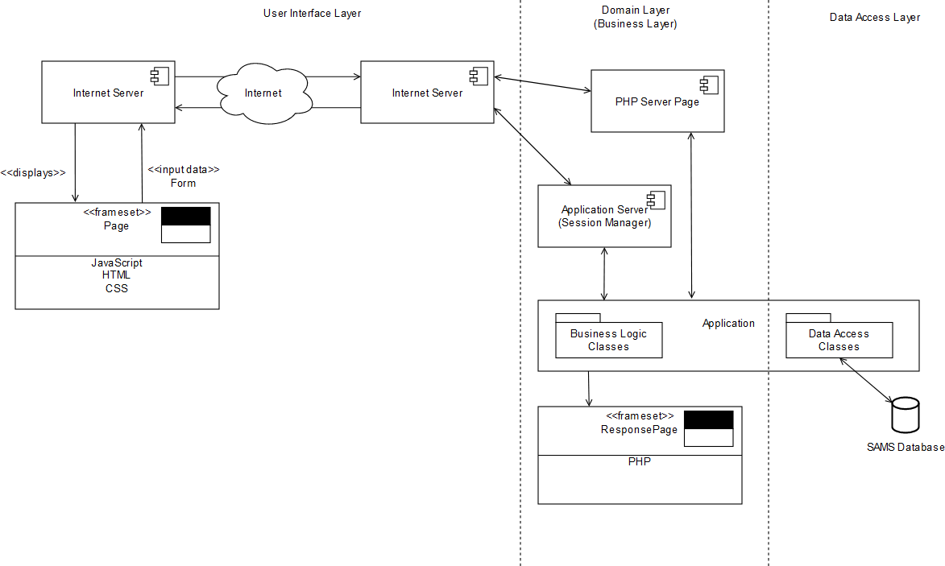

**CM000 Component Model of SAMS**

The diagram separated into three layers; The user interface layer, domain or business layer and data access layer. A stable internet connection is required to have a seamless experience when using SAMS. JavaScript, HTML and CSS is used for user interface layer. Combined, they make a user interface to display the system that the end-user can also interact with such as taking the input from the user. This input then get send to internet with internet server and end up in the domain layer. The input that the internet server sends then got separated into either PHP server page or Application Server. In application server the system is expected to run since the server provide the settings to run the application. As for the PHP server page, it is used for taking request from the user and then send it to the programs inside the application. PHP is used in the frameset or response page and acts to respond to any task that the user performs.

* 1. **Use Case Diagram**



**UCD000 Use Case Diagram of SAMS**

The figure above shows all of the functions that exist in the proposed system. Besides the use case and subsystems there are three users that directly involved in the system. The arrow shows users can only access certain functions. There are 17 use cases that divided into 5 subsystems. There are multiple use cases that included into another use case, this is because certain user like student can only access some of the original functions. The description on what the actors and use case’s role in the system will discussed in the next subchapter.

1. **Detailed Description of Components**
   1. **Complete Package Diagram**

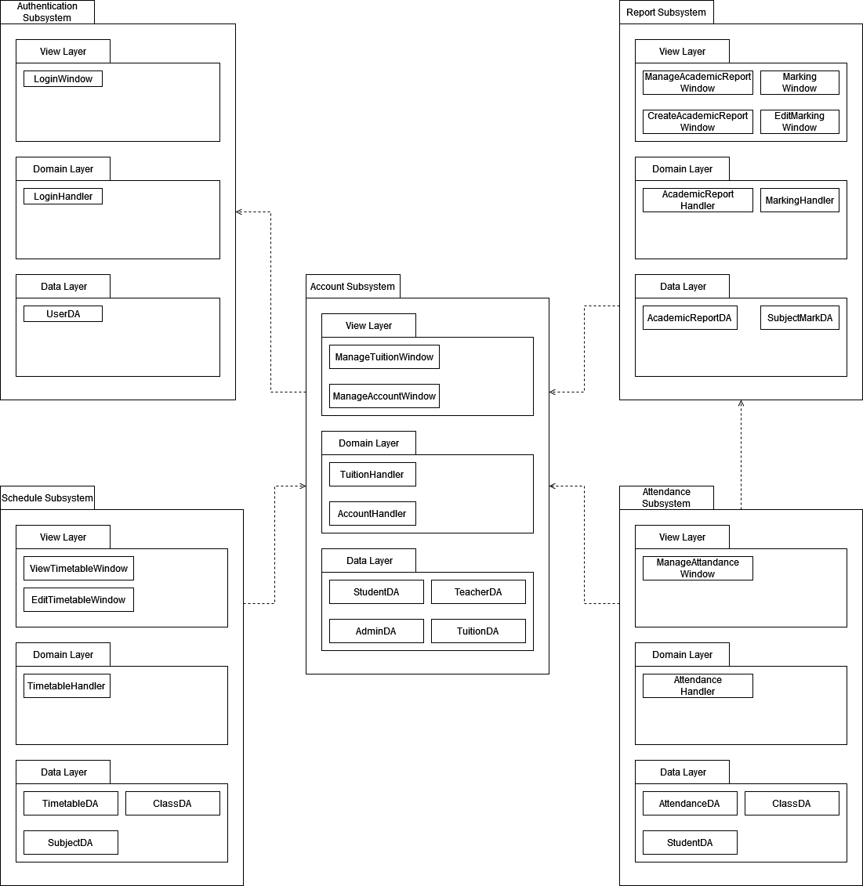

**CPD000 Complete Package Diagram of SAMS**

* 1. **Detailed Description**

Below is the detailed description of SAMS for each of the subsystems.

* + 1. **Subsystem Authentication**
       1. **P001: Package Authentication**

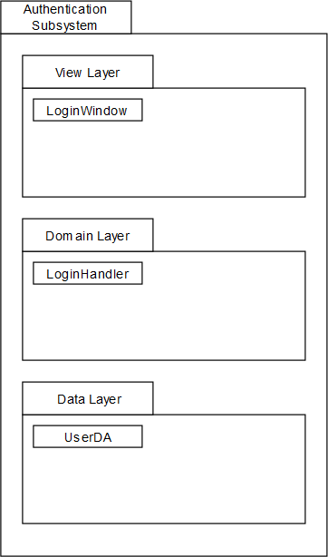

**PD001 Package Diagram of Authentication Subsystem**

* + - 1. **Class Diagram**

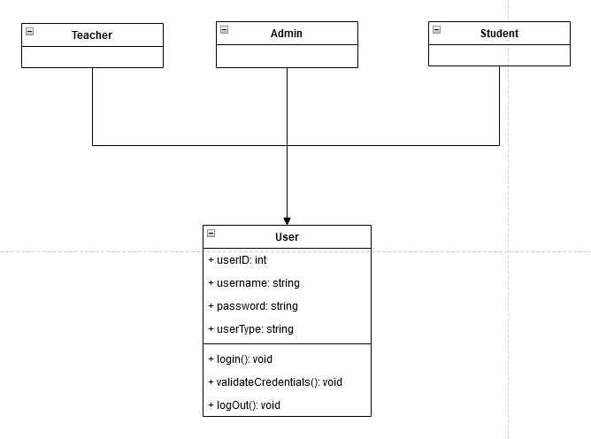

**CD001 Class diagram for Authentication Subsystem**

* + - 1. **Sequence Diagrams**

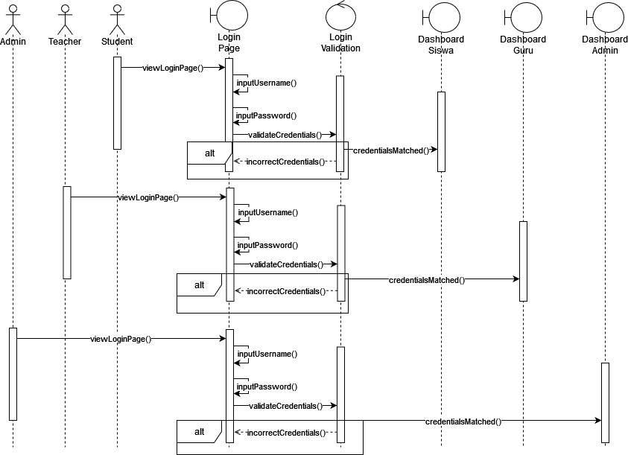

**SD001 Sequence Diagram of Sign In**

* + 1. **Subsystem Report**
       1. **P002: Package Report**

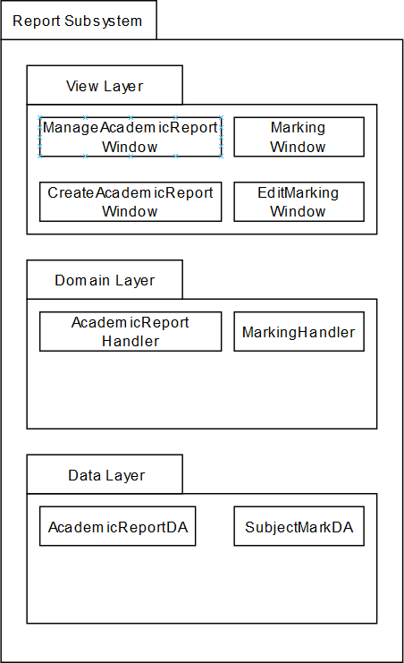

**PD002 Package Diagram of Report Subsystem**

* + - 1. **Class Diagram**

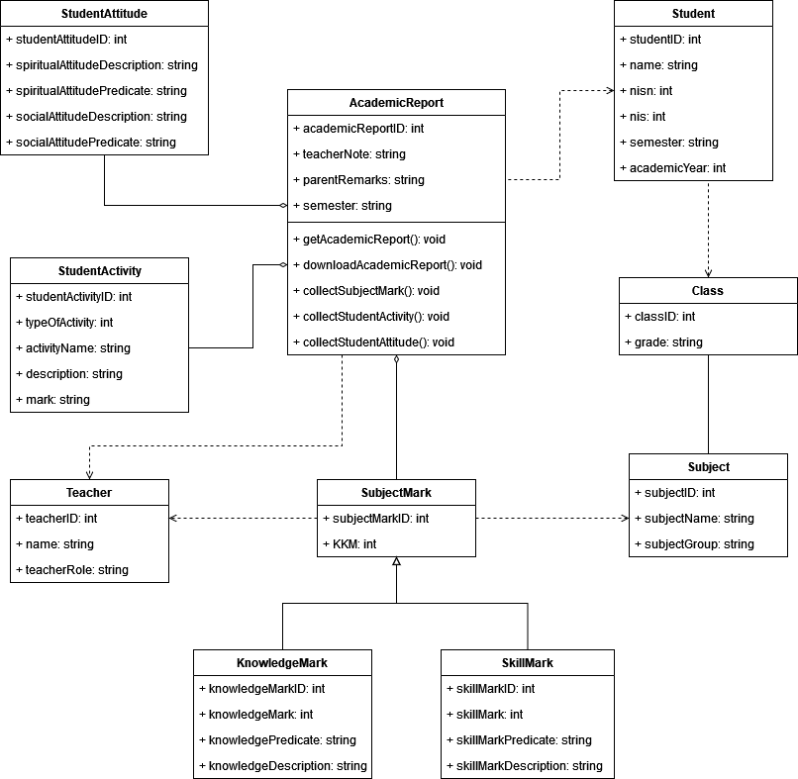

**CD002 Class Diagram for Report Subsystem**

* + - 1. **Sequence Diagrams**

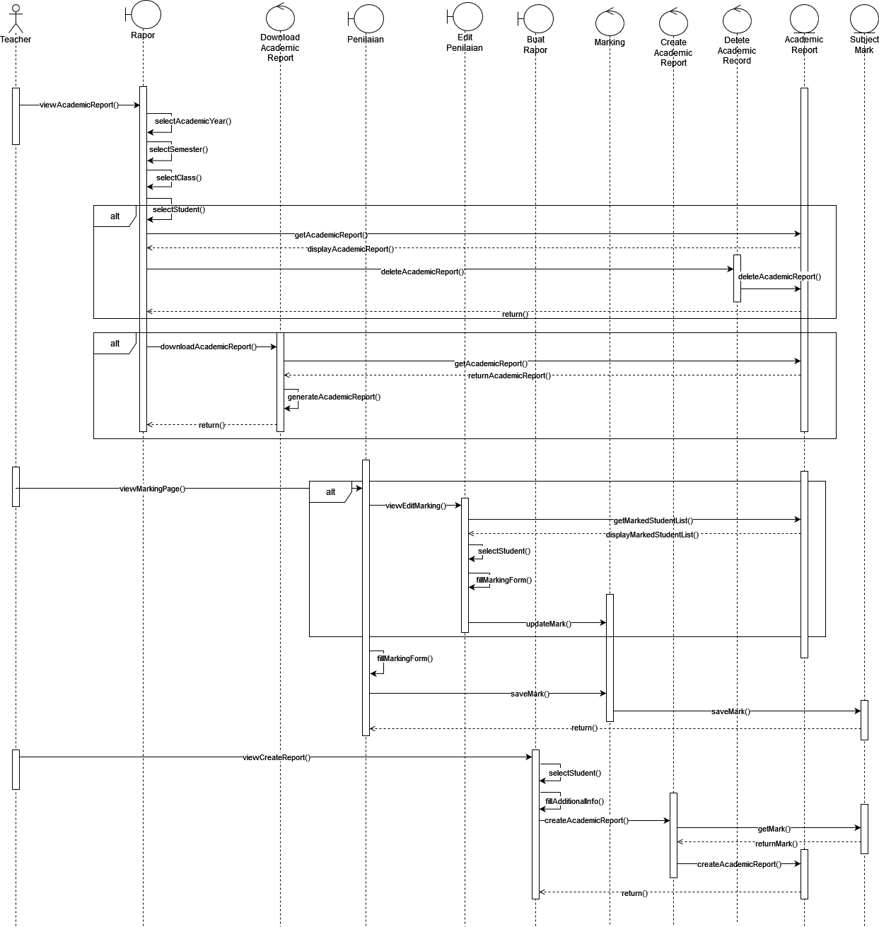

**SD002 Sequence Diagram of Manage Academic Report**

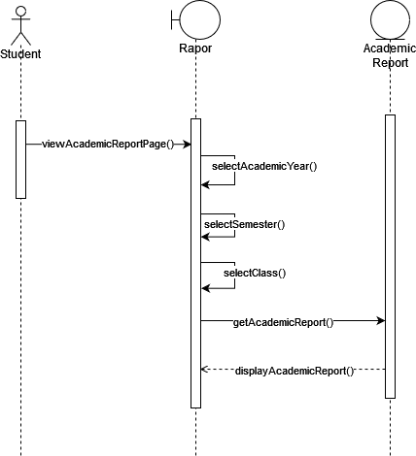

**SD003 Sequence Diagram of View Academic Report**

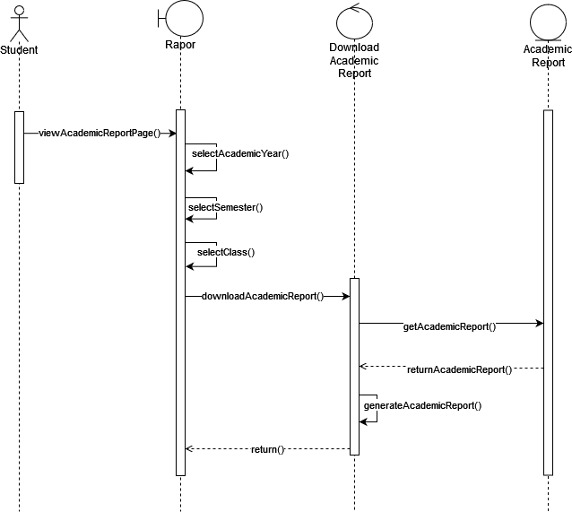

**SD004 Sequence Diagram of Download Academic Report**

* + 1. **Subsystem Attendance**
       1. **P003: Package Attendance**

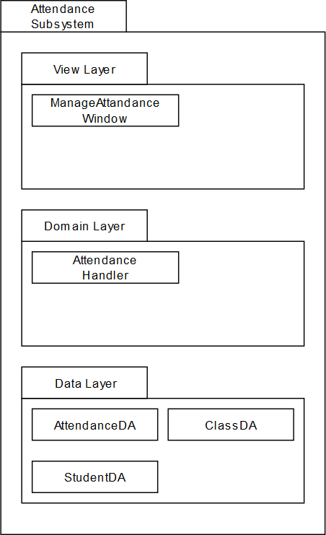

**PD003 Package Diagram of Attendance Subsystem**

* + - 1. **Class Diagram**

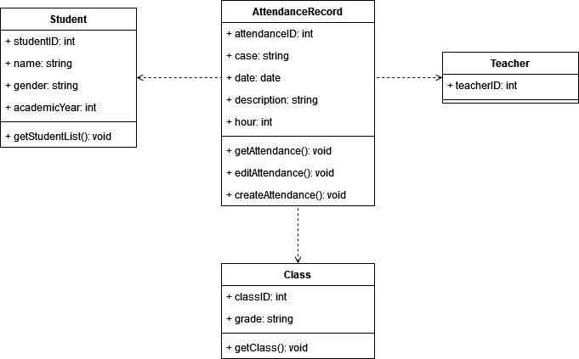

**CD003 Class Diagram for Attendance Subsystem**

* + - 1. **Sequence Diagrams**

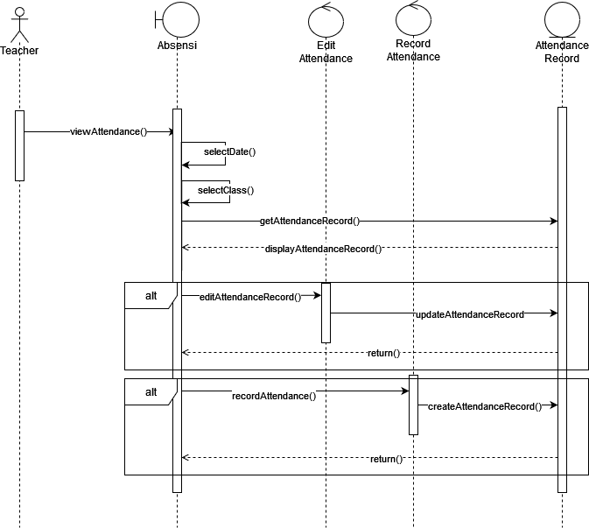

**SD005 Sequence Diagram of Manage Attendance Record**

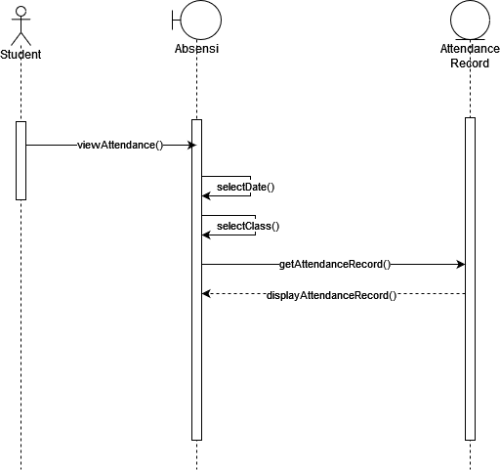

**SD006 Sequence Diagram of View Attendance Record**

* + 1. **Subsystem Schedule**
       1. **P004: Package Schedule**

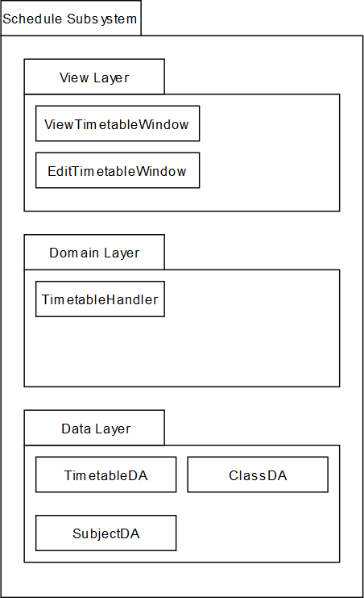

**PD004 Package Diagram of Schedule Subsystem**

* + - 1. **Class Diagram**

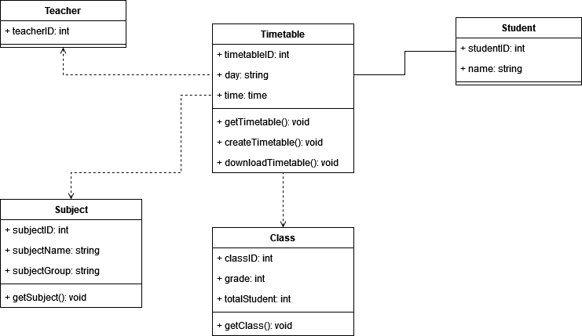

**CD004 Class Diagram for Schedule Subsystem**

* + - 1. **Sequence Diagrams**

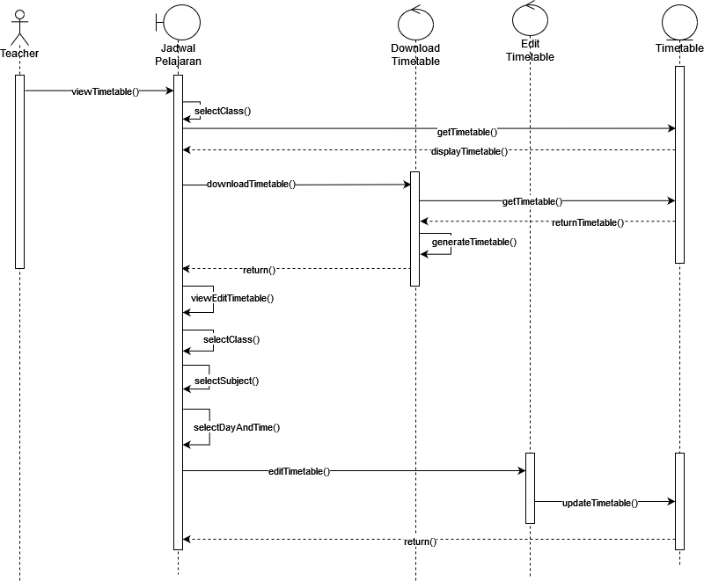

**SD007 Sequence Diagram of Manage Timetable**

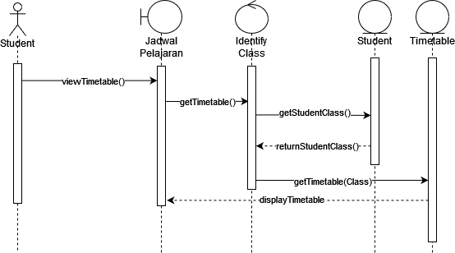

**SD008 Sequence Diagram of View Timetable**

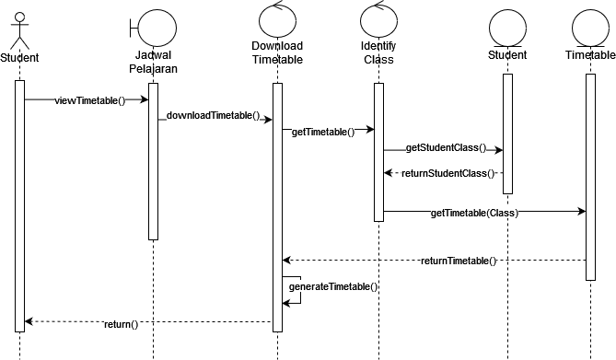

**SD009 Sequence Diagram of Download Timetable**

* + 1. **Subsystem Account**
       1. **P005: Package Account**

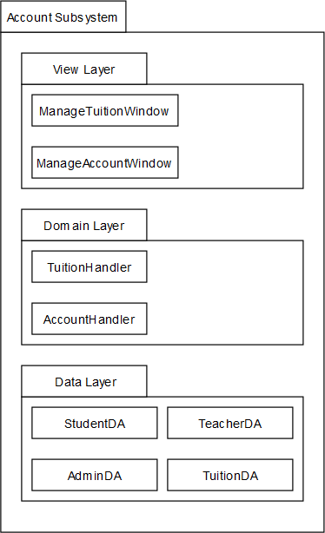

**PD005 Package Diagram of Account Subsystem**

* + - 1. **Class Diagram**

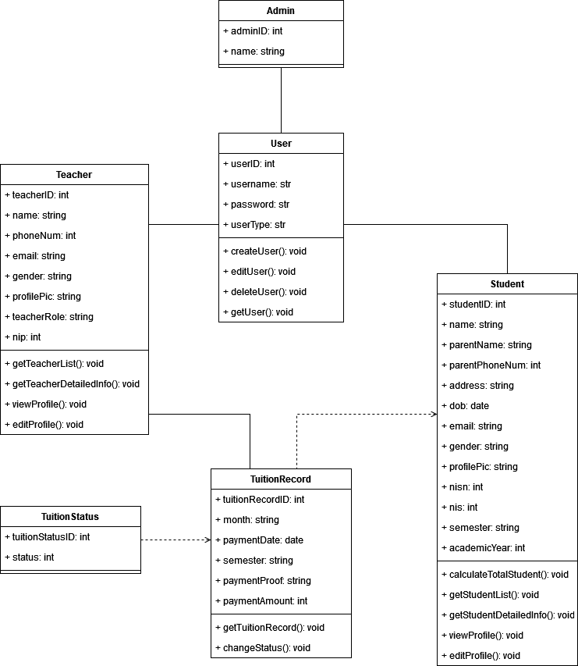

**CD005 Class Diagram for Account Subsystem**

* + - 1. **Sequence Diagrams**

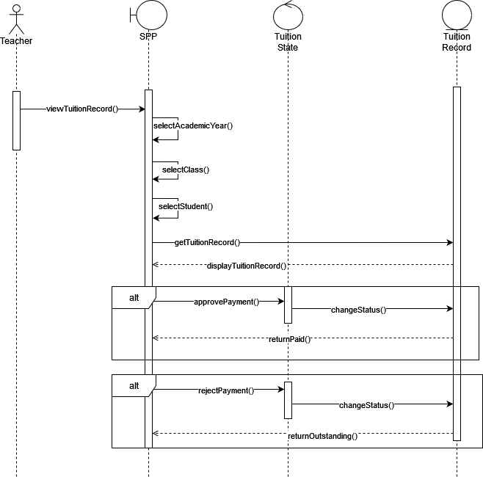

**SD010 Sequence Diagram of Manage Tuition Record**

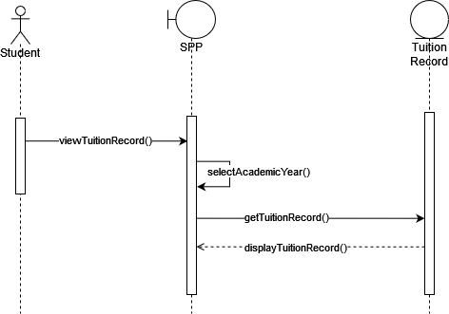

**SD011 Sequence Diagram of View Tuition Record**

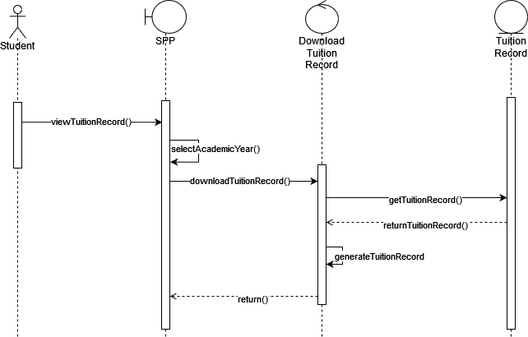

**SD012 Sequence Diagram of Download Tuition Record**

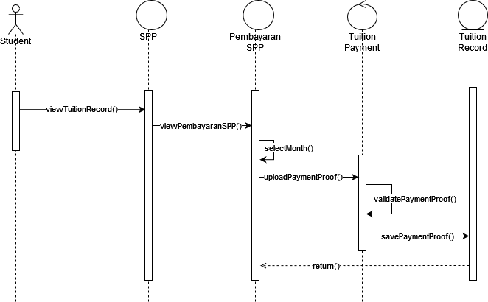

**SD013 Sequence Diagram of Make a Payment**

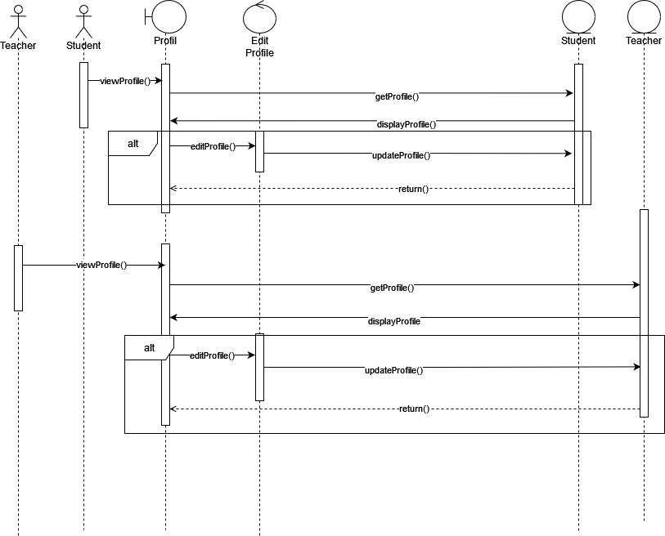

**SD014 Sequence Diagram of Manage Profile**

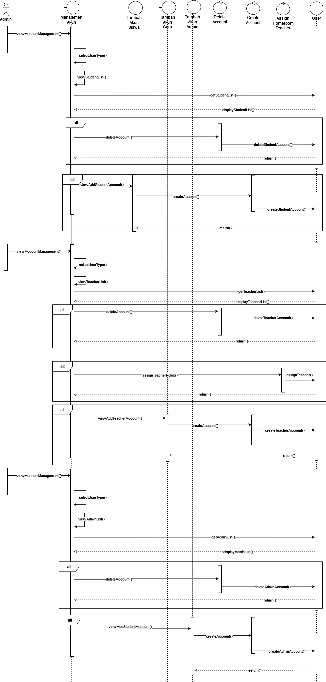

**SD015 Sequence Diagram of Manage User**

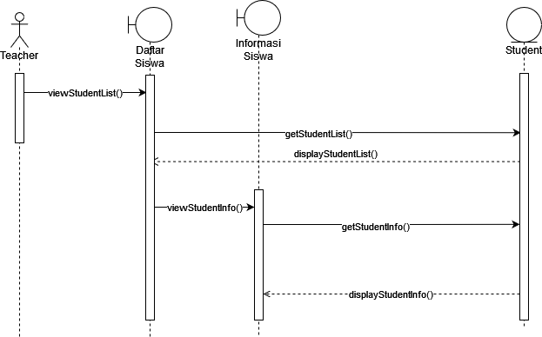

**SD0016 Sequence Diagram of View Student Info**

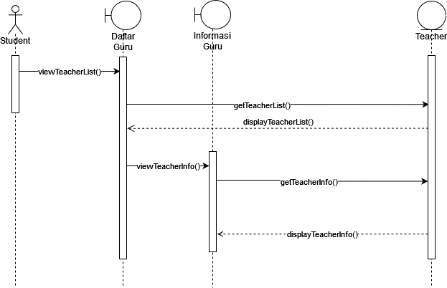

**SD0017 Sequence Diagram of View Teacher Info**

1. **Data Design**
   1. **Data Description**

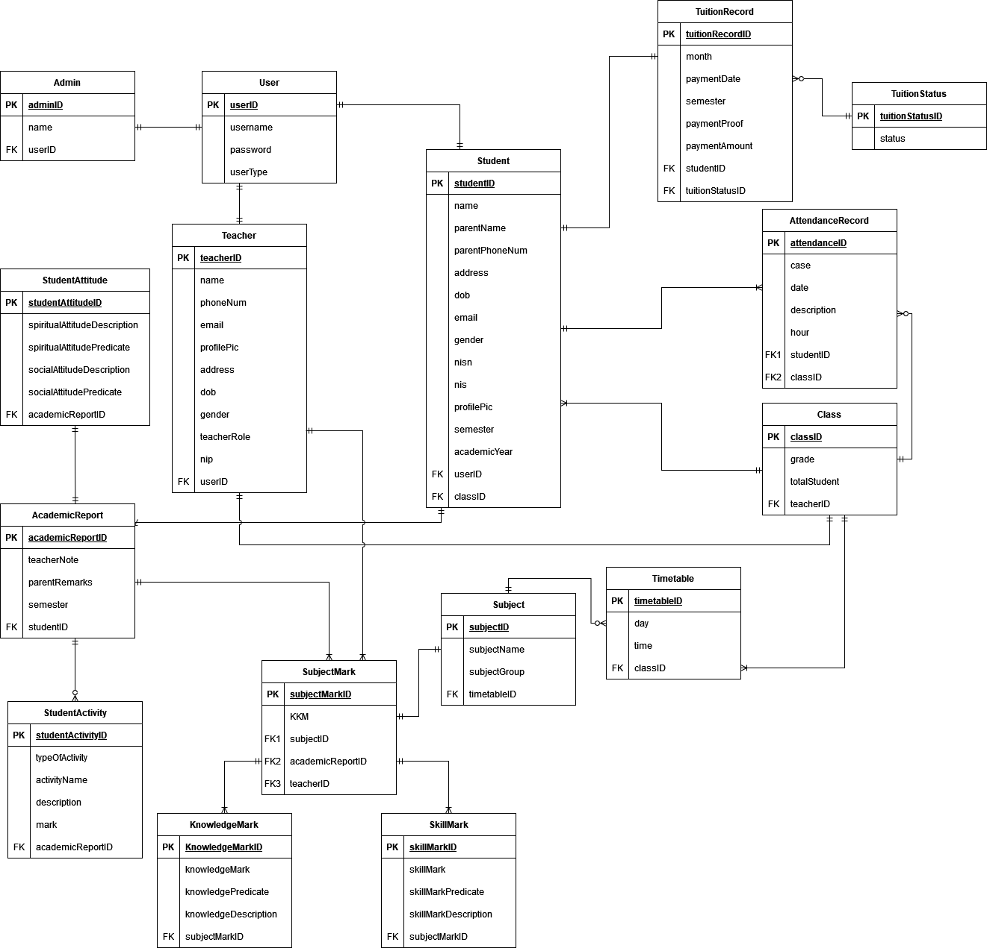

**ERD001 Entity Relationship Diagram of Student Academic Management System**

**Table 4.1 Data Description of Student Academic Management System**

|  |  |
| --- | --- |
| **Entity Name** | **Description** |

|  |  |
| --- | --- |
| User | This entity stores username and password of all users. It also stores the information about which user type is the account  (Admin, Teacher or Student) |
| Teacher | This entity stores all of the teacher user data. They consist of several personal information and also some information that can be showed when the student views the teacher list and their  detailed information. |
| Student | This entity stores all of the student user data. They consist of several personal information and also some information that can be showed when teacher view the student list and their  detailed information. |
| Admin | This entity stores all of the admin user data. |
| TuitionRecord | This entity stores the tuition record data that is important in managing the tuition record. It holds data such as the month that need to be paid, the payment date, proof and amount when  student paid their tuition. |
| TuitionStatus | This entity stores the status of tuition payment. Teacher can  either approved or disapprove it after checking the proof image. |
| AttendanceRecord | This entity stores the attendance data that will be filled when a teacher took an attendance. The student can also view the  attendance data of their own within a range of dates. |
| Class | This entity stores all the data of classrooms. They mainly consist of every classroom that exist in the school with grade as the classifier. It also stores total student of that certain  classroom. |
| Timetable | This entity stores the timetable data. The data stored here is used to view the timetable by student or teacher. The assigned homeroom teacher will fill their classroom timetable using day  time and the subject and it will be automatically generated. |
| Subject | This entity stores the subject data. It consists of every subject  in the school and will likely never change since adding a new |

|  |  |
| --- | --- |
|  | subject is a rare occasion. So, the data here is already exist  beforehand |
| SubjectMark | This entity stores the subject’s mark data. The mark for the subject is separated into two types of marks then will collected by this entity to combine then when creating academic report  later |
| KnowledgeMark | This entity stores the knowledge type mark of a subject. It consists of the mark itself, the predicate in which has a range from the best “A” to the worst “D”. It also contains the description from the teacher of how well the students did in  their subject. |
| SkillMark | This entity stores the knowledge type mark of a subject. It consists of the mark itself, the predicate in which has a range from the best “A” to the worst “D”. It also contains the description from the teacher of how well the students did in  their subject. |
| AcademicReport | This entity stores the academic report data that will be created by assigned homeroom teacher when the recap day has begun. It will collect all of the marks, activity, attitude and some student’s information which then will generate the final report  of that semester. The |
| StudentAttitude | This entity stores the student’s attitude data. The homeroom teacher can input the student’s attitude during the semester  either in spiritual aspect or social aspect |
| StudentActivity | This entity stores the student’s activity data. The homeroom  teacher can input the student’s activity during the semester either extracurricular or any achievement they got. |

* 1. **Data Dictionary**

|  |  |  |  |
| --- | --- | --- | --- |
| Teacher Table | | | |
| Field Name | Datatype | Constraint | Description |
| teacherID | BIGINT | Primary Key | Unique ID of the Teacher Table |
| name | CHAR | not null | Name of the Teacher |
| phoneNum | INT | not null | Phone number of the Teacher |
| email | VARCHAR | not null | Email of the Teacher |
| profilePic | VARCHAR | nullable | The url of the teacher profile picture |
| address | VARCHAR | not null | Address of the Teacher |
| dob | DATE | not null | Date of Birth of the Teacher |
| gender | CHAR | not null | Gender of the Teacher |
| teacherRole | CHAR | nullable | Signified the role of the teacher as a homeroom teacher of a class or not |
| nip | INT | not null | NIP of the Teacher |
| userID | BIGINT | Foreign Key | Unique ID of the User table |

|  |  |  |  |
| --- | --- | --- | --- |
| Student Table | | | |
| Field Name | Datatype | Constraint | Description |
| studentID | BIGINT | Primary Key | Unique ID of the Student table |
| name | CHAR | not null | name of the student |

|  |  |  |  |
| --- | --- | --- | --- |
| parentName | CHAR | not null | Student’s parent(s) name |
| parentPhoneNum | INT | not null | Student’s parent(s) phone number |
| address | VARCHAR | not null | Address of the student |
| dob | DATE | not null | Date of Birth of the student |
| email | VARCHAR | not null | Email of the student |
| gender | CHAR | not null | Gender of the student |
| nisn | INT | not null | “Nomor Induk Siswa Nasional” of the student |
| nis | INT | not null | “Nomor Induk Sekolah” of the student |
| profilePic | VARCHAR | nullable | The url of the teacher profile picture |
| semester | VARCHAR | not null | Current semester of the student |
| academicYear | INT | not null | Current academic year of the student |
| userID | BIGINT | Foreign Key | Unique ID of the User table |
| classID | BIGINT | Foreign Key | Unique ID of the Class table |

|  |  |  |  |
| --- | --- | --- | --- |
| User Table | | | |
| Field Name | Datatype | Constraint | Description |
| userID | BIGINT | Primary Key | Unique ID of the User table |
| username | VARCHAR | not null | username of the user |
| password | VARCHAR | not null | password of the user |

|  |  |  |  |
| --- | --- | --- | --- |
| Admin Table | | | |
| Field Name | Datatype | Constraint | Description |
| adminID | BIGINT | Primary Key | Unique ID of the Admin table |
| name | CHAR | not null | Name of the admin |
| userID | BIGINT | Foreign Key | Unique ID of the User table |

|  |  |  |  |
| --- | --- | --- | --- |
| TuitionRecord Table | | | |
| Field Name | Datatype | Constraint | Description |
| tuitionRecordID | BIGINT | Primary Key | Unique ID of the TuitionRecord table |
| month | TINYINT | not null | The month of the tuition to be paid |
| paymentDate | DATE | not null | Payment date for the tuition |
| semester | VARCHAR | not null | Semester of the tuition |
| paymentProof | VARCHAR | not null | The url of the uploaded image for the tuition’s proof of payment |
| paymentAmount | BIGINT | not null | The total amount of tuition that is needed to be paid |
| studentID | BIGINT | Foreign Key | Unique ID of the Student table |

|  |  |  |  |
| --- | --- | --- | --- |
| TuitionStatus Table | | | |
| Field Name | Datatype | Constraint | Description |
| tuitionStatusID | BIGINT | Primary Key | Unique ID of the TuitionStatus table |

|  |  |  |  |
| --- | --- | --- | --- |
| status | CHAR | not null | The status of approval for the tuition payment |

|  |  |  |  |
| --- | --- | --- | --- |
| AttendanceRecord Table | | | |
| Field Name | Datatype | Constraint | Description |
| attendanceID | BIGINT | Primary Key | Unique ID of the Attendance table |
| case | CHAR | not null | Case of attendance (Present, Not Present without reason, Sick, Leave permission) |
| date | DATE | not null | Date of the attendance |
| description | TEXT | nullable | Detail on why the student did not attend the class |
| hour | INT | nullable | School’s hour that usually consist of up to 8 hours per day |
| studentID | BIGINT | Foreign Key | Unique ID of the Student table |
| classID | BIGINT | Foreign Key | Unique ID of the Class table |

|  |  |  |  |
| --- | --- | --- | --- |
| Class Table | | | |
| Field Name | Datatype | Constraint | Description |
| classID | BIGINT | Primary Key | Unique ID of the Class table |
| grade | VARCHAR | not null | Grade of the class |
| totalStudent | INT | not null | Total student in the class |
| teacherID | BIGINT | Foreign Key | Unique ID of the Teacher table |

|  |  |  |  |
| --- | --- | --- | --- |
| Timetable Table | | | |
| Field Name | Datatype | Constraint | Description |
| timetableID | BIGINT | Primary Key | Unique ID of the Timetable table |
| day | CHAR | not null | Day of the subject |
| time | TIME | not null | Time of the subject |
| classID | BIGINT | Foreign Key | Unique ID of the Class table |

|  |  |  |  |
| --- | --- | --- | --- |
| Subject Table | | | |
| Field Name | Datatype | Constraint | Description |
| subjectID | BIGINT | Primary Key | Unique ID of the Subject table |
| subjectName | VARCHAR | not null | Name of the subject |
| subjectGroup | CHAR | not null | Group of the subject |
| subjectScheduleID | BIGINT | Foreign Key | Unique ID of the SubjectSchedule table |

|  |  |  |  |
| --- | --- | --- | --- |
| SubjectMark Table | | | |
| Field Name | Datatype | Constraint | Description |
| subjectMarkID | BIGINT | Primary Key | Unique ID of the Subject Mark table |
| KKM | INT | not null | KKM (Kriteria Ketuntasan Minimal) or Minimum Completeness Criteria is set by the school to determine whether a student pass the subject or not |

|  |  |  |  |
| --- | --- | --- | --- |
| subjectID | BIGINT | Foreign Key | Unique ID of the Subject table |
| academicReportID | BIGINT | Foreign Key | Unique ID of the AcademicReport table |
| teacherID | BIGINT | Foreign Key | Unique ID of the Student table |

|  |  |  |  |
| --- | --- | --- | --- |
| SkillMark Table | | | |
| Field Name | Datatype | Constraint | Description |
| skillMarkID | BIGINT | Primary Key | Unique ID of the SkillMark table |
| skillMark | INT | not null | Skill Mark of a student for a subject |
| skillMarkPredicate | CHAR | not null | The predicate of the Skill mark that the student got for a subject |
| skillMarkDescription | TEXT | nullable | The Description of the Skill mark that the student got for a subject |
| subjectMarkID | BIGINT | Foreign Key | Unique ID of the SubjectMark table |

|  |  |  |  |
| --- | --- | --- | --- |
| KnowledgeMark table | | | |
| Field Name | Datatype | Constraint | Description |
| knowledgeMarkID | BIGINT | Primary Key | Unique ID of the KnowledgeMark table |

|  |  |  |  |
| --- | --- | --- | --- |
| knowledgeMark | INT | not null | Knowledge mark of a student for a subject |
| knowledgePredicate | CHAR | not null | The predicate of the knowledge mark that the student got for a subject |
| knowledgeDescription | TEXT | nullable | The Description of the knowledge mark that the student got for a subject |
| subjectMarkID | BIGINT | Foreign Key | Unique ID of the SubjectMark table |

|  |  |  |  |
| --- | --- | --- | --- |
| AcademicReport Table | | | |
| Field Name | Datatype | Constraint | Description |
| academicReportID | BIGINT | Primary Key | Unique ID of the AcademicReport table |
| teacherNote | TEXT | not null | Note from the teacher about the student |
| semester | VARCHAR | not null | The semester of the student |
| studentID | BIGINT | Foreign Key | Unique ID of the Student table |

|  |  |  |  |
| --- | --- | --- | --- |
| StudentActivity | | | |
| Field Name | Datatype | Constraint | Description |
| achievementID | BIGINT | Primary Key | Unique ID of the Achievement table |
| typeOfActivity | INT | nullable | Type of activity that the student got the achievement for |
| description | TEXT | nullable | Details of the achievement |

|  |  |  |  |
| --- | --- | --- | --- |
| mark | CHAR | nullable | The mark for the activity |
| academicReportID | BIGINT | Foreign Key | Unique ID of the AcademicReport table |

|  |  |  |  |
| --- | --- | --- | --- |
| StudentAttitude Table | | | |
| Field Name | Datatype | Constraint | Description |
| studentAttitudeID | BIGINT | Primary Key | Unique ID of the StudentAttitude table |
| spiritualAttitudeDescription | TEXT | not null | The description of the student’s spiritual attitude |
| spiritualAttitudePredicate | CHAR | not null | The predicate of the student’s spiritual attitude |
| socialAttitudeDescription | TEXT | not null | The description of the student’s social attitude |
| socialAttitudePredicate | CHAR | not null | The predicate of the student’s social attitude |
| academicReportID | BIGINT | Foreign Key | Unique ID of the AcademicReport table |

1. **User Interface Design**
   1. **Overview of User Interface**

Page navigation diagram is provided below to describe the flow of the user interface. There are three users/actors in the system which mean there will be three different dashboards for each user. The following figures are the page navigation design for teacher, student and admin.



Figure 5.1 Page Navigation for Teacher in SAMS

After entering the system successfully through login, the teacher will be redirect to their own dashboard. From this dashboard the teacher can access all kind of different functions from creating academic report page to managing their profile.



Figure 5.2: Page Navigation for Student in SAMS

After the student login into the system, they also welcomed with their own dashboard. From the dashboard the student can access manage profile page, teacher list page, timetable page, academic report page, tuition page and attendance page.



Figure 4.8: Page Navigation for Admin in SAMS

From the figure above, the admin can access to multiple pages after successfully enter the system. These pages are added teacher page, account management page, add student page and add admin page.

* 1. **Screen Images**
     1. **Login UI**



Figure 5.1: Login Page of SAMS

* + 1. 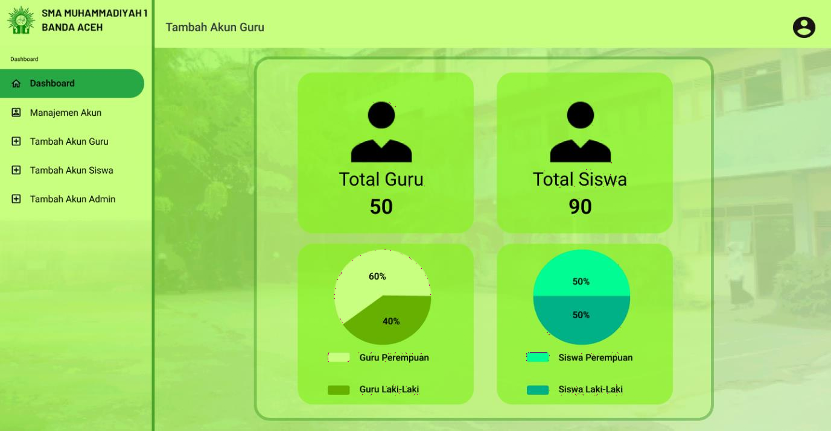**Admin UI**

Figure 5.2: Admin Dashboard of SAMS

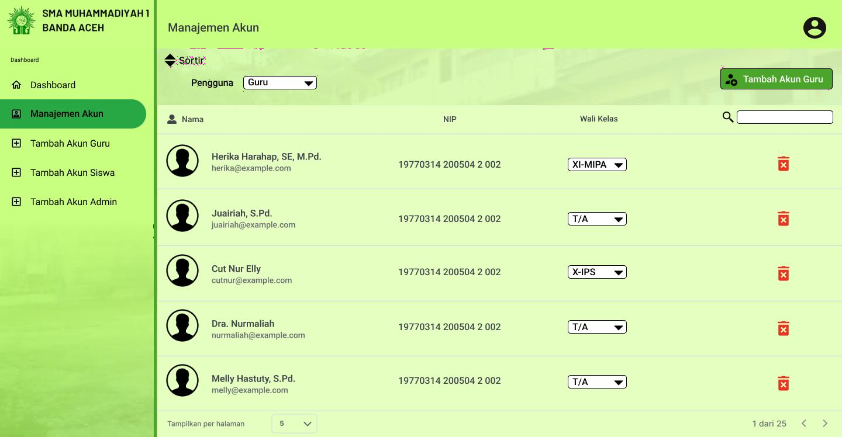

Figure 5.3: Teacher Account Management of SAMS

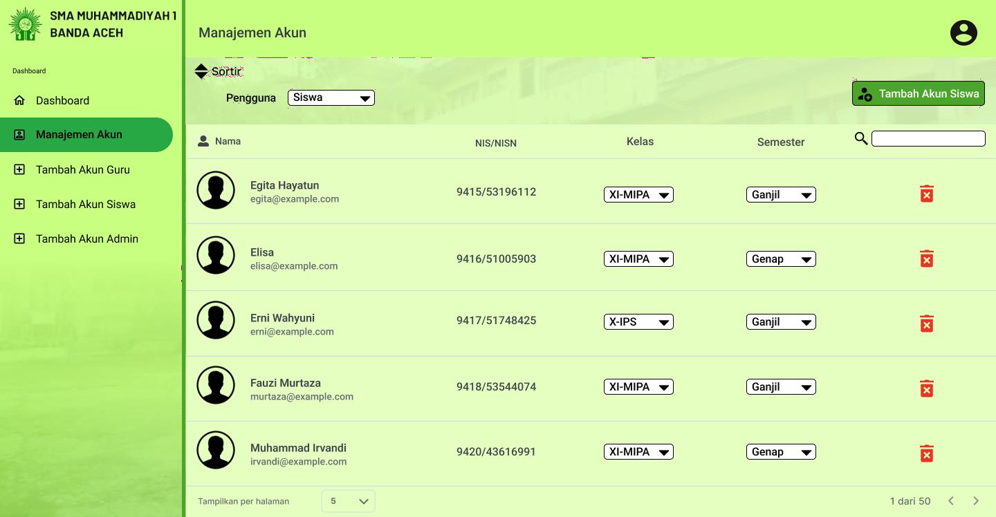

Figure 5.4: Student Account Management of SAMS

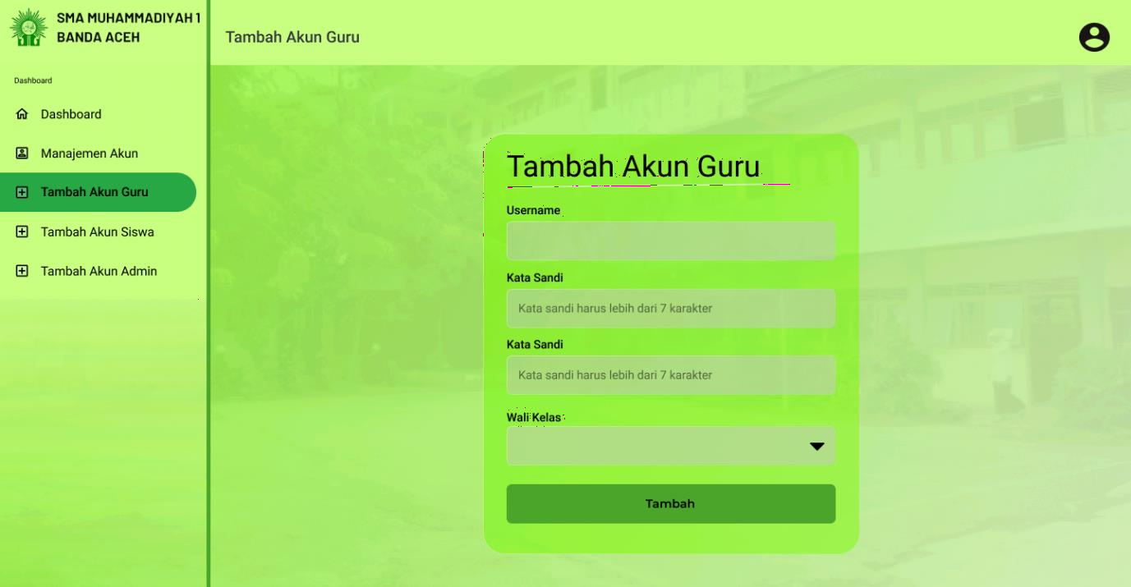

Figure 5.5: Add Teacher Account of SAMS

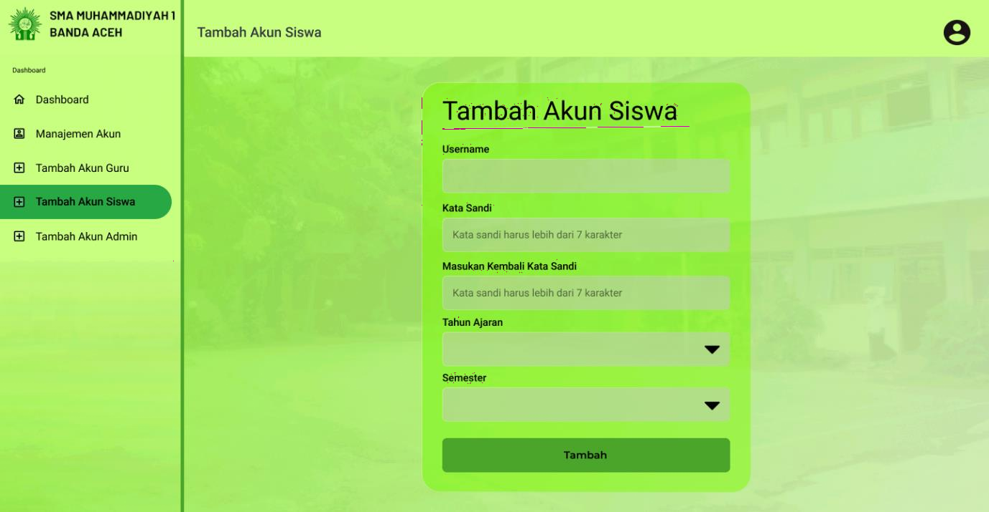

Figure 5.6: Add Student Account of SAMS

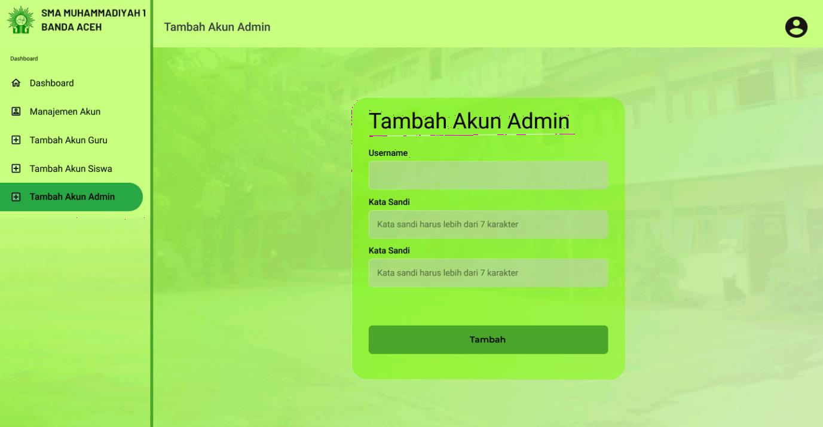

Figure 5.7: Add Admin Account of SAMS

* + 1. **Teacher UI**

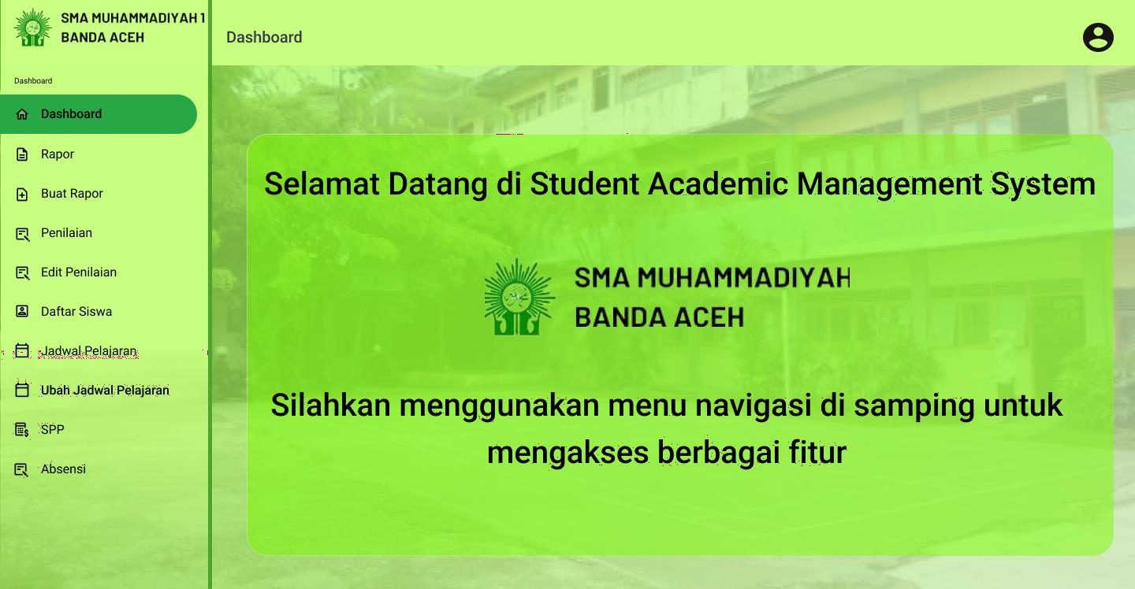

Figure 5.8: Teacher Dashboard of SAMS

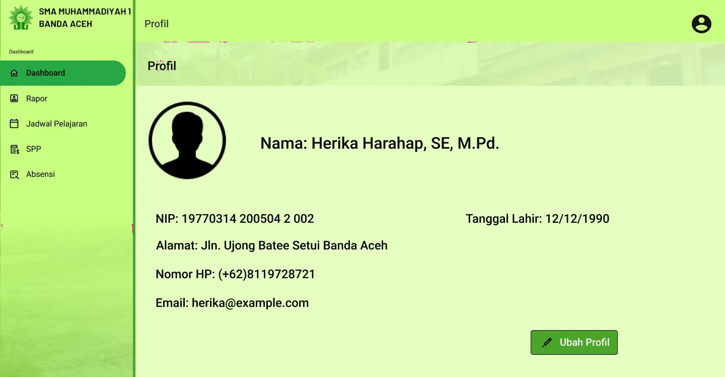

Figure 5.9: Manage Teacher Profile of SAMS

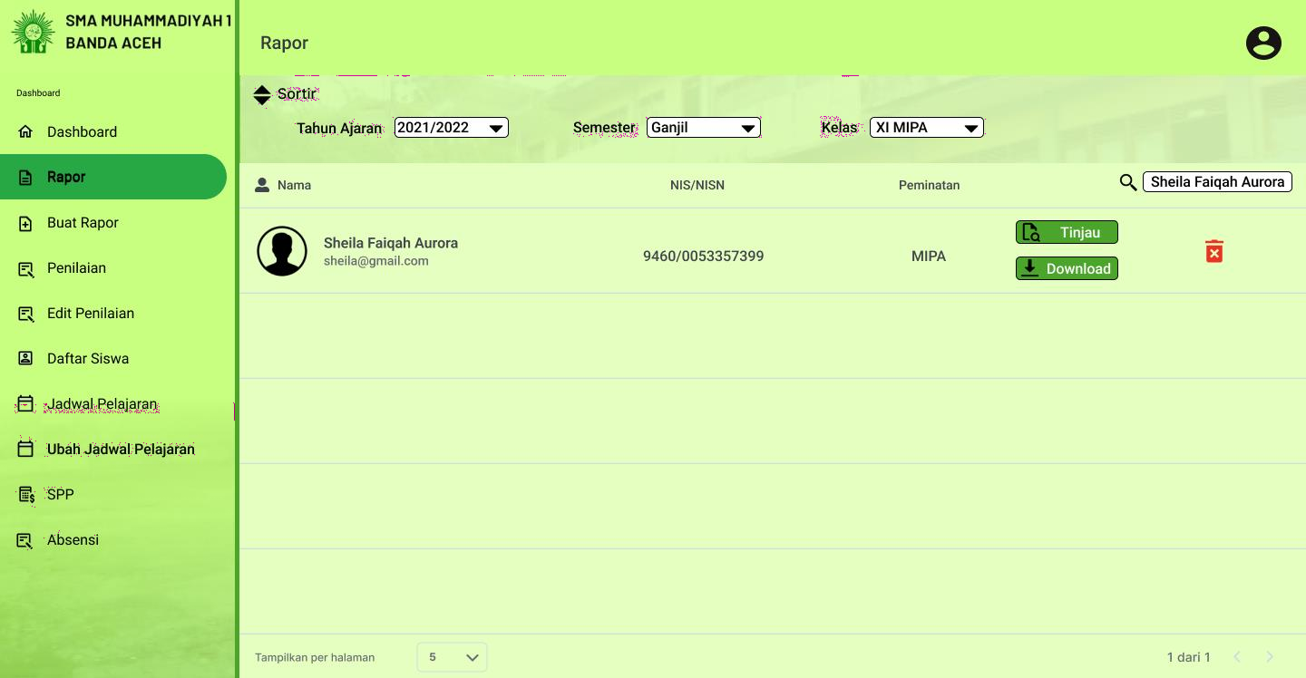

Figure 5.10: Manage Academic Report of SAMS

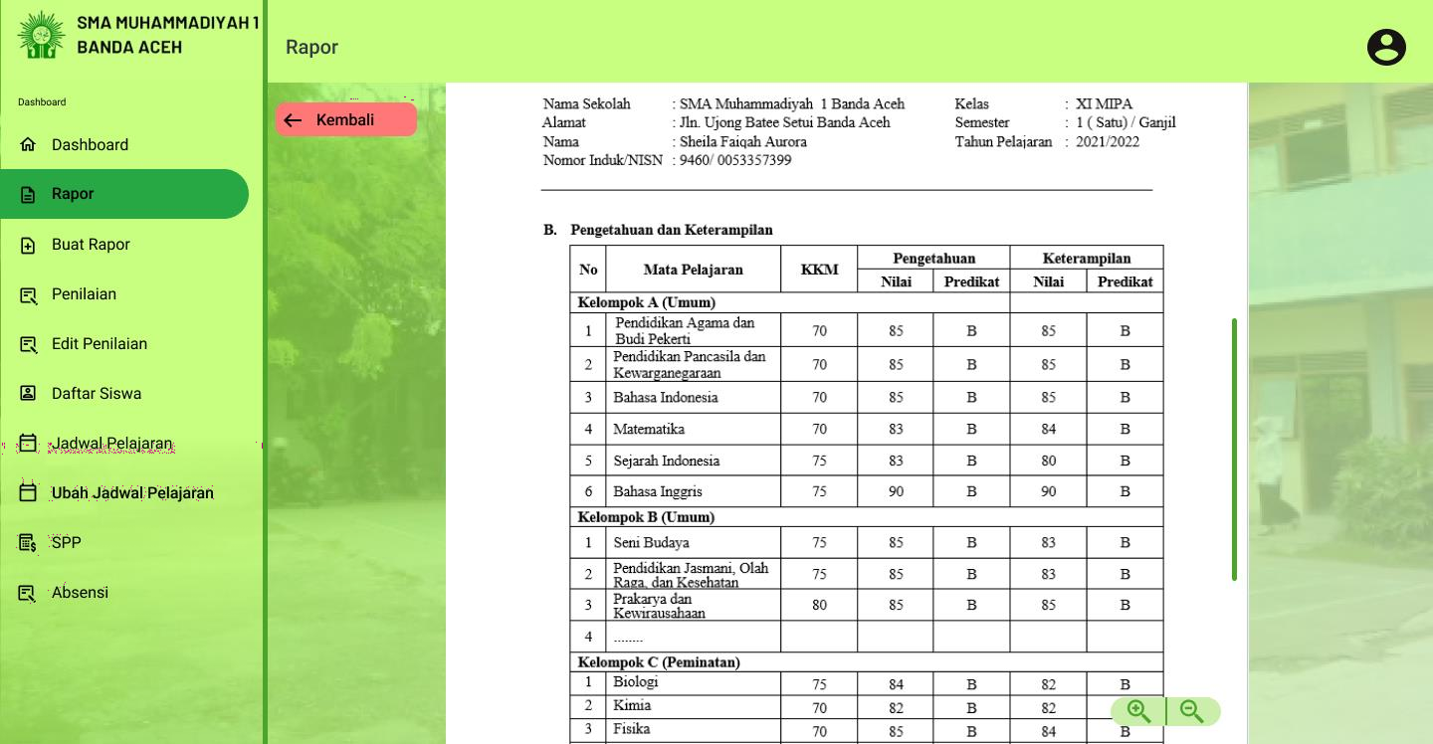

Figure 5.11: View Academic Report of SAMS

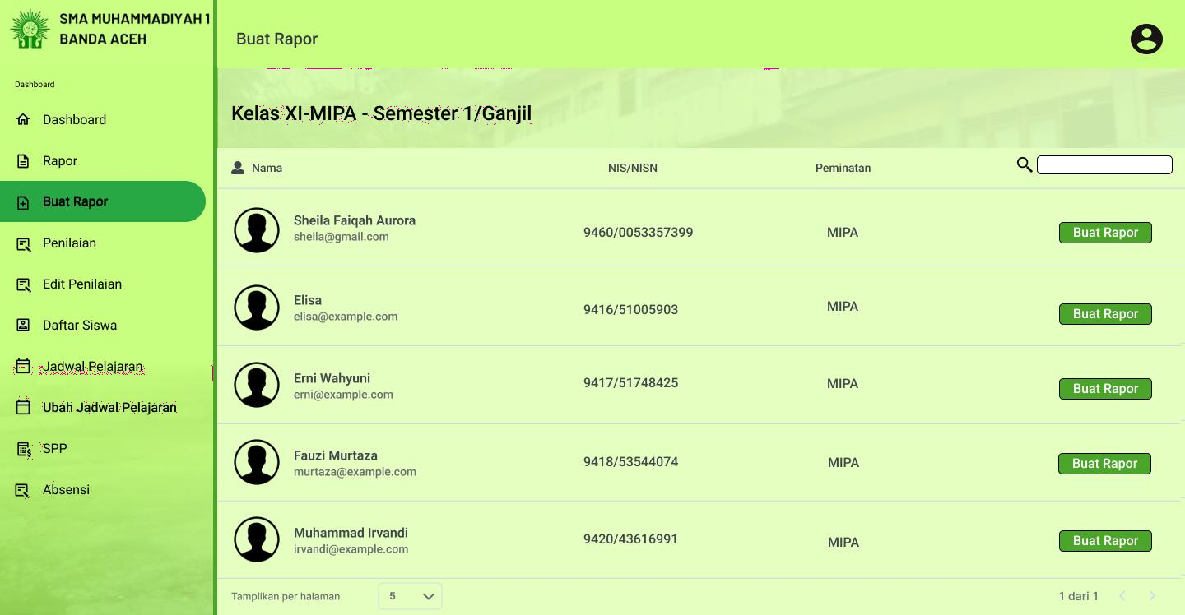

Figure 5.12: Create Academic Report of SAMS

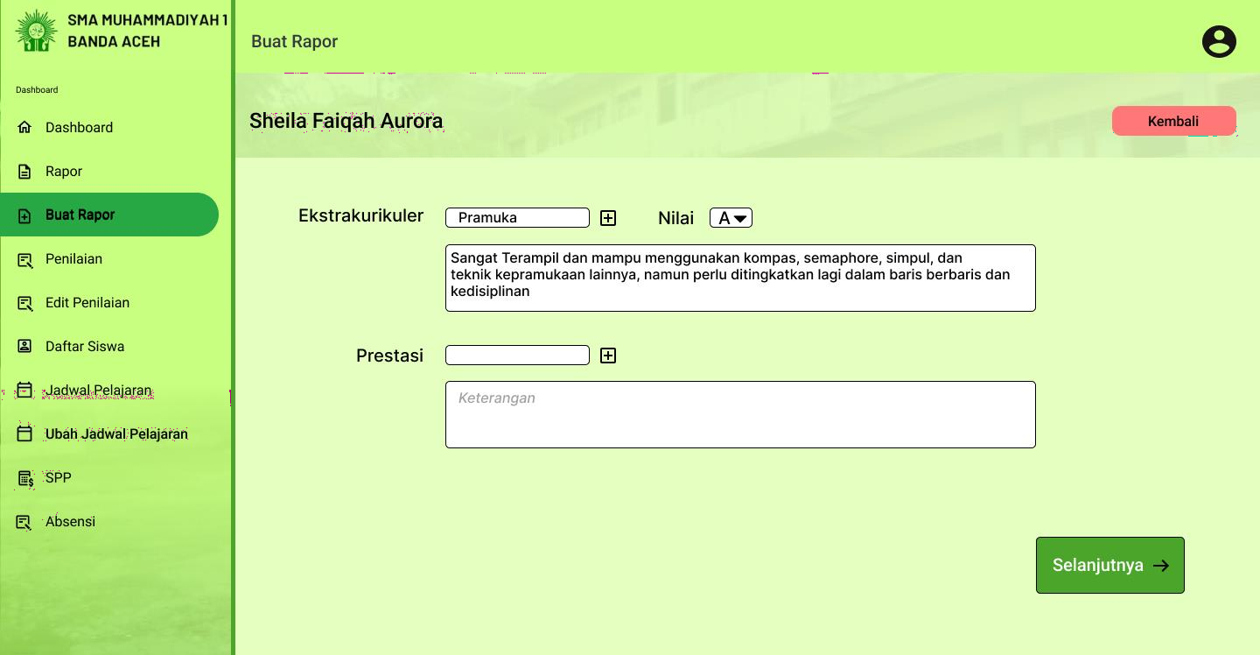

Figure 5.13: Form 1 for Create Academic Report of SAMS

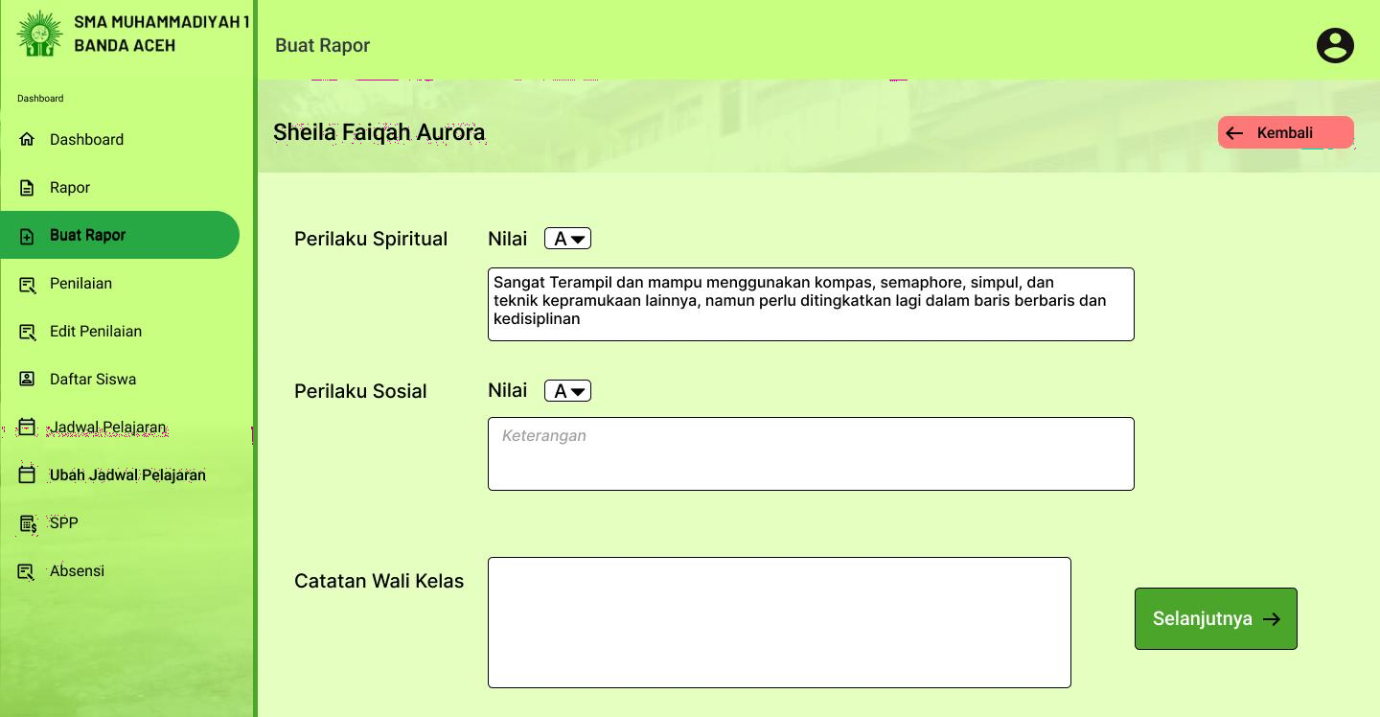

Figure 5.14: Form 2 for Create Academic Report of SAMS

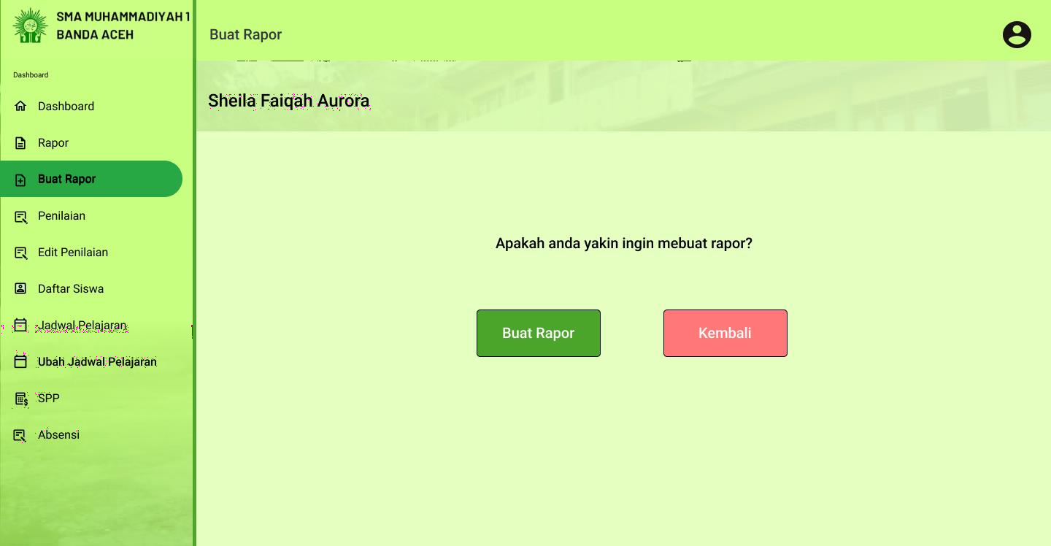

Figure 5.15: Confirmation for Create Academic Report of SAMS

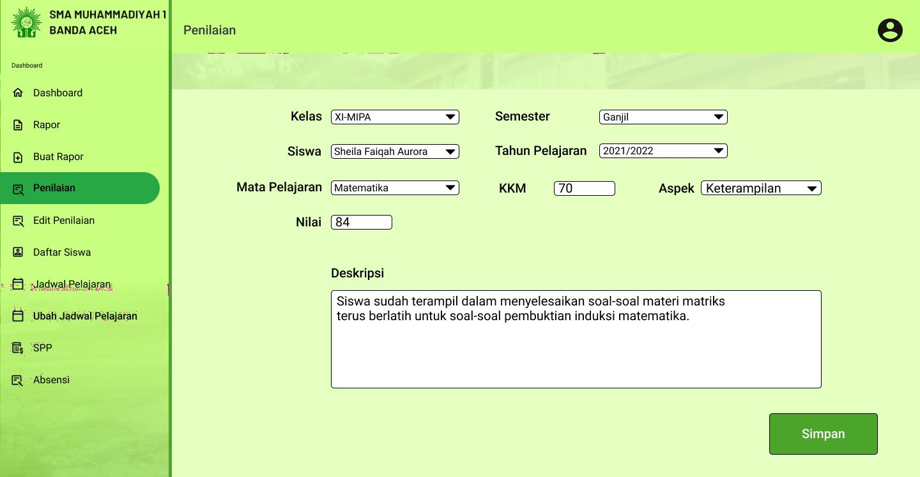

Figure 5.16: Marking of SAMS

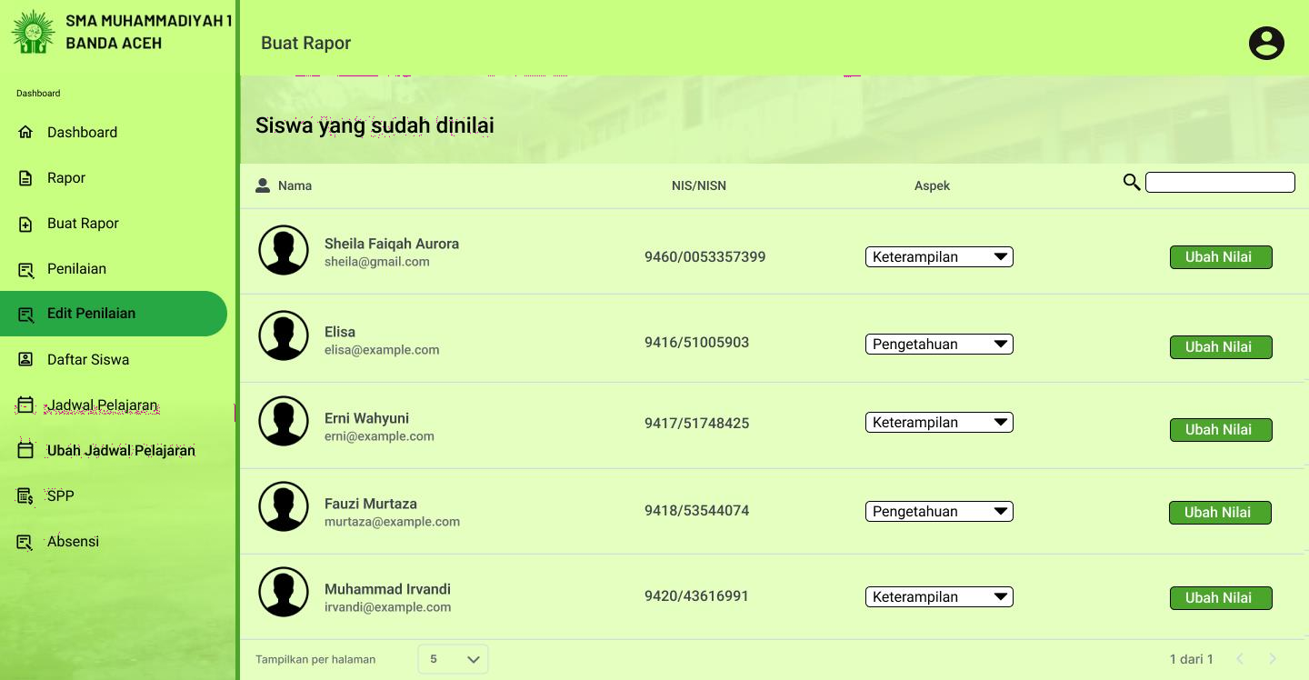

Figure 5.17: View Edit Marking of SAMS

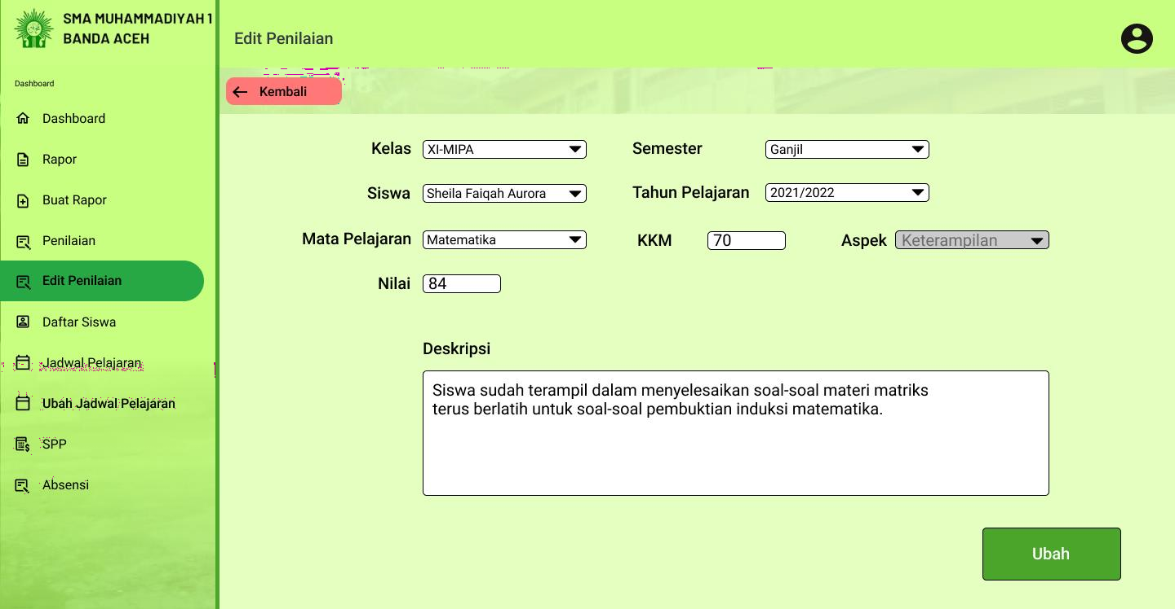

Figure 5.18: Edit Marking Form of SAMS

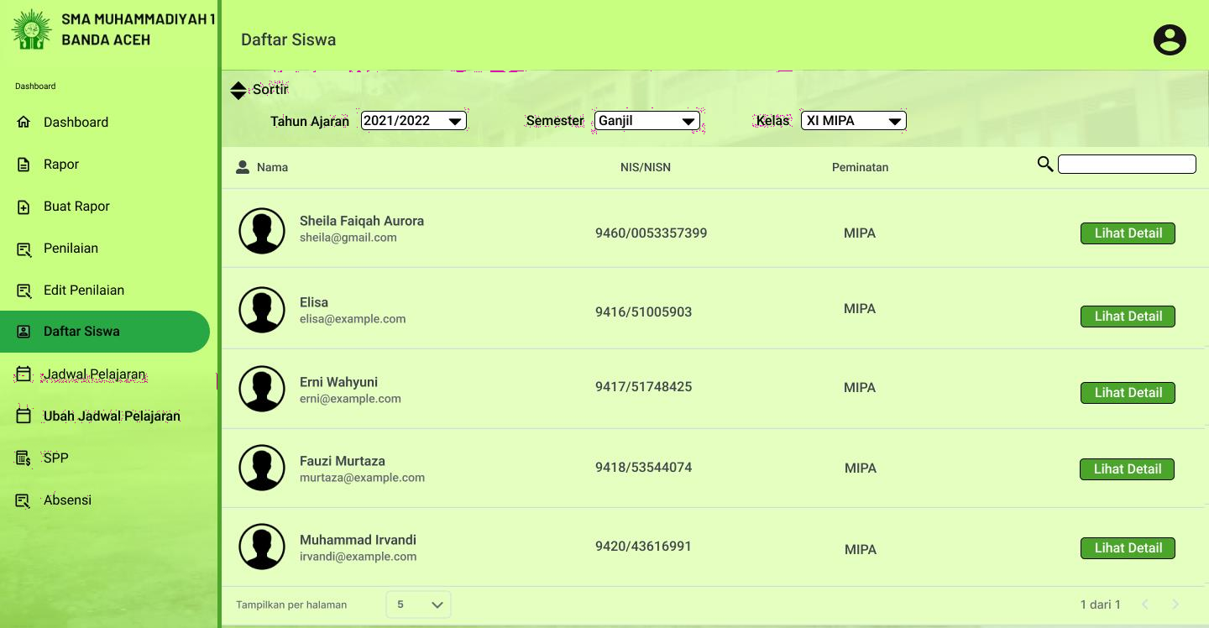

Figure 5.19: List of students of SAMS

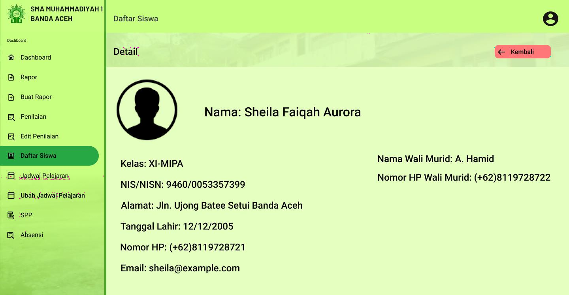

Figure 5.20: Detailed info of students of SAMS

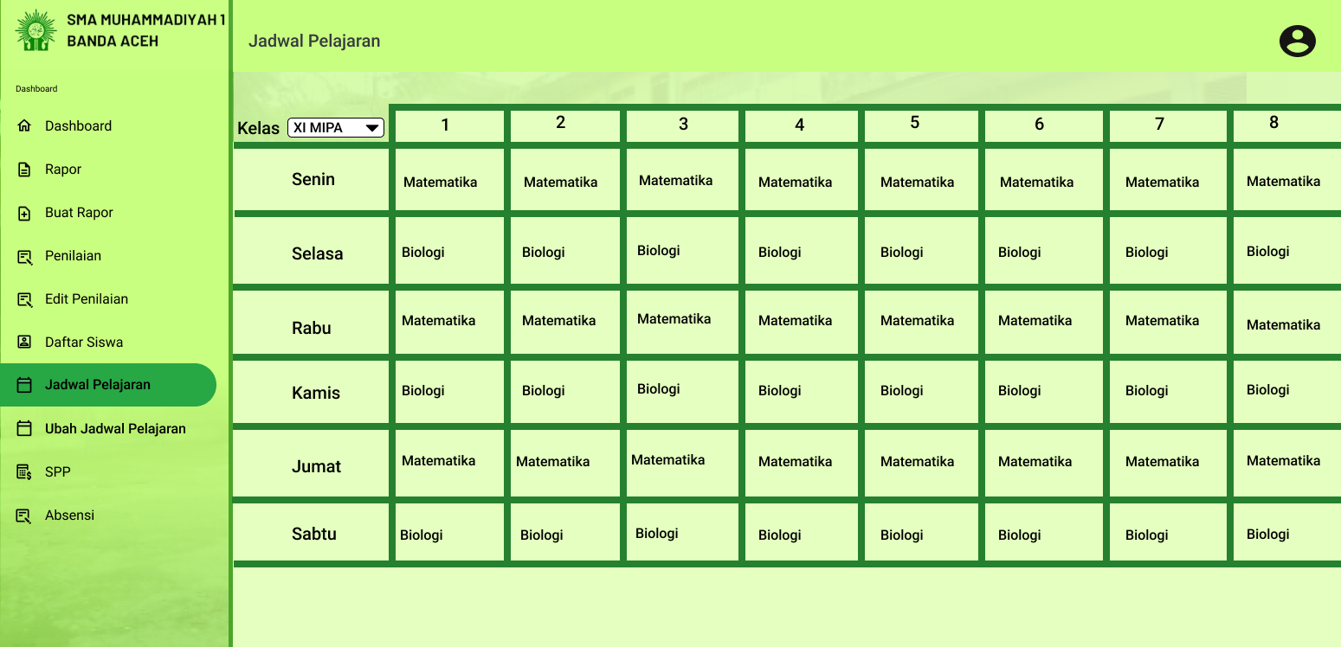

Figure 5.21: View timetable of SAMS

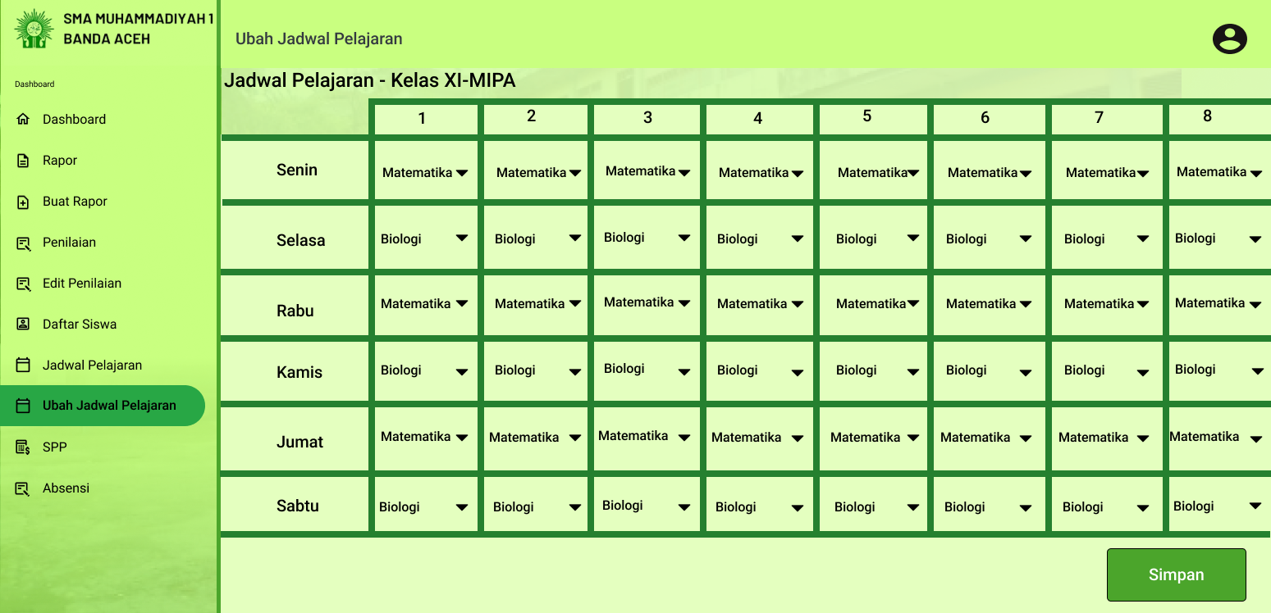

Figure 5.22: Edit timetable of SAMS

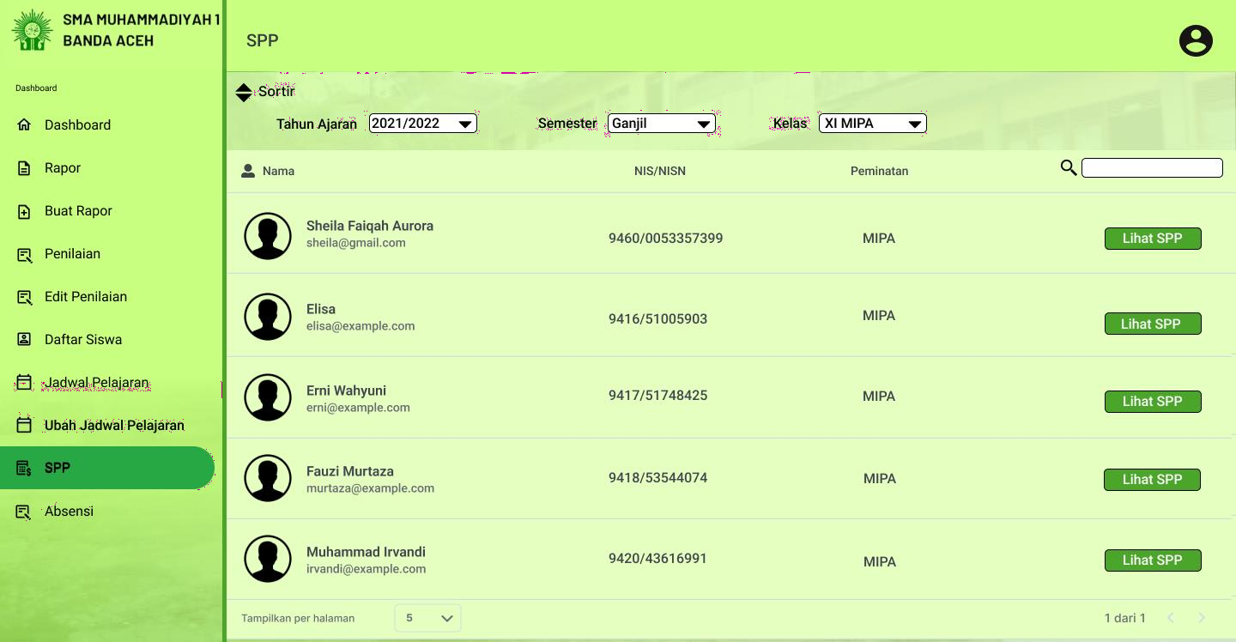

Figure 5.23: Manage tuition record of SAMS

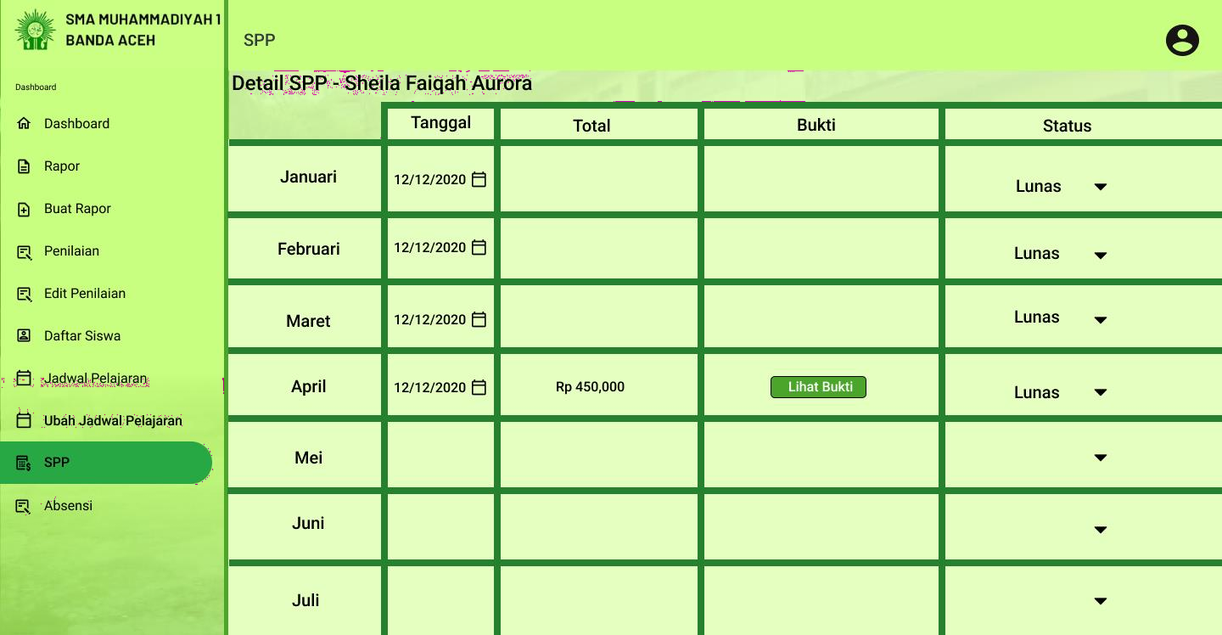

Figure 5.24: Change tuition status of SAMS

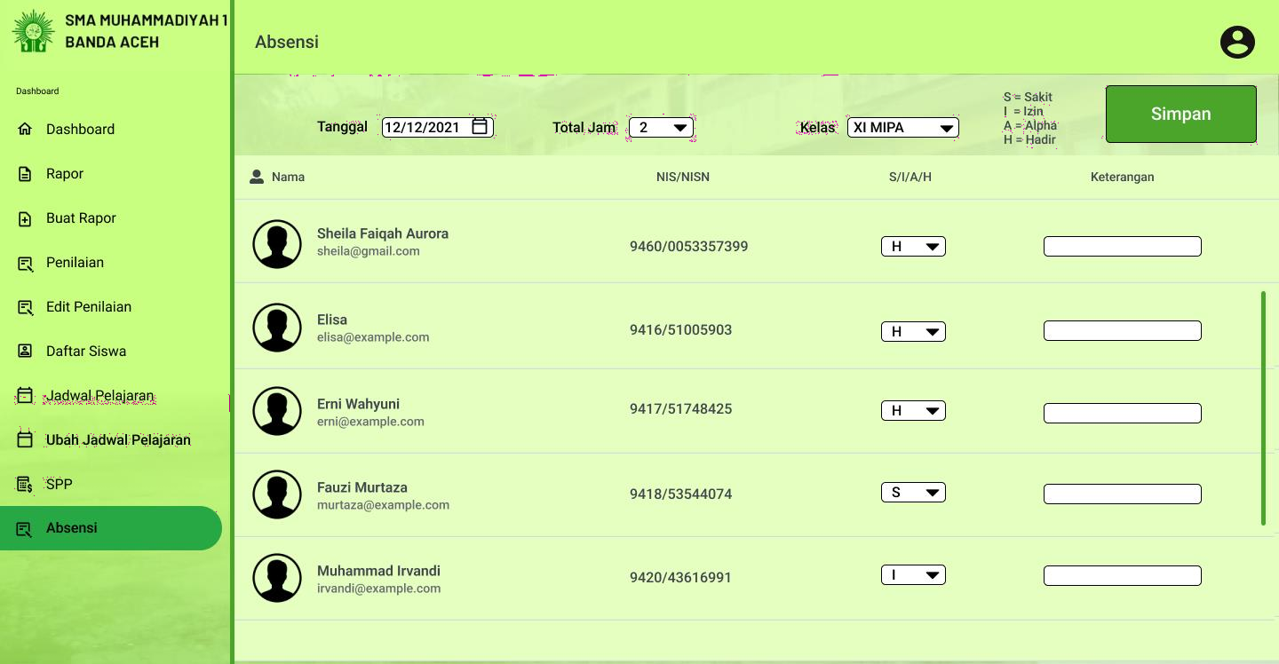

Figure 5.25: Record attendance of SAMS

* + 1. 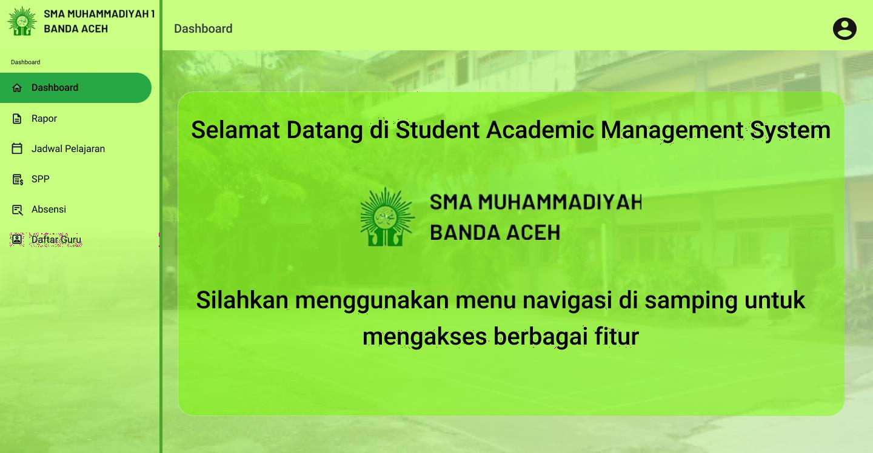**Student UI**

Figure 5.26: Student dashboard of SAMS

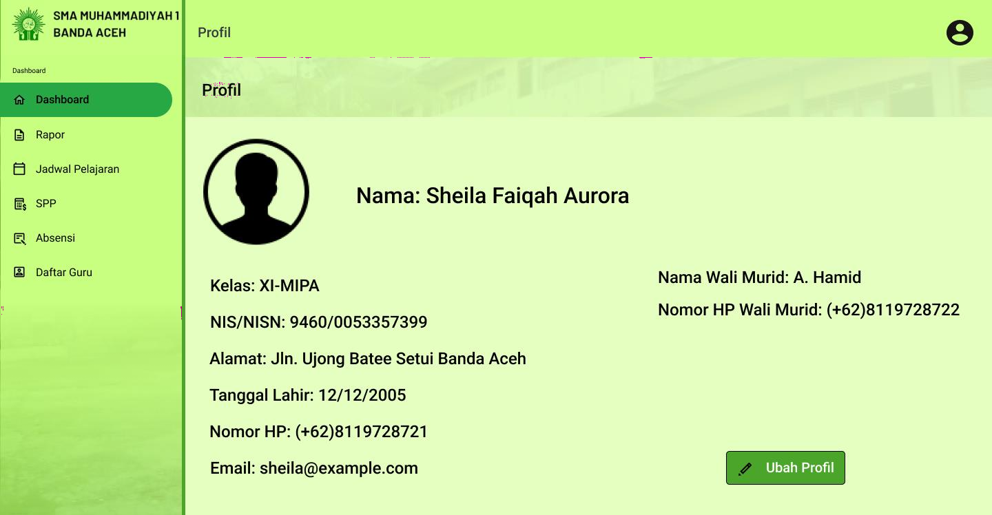

Figure 5.27: Manage student profile of SAMS

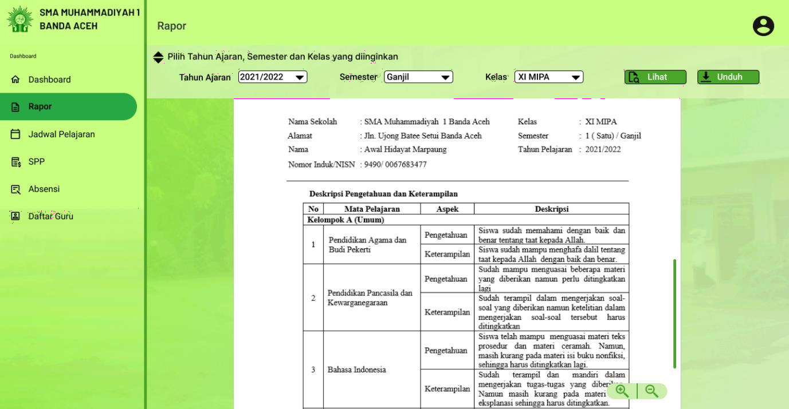

Figure 5.28: View academic report of SAMS

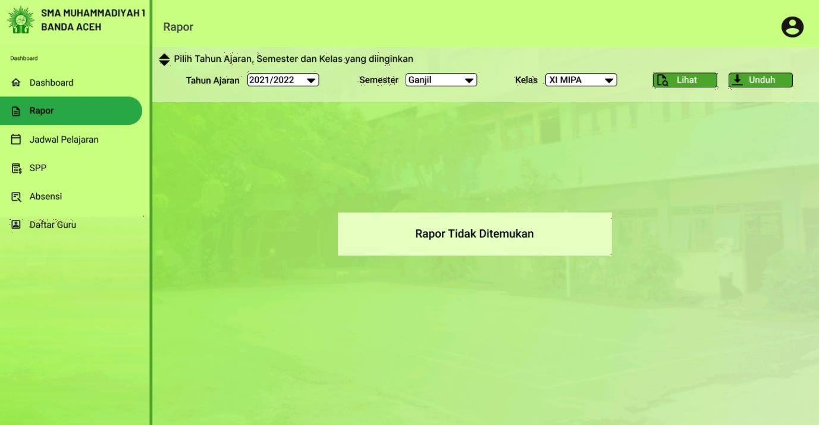

Figure 5.29: View academic report (when there is no academic report) of SAMS

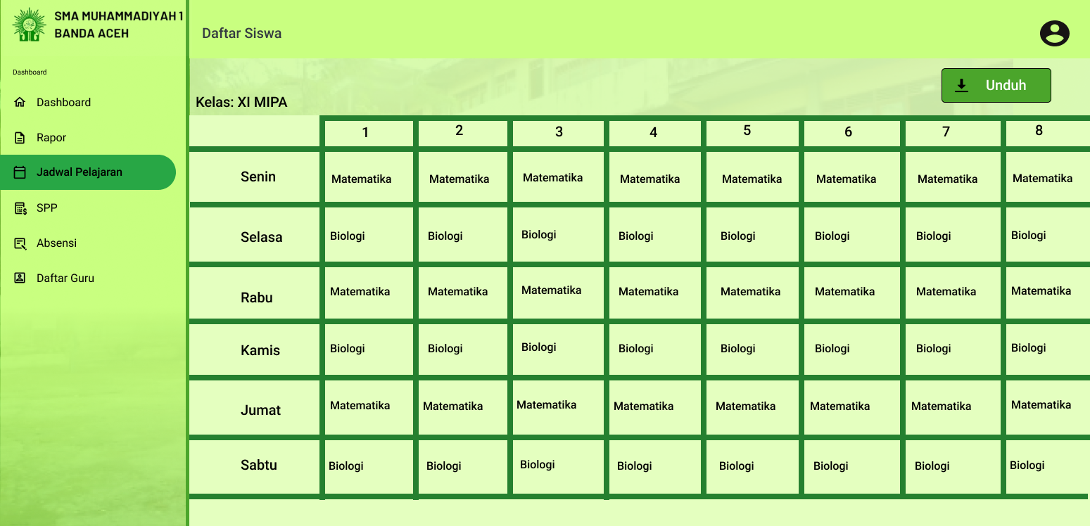

Figure 5.30: View timetable of SAMS

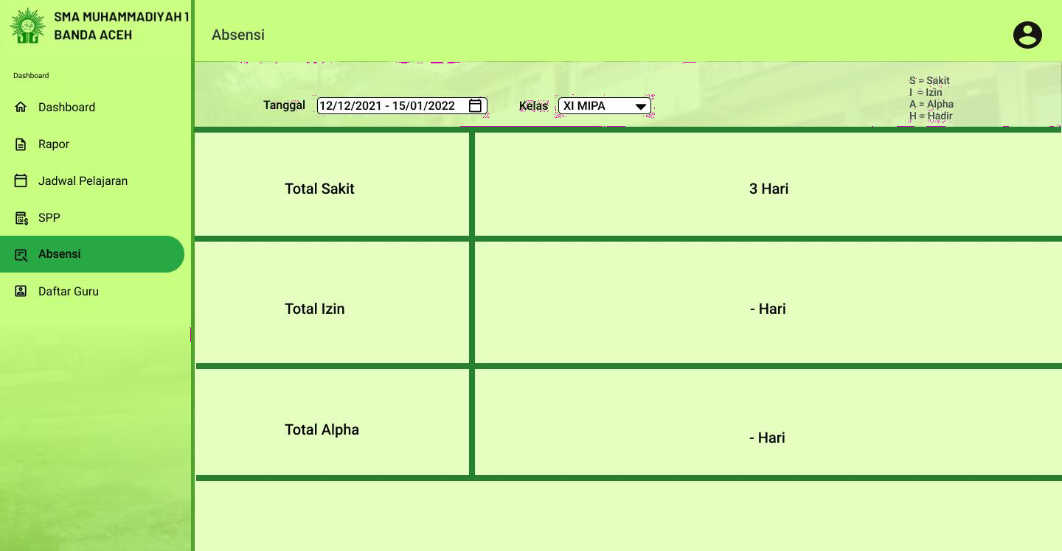

Figure 5.31: View attendance of SAMS

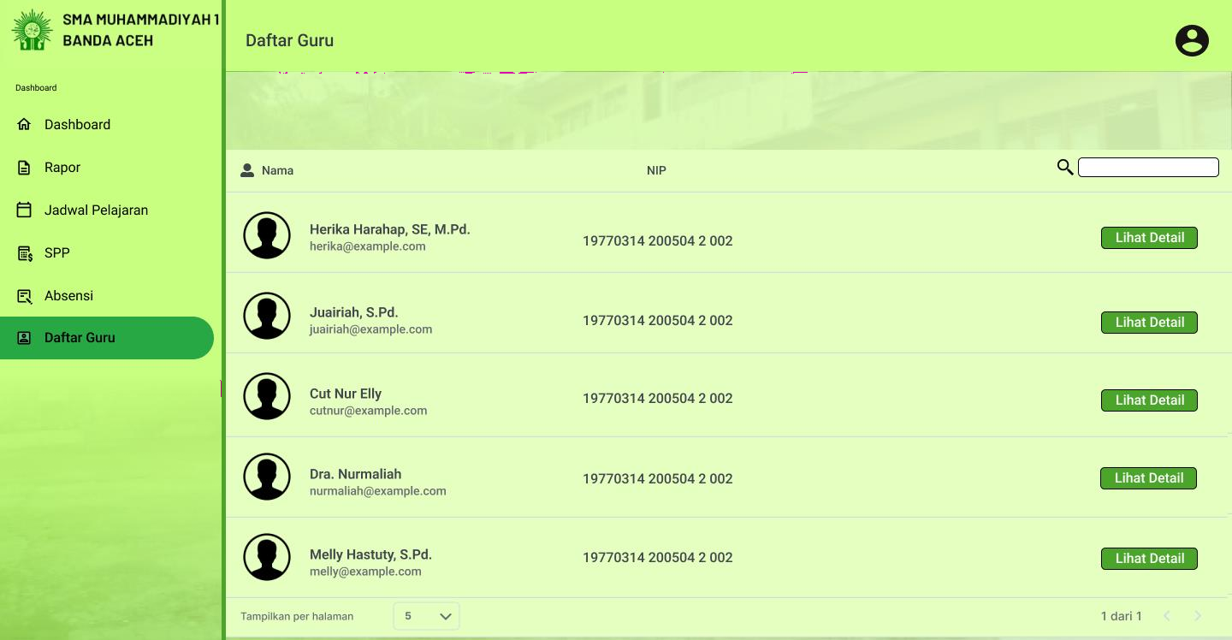

Figure 5.32: List of teachers of SAMS

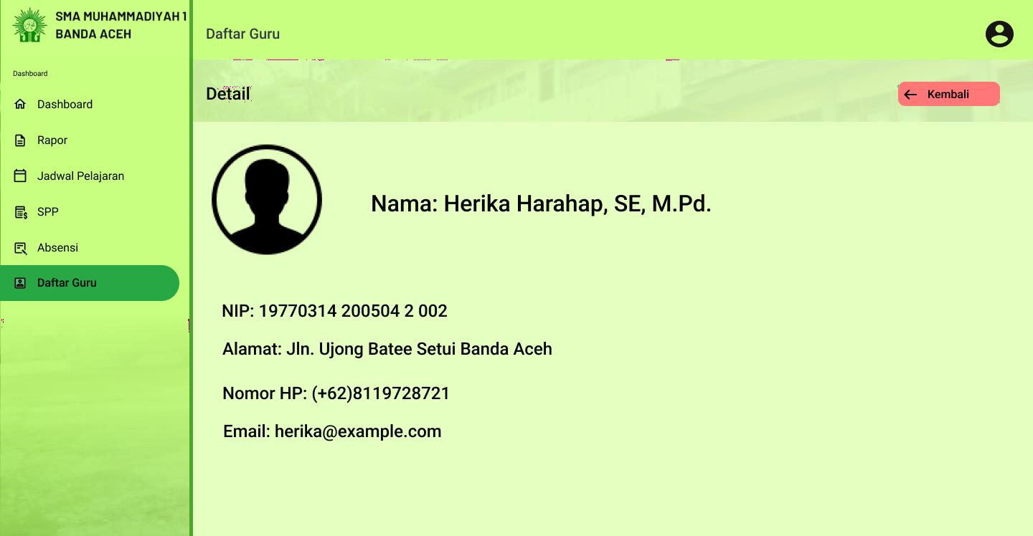

Figure 5.33: Teacher’s detailed information of SAMS

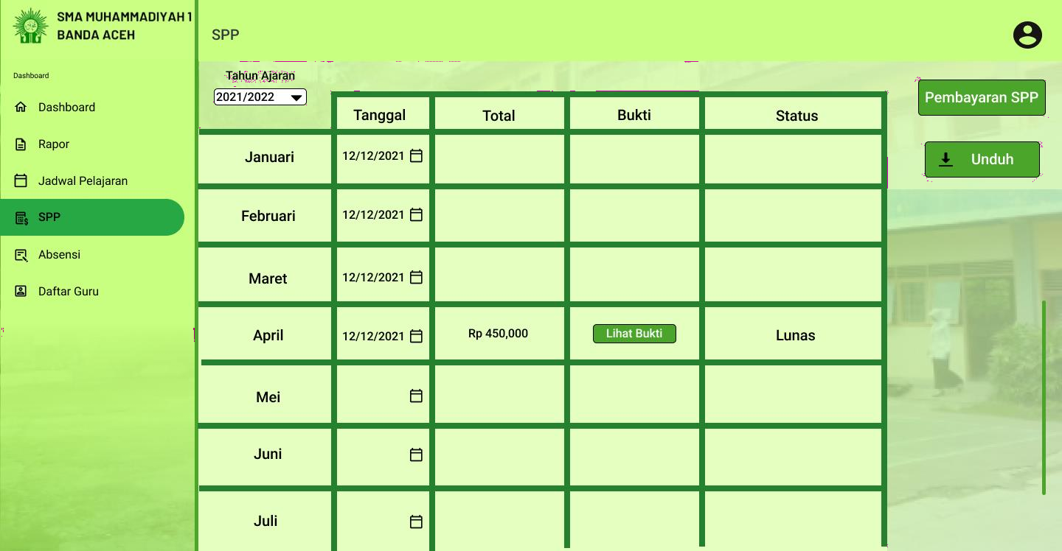

Figure 5.34: View tuition record of SAMS

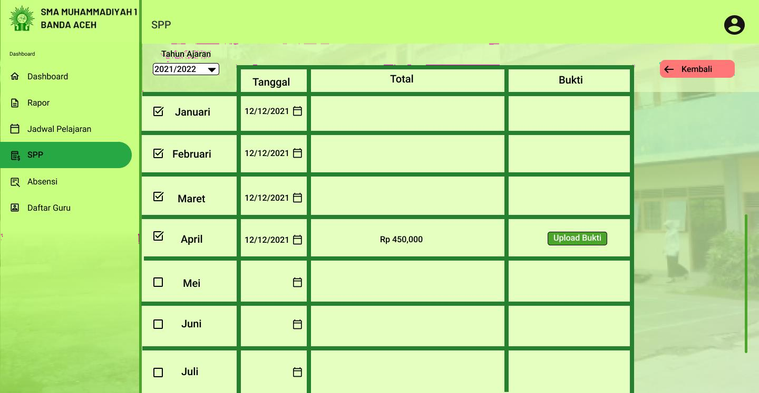

Figure 5.35: Make a payment of SAMS

1. **Requirements Matrix**

Requirement matrix is use to determine which component of the system satisfy the requirements mentioned in the SRS. In this case, the following table shows the use case stated in the SRS is compared with the sequence diagram.

|  |  |  |  |  |  |  |  |  |  |  |  |  |  |  |  |  |  |
| --- | --- | --- | --- | --- | --- | --- | --- | --- | --- | --- | --- | --- | --- | --- | --- | --- | --- |
|  | SD 001 | SD 002 | SD 003 | SD 004 | SD 005 | SD 006 | SD 007 | SD 008 | SD 009 | SD 010 | SD 011 | SD 012 | SD 013 | SD 014 | SD 015 | SD 016 | SD 017 |
| UC 001 | **x** |  |  |  |  |  |  |  |  |  |  |  |  |  |  |  |  |
| UC 002 |  | **x** |  |  |  |  |  |  |  |  |  |  |  |  |  |  |  |
| UC 003 |  |  | **x** |  |  |  |  |  |  |  |  |  |  |  |  |  |  |
| UC 004 |  |  |  | **x** |  |  |  |  |  |  |  |  |  |  |  |  |  |
| UC 005 |  |  |  |  | **x** |  |  |  |  |  |  |  |  |  |  |  |  |
| UC 006 |  |  |  |  |  | **x** |  |  |  |  |  |  |  |  |  |  |  |
| UC 007 |  |  |  |  |  |  | **x** |  |  |  |  |  |  |  |  |  |  |
| UC 008 |  |  |  |  |  |  |  | **x** |  |  |  |  |  |  |  |  |  |
| UC 009 |  |  |  |  |  |  |  |  | **x** |  |  |  |  |  |  |  |  |
| UC 010 |  |  |  |  |  |  |  |  |  | **x** |  |  |  |  |  |  |  |
| UC 011 |  |  |  |  |  |  |  |  |  |  | **x** |  |  |  |  |  |  |
| UC 012 |  |  |  |  |  |  |  |  |  |  |  | **x** |  |  |  |  |  |
| UC 013 |  |  |  |  |  |  |  |  |  |  |  |  | x |  |  |  |  |

|  |  |  |  |  |  |  |  |  |  |  |  |  |  |  |  |  |  |
| --- | --- | --- | --- | --- | --- | --- | --- | --- | --- | --- | --- | --- | --- | --- | --- | --- | --- |
| UC 014 |  |  |  |  |  |  |  |  |  |  |  |  |  | x |  |  |  |
| UC 015 |  |  |  |  |  |  |  |  |  |  |  |  |  |  | x |  |  |
| UC 016 |  |  |  |  |  |  |  |  |  |  |  |  |  |  |  | x |  |
| UC 017 |  |  |  |  |  |  |  |  |  |  |  |  |  |  |  |  | x |

1. **Appendices**

Provide appendices if any.

**Appendix C Software Testing Documentation**



**Software Testing Documentation**

Project Title Version 1.0

24 June 2023 Department and Faculty

Prepared by: Muhammad Darlen Sava

**Revision Page**

1. **Overview**

This is the first draft of the Software Requirements Specification (SRS) for Student Academic Management System (SAMS).

1. **Target Audience**

Student, Teacher and Admin of SMAS Muhammadiyah 1

1. **Project Team Members**

Muhammad Darlen Sava

1. **Version Control History**

|  |  |  |  |
| --- | --- | --- | --- |
| **Version** | **Primary Author(s)** | **Description of Version** | **Date Completed** |
| 1.0 | **Muhammad Darlen Sava** | **Initial Draft** | **24 June 2023** |

**Note:**

This template is an annotated outline for a software testing document. It is based on IEEE standards 829, 1008, 1012 and 1012a. This document covers: unit testing (the verification of individual sub-systems or components of the system against their specifications), integration testing (the testing of inter-operating sub-systems or components against their specifications) and system testing (both verification against the system specification, and validation against the user requirements).This template has been simplified and customized to meet the need of SCSJ2203 course at Faculty of Computing, UTM. Compiled by Ruhaidah Samsudin, PhD and checked by Masitah Ghazali, PhD and Shahida Sulaiman, PhD (revised on 14 May 2016).

**Table of Contents**

|  |  |  |  |
| --- | --- | --- | --- |
| **1** | **Introduction** | | 1 |
|  | 1.1 | Purpose | 1 |
|  | 1.2 | Scope | 1 |
|  | 1.3 | Definitions, Acronyms and Abbreviations | 1 |
|  | 1.4 | Reference Materials | 1 |
|  | 1.5 | System Overview | 2 |
| **2** | **Test Cases** | |  |
|  | 2.1 | Test TC001 for Module Authentication: <Sign In (UC001)> | 3 |
|  | 2.2 | Test TC002 for Module Report: <Manage Academic Report (UC002)> | 3 |
|  | 2.3 Test TC003 for Module Report: <View Academic Report (UC003)> | | 7 |
|  | 2.4 Test TC004 for Module Report: <Download Academic Report (UC004)> | | 7 |
|  | 2.5 Test TC003 for Module Report: <Manage Attendance Record (UC005)> | | 8 |
|  | 2.6 Test TC003 for Module Report: <View Attendance Record (UC006)> | | 8 |
|  | 2.7 Test TC003 for Module Report: <Manage Timetable (UC007)> | | 9 |
|  | 2.8 Test TC003 for Module Report: <View Timetable (UC008)> | | 10 |
|  | 2.9 Test TC003 for Module Report: <Download Timetable (UC009)> | | 10 |
|  | 2.10 Test TC003 for Module Report: <Manage Tuition Record (UC010)> | | 10 |
|  | 2.11 Test TC003 for Module Report: <View Tuition Record (UC011)> | | 11 |
|  | 2.12 Test TC003 for Module Report: <Download Tuition Record (UC012)> | | 12 |

|  |  |
| --- | --- |
| 2.13 Test TC003 for Module Report: <Make a Payment (UC013)> | 12 |
| 2.14 Test TC003 for Module Report: <Manage Profile (UC014)> | 13 |
| 2.15 Test TC003 for Module Report: <Manage User (UC015)> | 14 |
| 2.16 Test TC003 for Module Report: <View Teacher Info (UC016)> | 14 |
| 2.17 Test TC003 for Module Report: <View Student Info (UC017)> | 15 |

187

* 1. **Introduction**
     1. **Purpose**

This STD describes the test design for the Student Academic Management System which is a system dedicated to SMAS Muhammadiyah 1 Banda Aceh. This STD is required to determine the test design for the development phase, it also acts as a reference point when testing the system during development.

* + 1. **Scope**

The current system of SMAS Muhammadiyah is still involving manual task execution with a decentralized database. So this project only focused on the conversion of manually managing student data to a website that stores all of the student’s data, which can be accessed by teachers, students, and their parents. As such, SMAS Muhammadiyah will only provide the student’s data throughout the development of the project. The users in this system will be the teachers, students/parents, and admins of SMAS Muhammadiyah. The goal of this project is to create an effective solution to enable the institution to convert its manual student management system into a computerized system.

* + 1. **Definitions, Acronyms and Abbreviation**

1. SAMS - Student Academic Management System
2. STD - Software Testing Documentation
   * 1. **References**

My.utm.my. (n.d.). Retrieved May 16, 2022, from <https://my.utm.my/home>

Aplikasi Rapor online - solusi. Sekawan Media. (2022, May 16). Retrieved May 16, 2022, from <https://www.sekawanmedia.co.id/solusi/aplikasi-rapor-online/>

Miller, J., Kostogriz, A., & Gearon, M. (Eds.). (2009). Culturally and linguistically diverse classrooms: New dilemmas for teachers. Bristol, UK: Multilingual Matters.

Dinustek. (n.d.). Solusi Rapor Sekolah online. evaluation. Retrieved May 16, 2022, from <https://evaluation.id/>

* + 1. **System Overview**

This STD is divided into four chapters. The first chapter is the introduction which consists of the purpose and scope of the project. It also includes all the acronyms/abbreviation descriptions and references that exist in this STD and a short overview of the whole project. For the second chapter, The STD focused on the test cases for the system. This chapter delves into the test cases that will be used when testing the system. In the third chapter, the analysis of the test approach is described. It consists of which technique or method that is used when testing the system and whether it will be successful or a failure. Chapter 4 of this SDD includes the design of data which consist of Entity Relationship Diagram and data dictionary. The fifth chapter shows the mockup user interface design for the system. In the final chapter it is stated which system component satisfy the SRS.

1. **Test Cases**
   1. **Test TC001 for Module Authentication: <Sign In (UC001)>**

**TC001_01**

|  |  |  |  |
| --- | --- | --- | --- |
| **Action** | **Input data** | **Expected result** | **Actual result** |
| Input Username | abc123 | Username Field is  filled | Username Field is  filled |
| Input Password | qwerty123 | Password is field is filled | Password is field is filled |
| Click Login | - | Successfully enter  the system | Successfully enter  the system |

* 1. **Test TC002 for Module Report: <Manage Academic Report (UC002)> TC002_01**

|  |  |  |  |
| --- | --- | --- | --- |
| **Action** | **Input data** | **Expected result** | **Actual result** |
| Click the “Rapor” menu | - | The list of students displayed | The list of students displayed |
| Input the academic year, semester, class and name | Year: 2021/202  2  Semester  : Ganjil Class: XI MIPA  Name: Sheila | The specific student is displayed | The specific student is displayed |
| Click the “Tinjau”/”Downlo ad” button or the  “Trash” icon | - | The academic report is displayed/downloaded/del eted | The academic report is displayed/downloaded/del eted |

**TC002_02**

|  |  |  |  |
| --- | --- | --- | --- |
| **Action** | **Input data** | **Expected result** | **Actual result** |
| Click the “Buat  Rapor” menu | - | The list of students  displayed | The list of students  displayed |
| Search the specific student | Sheila | The specific student is displayed | The specific student is displayed |
| Click the “Buat Rapor” button | - | The create academic report form is displayed | The create academic  report form is displayed |

|  |  |  |  |
| --- | --- | --- | --- |
| Input the  extracurricular | Pramuka | The extracurricular is field  is filled | The extracurricular is  field is filled |
| Select the extracurricular  mark | A | The extracurricular mark is selected | The extracurricular mark is selected |
| Click the  “Selanjutnya” Button | - | The next create academic report form is displayed | The next create  academic report form is displayed |
| Select the  spiritual attitude mark | A | The spiritual attitude mark is selected | The spiritual attitude mark is selected |
| Fill in the spiritual attitude description | Selalu berdoa sebelum melakukan  kegiatan | The spiritual attitude is field is filled | The spiritual attitude is field is filled |
| Select the social  attitude mark | A | The social attitude mark is  selected | The social attitude  mark is selected |
| Fill in the social attitude description | Mulai konsisten  perilaku jujur | The social attitude is field is filled | The social attitude is field is filled |
| Click the “Selanjutnya”  button | - | The confirmation page is displayed | The confirmation page is displayed |
| Click the “Buat  Rapor” button | - | The academic report is  created | The academic report is  created |

**TC002_03**

|  |  |  |  |
| --- | --- | --- | --- |
| **Action** | **Input data** | **Expected result** | **Actual result** |
| Click the “Penilaian”  menu | - | The marking form is displayed | The marking form is displayed |
| Select the academic year, semester, class, subject, aspect. | Year: 2021/2022  Semester: Ganjil  Class: XI  MIPA  Name: Sheila Subject: Matematika  Aspect: Keterampilan | The form option is selected | The form option is selected |
| Input the “KKM”, mark and description field | KKM: 70  Mark: 84 Description:  Siswa terampil | KKM, description and mark field are filled | KKM, description and mark field are filled |

|  |  |  |  |
| --- | --- | --- | --- |
|  | dalam mengerjakan  soal |  |  |
| Click the  “Simpan” buttton | - | The mark is saved | The mark is saved |

**TC002_04**

|  |  |  |  |
| --- | --- | --- | --- |
| **Action** | **Input data** | **Expected result** | **Actual result** |
| Click the “Ubah  Penilaian” menu | - | The marked student list  is displayed | The marked student list is  displayed |
| Select the  student and mark aspect. | Name: Sheila  Aspect: Keterampilan | The form option is selected | The form option is selected |
| Click the “Ubah  Nilai” button | - | The edit mark form is  dieplayed | The edit mark form is  dieplayed |
| Select the academic year, semester, class, subject, aspect. | Year: 2021/2022  Semester: Ganjil  Class: XI  MIPA  Name: Sheila Subject: Matematika Aspect:  Keterampilan | The form option is selected | The form option is selected |
| Input the “KKM”, mark and description field | KKM: 70  Mark: 84 Description: Siswa terampil dalam  mengerjakan soal | KKM, description and mark field are filled | KKM, description and mark field are filled |
| Click the  “Simpan” buttton | - | The mark is saved | The mark is saved |

* 1. **Test TC003 for Module Report: <View Academic Report (UC003)> TC003_01**

|  |  |  |  |
| --- | --- | --- | --- |
| **Action** | **Input data** | **Expected result** | **Actual result** |
| Click the  “Rapor” menu | - | The list of students  displayed | The list of students  displayed |
| Input the  academic year, semester and class | Year: 2021/2022  Semester: Ganjil Class: XI MIPA | The specific student is displayed | The specific student is displayed |
| Click the  “Tinjau” Button | - | The academic report is displayed | The academic report is displayed |

* 1. **Test TC004 for Module Report: <Download Academic Report (UC004)> TC004_01**

|  |  |  |  |
| --- | --- | --- | --- |
| **Action** | **Input data** | **Expected result** | **Actual result** |
| Click the  “Rapor” menu | - | The list of students  displayed | The list of  students displayed |
| Input the academic year, semester and class | Year: 2021/2022  Semester: Ganjil Class: XI MIPA | The specific student is displayed | The specific student is displayed |
| Click the  “Download” Button | - | The academic  report is downloaded | The academic  report is downloaded |

* 1. **Test TC005 for Module Attendance: <Manage Attendance Record (UC005)>**

**TC005_01**

|  |  |  |  |
| --- | --- | --- | --- |
| **Action** | **Input data** | **Expected result** | **Actual result** |
| Click the “Absensi” menu | - | The list of students displayed | The list of students displayed |
| Select the date, total hour and class | Date: 12/12/2021  Total hour: 2  Class: XI MIPA | The form option is selected | The form option is selected |
| Select one of the student  presences | S | The form option is selected | The form option is selected |
| Click the  “Simpan” Button | - | The attendance record is  saved | The attendance record is  saved |

* 1. **Test TC006 for Module Attendance: <View Attendance Record (UC006)> TC006_01**

|  |  |  |  |
| --- | --- | --- | --- |
| **Action** | **Input data** | **Expected result** | **Actual result** |
| Click the “Absensi” menu | - | The attendance record view displayed | The attendance record view displayed |
| Select the date range, and class | Date: 12/12/2021  – 15/01/2022  Class: XI MIPA | The attendance record is displayed | The attendance record is displayed |

* 1. **Test TC007 for Module Schedule: <Manage Timetable (UC007)>**

**TC007_01**

|  |  |  |  |
| --- | --- | --- | --- |
| **Action** | **Input data** | **Expected result** | **Actual result** |
| Click the “Jadwal  Pelajaran” menu | - | The timetable UI is displayed | The timetable UI is displayed |
| Select the class | Class: XI MIPA | The Timetable is displayed | The Timetable is displayed |

**TC007_02**

|  |  |  |  |
| --- | --- | --- | --- |
| **Action** | **Input data** | **Expected result** | **Actual result** |
| Click the “Ubah  Jadwal Pelajaran” menu | - | The edit timetable UI is displayed | The edit timetable UI is displayed |
| Select the hour and subject | Hour: 1 Subject: Matematika | The form option is selected | The form option is selected |
| Click the  “Simpan” Button | - | The attendance record is  saved | The attendance record is  saved |

* 1. **Test TC008 for Module Schedule: <View Timetable (UC008)> TC008_01**

|  |  |  |  |
| --- | --- | --- | --- |
| **Action** | **Input data** | **Expected result** | **Actual result** |
| Click the “Jadwal  Pelajaran” menu | - | The timetable is displayed | The timetable is displayed |

* 1. **Test TC009 for Module Schedule: <Download Timetable (UC009)> TC009_01**

|  |  |  |  |
| --- | --- | --- | --- |
| **Action** | **Input data** | **Expected result** | **Actual result** |
| Click the  “Jadwal Pelajaran” menu | - | The timetable UI is displayed | The timetable UI is displayed |
| Click the  “Unduh” button | - | The Timetable is  downloaded | The Timetable is  downloaded |

* 1. **Test TC010 for Module Account: <Manage Tuition Record (UC010)>**

**TC010_01**

|  |  |  |  |
| --- | --- | --- | --- |
| **Action** | **Input data** | **Expected result** | **Actual result** |
| Click the “SPP”  menu | - | The list of students displayed | The list of students displayed |
| Select the academic year, semester, class and name | Year: 2021/2022  Semester: Ganjil Class: XI MIPA  Name: Sheila | The specific student is displayed | The specific student is displayed |
| Choose one of the students and click “Lihat  SPP” | - | The student’s tuition record is displayed | The student’s tuition record is displayed |
| Click the “Lihat  Bukti” button | - | The uploaded payment proof by the student is displayed | The uploaded payment proof by the student is displayed |
| Change the status to approve the  payment | Lunas | The Tuition status is approved | The Tuition status is approved |

* 1. **Test TC011 for Module Account: <View Tuition Record (UC011)>**

**TC011_01**

|  |  |  |  |
| --- | --- | --- | --- |
| **Action** | **Input data** | **Expected result** | **Actual result** |
| Click the “SPP”  menu | - | The tuition record UI is displayed | The tuition record UI is displayed |
| Select the academic year, semester | Year: 2021/2022  Semester: Ganjil | The specific tuition record is displayed | The specific tuition record is displayed |
| Click the “Lihat Bukti”  button | - | The uploaded payment proof by the student is displayed | The uploaded payment proof by the student is displayed |

* 1. **Test TC012 for Module Account: <Download Tuition Record (UC012)> TC012_01**

|  |  |  |  |
| --- | --- | --- | --- |
| **Action** | **Input data** | **Expected result** | **Actual result** |
| Click the  “SPP” menu | - | The tuition record UI  is displayed | The tuition record UI  is displayed |
| Select the academic year, semester | Year: 2021/2022  Semester: Ganjil | The specific tuition record is displayed | The specific tuition record is displayed |
| Click the  “Download” button | - | The tuition record is downloaded | The tuition record is downloaded |

* 1. **Test TC013 for Module Account: <Make a Payment (UC013)>**

**TC013_01**

|  |  |  |  |
| --- | --- | --- | --- |
| **Action** | **Input data** | **Expected result** | **Actual result** |
| Click the “SPP” menu | - | The tuition record UI is displayed | The tuition record UI is displayed |
| Click the  “Pembayaran SPP” button | - | The tuition record is downloaded | The tuition record is downloaded |
| Select the academic year, semester | Year: 2021/2022  Semester: Ganjil | the academic year and semester are selected | the academic year and semester are selected |
| Check the month that want to be  paid | Januari. Februari | The specific month is checked | The specific month is checked |
| Click “Upload Bukti”  Button | - | The prompt to upload the payment proof is displayed | The prompt to upload the payment proof is displayed |
| Upload the  proof of payment file | Payment.png | The file is uploaded | The file is uploaded |
| Click  “Simpan” button | - | The payment proof is saved | The payment proof is saved |

* 1. **Test TC014 for Module Account: <Manage Profile (UC014)> TC014_01**

|  |  |  |  |
| --- | --- | --- | --- |
| **Action** | **Input data** | **Expected**  **result** | **Actual result** |
| Click  Profile menu | - | The user profile is displayed | The user profile is displayed |
| Click “Ubah  Profile” Button | - | The user can edit their profile | The user can edit their profile |
| Change the  email address | [sheila@example.com](mailto:sheila@example.com) | The edit email  address field is filled | The edit email  address field is filled |
| Click “Simpan”  button | - | The profile is updated | The profile is updated |

* 1. **Test TC015 for Module Account: <Manage User (UC015)>**

**TC015_01**

|  |  |  |  |
| --- | --- | --- | --- |
| **Action** | **Input data** | **Expected result** | **Actual result** |
| Click the “Manajemen  Akun” menu | - | The account management UI  is displayed | The account management UI is  displayed |
| Select the user type | Guru | The list of teacher user account  displayed | The list of teacher user account displayed |
| Select the homeroom teacher | XI MIPA | The selected teacher became the homeroom of  the selected class | The selected teacher became the homeroom of the  selected class |
| Click “Trash” icon | - | The user account is deleted | The user account is deleted |

* 1. **Test TC016 for Module Account: <View Student Info (UC016)> TC016_01**

|  |  |  |  |
| --- | --- | --- | --- |
| **Action** | **Input data** | **Expected result** | **Actual result** |
| Click the “Daftar  Siswa” menu | - | The list of students is  displayed | The list of students is displayed |
| Select the academic year, semester and  class | Year: 2021/2022  Semester: Ganjil Class: XI MIPA | The list of specified students displayed | The list of specified students displayed |
| Click “Lihat Detail” button | - | The detailed information of  the student is displayed | The detailed information of the student is displayed |

* 1. **Test TC017 for Module Account: <View Teacher Info (UC017)>**

**TC017_01**

|  |  |  |  |
| --- | --- | --- | --- |
| **Action** | **Input data** | **Expected result** | **Actual result** |
| Click the “Daftar Teacher”  menu | - | The list of students is displayed | The list of students is displayed |
| Click “Lihat Detail” button | - | The detailed information of the student is  displayed | The detailed information of the student is displayed |

**Appendix D Gannt Chart**

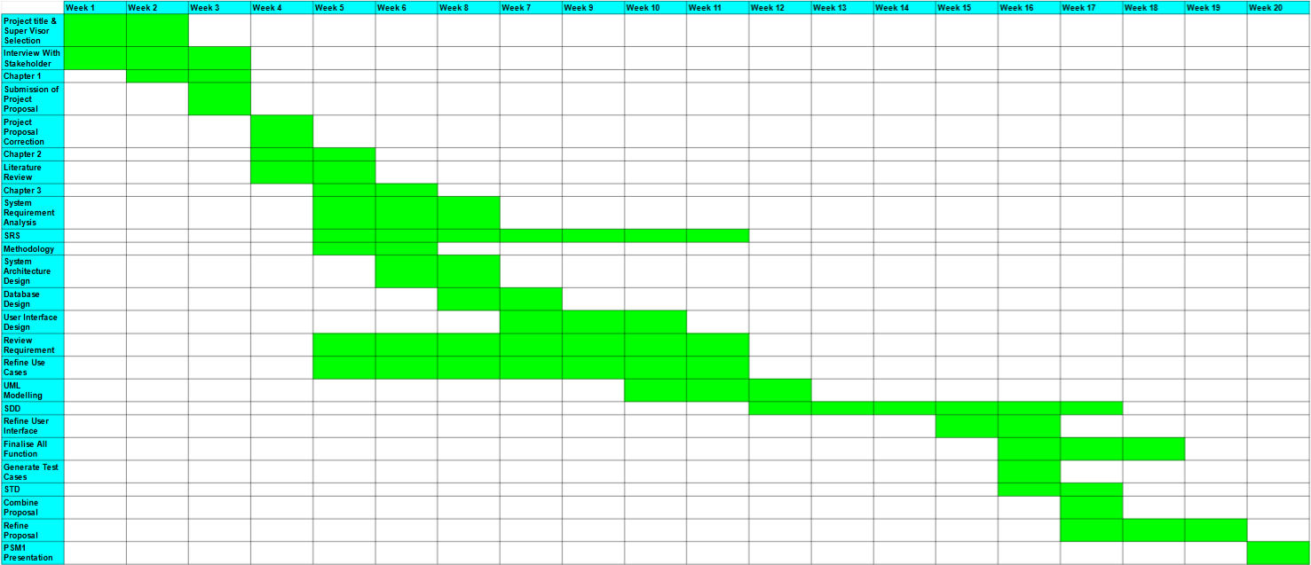

Figure D.1: PSM 1 Gantt Chart

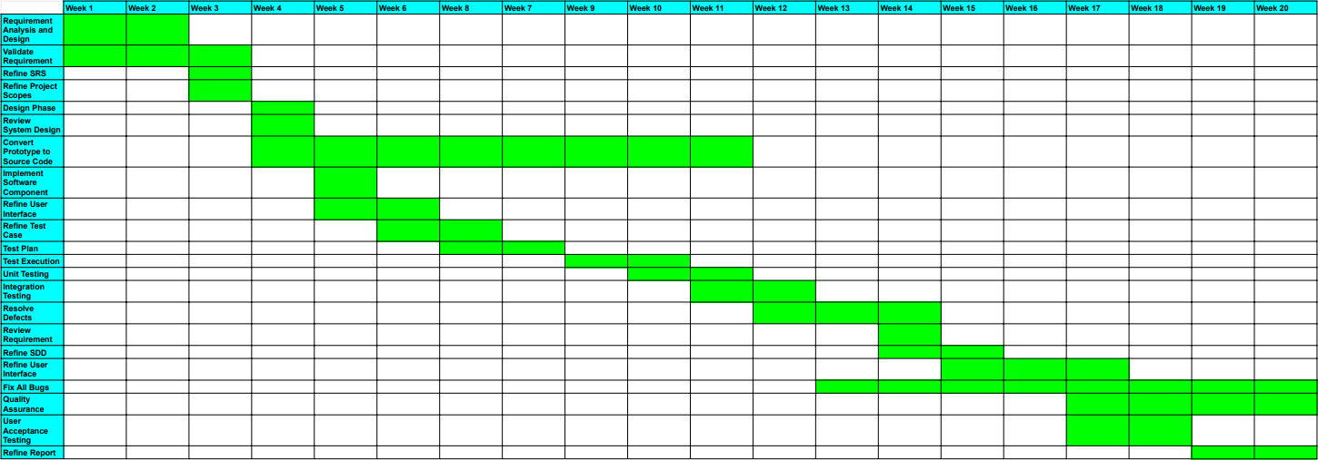

Figure D.2: PSM 2 Gantt Chart